Questions for Sephton Water Technology, Inc
- The submission notes that steam electricity for the extraction of 3-4 million tons of salt annually would be needed. What would be your vision for how this service would be contracted out? Would this rely on PPAs, steam sales or "salt extraction" contracts with existing or new developers?
- Would the state run the salt extraction facilities and contract for the energy (electricity for which could be provided by sources other than geothermal; sparing geothermal for thermal uses), or contract for the services? Please describe a picture of what you think various commercial arrangements might be. Would that be different if the salt removal plant were on one side of the border or another? Could the state simply tender to multiple service providers?
- Using the New and Alamo River channels is a crafty solution to avoid some permitting and construction issues. What would be the major downsides of that arrangement?
Regarding Question 1:
If sufficient freshwater were delivered to the Salton Sea to sustain a target elevation and dilute the salinity and other contaminants, (Proposal Concepts B and C) there are still 3 to 4 million metric tons of salt flowing into the Salton Sea annually from agricultural drainage in the Imperial and Coachella Valleys and small sources like Salt Creek that need to be removed. If ocean water were delivered directly to the Salton Sea (as with Concept A) the total salt loading would be closer to 26 million metric tons annually.
Both heat and electricity are needed to power the salt extraction and water recycling process. The process first requires electricity to pump water from the Salton Sea to plants on shore. Second the process requires electricity to run moderately high pressure pumps and controls for the ultra-filtration and two step nanofiltration process that separates 95% of the Salton Sea water to a high purity sodium chloride brine with mixed salts in the remaining 5% volume. Third there is a large heat requirement at 200°C or more along with a moderate electrical requirement for low pressure circulation pumps and controls to use high performance multi-effect distillation to concentrate the sodium chloride brine to saturation while recovering over 92% of the water as pure distillate to return to the Salton Sea or to habitat projects. The sodium chloride brine gets pumped either to evaporation ponds for solar grade commercial salt or to further refinement. Fourth there is a similar heat and electrical requirement, but a 1/20th the scale, to concentrate the 5% stream of mixed salts close to saturation and deliver them to salinity gradient solar ponds for solar energy collection and storage while recovering 75% of the water. Fifth, there is a need for both heat and electricity to refine salts by vacuum evaporation to food grade commercial salt. Finally there is heat needed for drying solid salt and a modest amount of electrical power needed for grinding, sorting, bagging, and loading salt on rail cars.
For all three concepts (A, B, and C), the salt extraction process in the U.S. is costed on purchasing heat from geothermal power plants at the southeast end the Salton Sea in the form a flashed geothermal steam at 200°C or higher. The thermal energy rate was quoted by a major local geothermal developer to be the same dollar amount that developer would get if they used the geothermal steam to run turbines and generate power. The salt extraction / distillation operator could be a separate commercial entity from the geothermal developer and would, in that case, purchase steam in the form of a thermal PPA and could also purchase power from the geothermal developer in a standard PPA. Alternatively electrical power could be purchased from the local utility, the Imperial Irrigation District (IID) or from a solar developer if energy storage for 24/7 operation is included. It should also be noted that both the needed heat and power could be purchased from a concentrating solar thermal power (CSP) developer although CSP is not common in the region now.
In the past, local geothermal developers have focused on power. The largest got burned 18 years ago with a zinc operation that lost money. But now all current and new developers on the Salton Sea Known Geothermal Resource Area (KGRA) are aggressively pursuing lithium extraction from the geothermal brine. Depending how the lithium ventures go, new and existing geothermal developers of the Salton Sea KGRA may or may not develop an interest in other minerals, including abundant Salton Sea minerals like salt, gypsum, sodium sulfate, and magnesium. Marketing minerals is not an expertise the Salton Sea KGRA geothermal developers have yet, so while logical from a process standpoint, it’s not clear whether or not there will be an interest from those developers in adding commercial salt to their product portfolio. If so, then one or more local geothermal developers could contract with the State to access the salt resources in the Salton Sea water. If not, then one or more private salt extraction / distillation operators would in essence buy the rights to the public salt resource by returning pure water to the ecosystem (plus some cash to the State) and buy heat through thermal PPA’s with both new and existing geothermal developers. It should be noted that certain new geothermal developments focused primarily on lithium extraction are designing around a substantial excess of geothermal steam not needed for power that can be sold as heat for salt extraction / distillation.
Regarding Question 2:
While it could be possible for the State to run a salt extraction / distillation operation, there is no California State agency with experience in this kind of mineral extraction and sales enterprise. The more logical scenario is for the State, and/or Federal Government, to license access to the salt resource, Salton Sea water, to one or more private enterprises that would focus on efficiently extracting the salt and distilling the water, with an obligation to return 90% of that water to the Salton Sea ecosystem. The private enterprises would also have the right to revenue from other minerals in the Salton Sea water, returning only pure distilled water. The private enterprises would also make cash payment to the State to fund the operating cost and pay off the construction bonds on any water conveyance infrastructure the State supports to import water to the Salton Sea.
As noted in the answer to Question 1, the private salt extraction / distillation enterprises would contract with local geothermal and/or solar developers for heat and power. Grid power could also be purchased from IID, however IID power is mostly fossil fuel based, so that’s not a preferred option at this time. Also noted in the answer to Question 1, one or more geothermal developers may take interest in adding a salt extraction / distillation operation to their business. The necessary proximity to steam and the similarity of most process operations of salt extraction / distillation plants to a geothermal operation with lithium extraction make this logical, but it is outside the experience of the current geothermal operators at the Salton Sea KGRA, so they may or may not be willing to invest in it. The larger local geothermal companies do have the needed access to capital, should there be an interest.
The commercial structure in Mexico is quite different. The Cerro Prieto geothermal power plants are operated by the Comisión Federal de Electricidad (CFE) an agency of the Mexican Federal Government. While there are small private salt producers in Mexico, the largest producer is Exportadora de Sal located at Guerrero Negro on the Pacific Coast of Baja California. Producing up to 9 million metric tons of salt annually, and exporting to nations around the world including a large portion to the western US, the operation is 51% owned by the Mexican Federal Government and 49% by Mitsubishi Corporation. Past plans to expand the operation at Guerrero Negro were blocked by environmental groups in Mexico due to the impact of the vast salt evaporation pond operation on the El Vizcaino Biosphere Reserve’s sensitive marine life and gray whale breeding area.
The geothermal heat and power for a non-evaporation pond based salt extraction / distillation operation at Cerro Prieto would definitely have to be supplied by an arrangement with CFE. This would be done by increasing the Cerro Prieto plant capacity (the required undeveloped geothermal field capacity has been demonstrated) to extract salt and distill seawater brought north from the Sea of Cortez. In Mexico it would be practical for the salt extraction / distillation operation at Cerro Prieto to be fully run by the Federal Government with distribution and marketing by Exportadora de Sal and export from either San Felipe or Mexico’s Pacific Coast ports. This would enable the previously sought expansion of Exportadora de Sal’s production without damage to a highly sensitive marine environment.
If the great majority of the salt extraction / distillation operation is in Mexico with roughly 500,000 acre feet per year of pure distilled water delivered across the border to sustain the Salton Sea, the Mexican Federal Government would be in control of the operation. In addition to salt and power revenue, the operation can benefit Mexico by distilling more seawater than the 500,000 acre feet needed for the Salton Sea and supplying that for urban use in Mexicali and Tijuana. The Mexicali Valley and most of Northern Baja has a serious water shortage and would benefit from new affordable distilled water supply with the cost offset by salt sales.
In order to secure continued flow of distilled water to sustain the Salton Sea it would be appropriate for the State of California to help Mexico back the construction bonds to build the canal and pump infrastructure to bring seawater 108 miles north and up 40 feet of elevation to Cerro Prieto. The State could also back construction bonds for water treatment infrastructure, and back the existing waterway and new conveyance improvements to move potable water from Cerro Prieto to Mexicali and to the border. The Baja State Water Commission already has pump and pipe infrastructure to move freshwater from Mexicali to Tijuana. The U.S. Federal Government would have to be involved negotiating such an arrangement with the Mexican Federal Government. The U.S. and Mexican sections of the International Boundary and Water Commission would likely negotiate details of how, when, and at what quality water moves across the border. A new minute (amendment) to the existing U.S. / Mexico water treaty could secure delivery, although it’s not required for entities Mexico to move water across the existing New and Alamo River border crossings.
If State and Federal agencies on both sides of the border are incapable of reaching an agreement, or if political intransigence in the U.S. blocks any progress, there is a longer shot option where a private benefactor works with the Mexican Government to fund the conveyance and plant infrastructure, collects a share of the profit from sales of salt and power produced in Mexico, and pays the Mexican Government to deliver clean water to the Mexican side of the New and Alamo River channels, letting the Salton Sea sustaining water flow across with no International agreement and no U.S. side permits.
For salt extraction / distillation operations in the U.S., the State can and most likely would contract with one or more private operators. These private operators would purchase heat and power from both new and existing geothermal or solar power providers. Alternatively, the State may contract with vertically integrated salt extraction / distillation / geothermal power / lithium developers should one or more of those enterprises chose to enter the business. These contracts would differ from a standard tender in that the private entities would pay the State for continuous access to the mineral resources in the Salton Sea water. So long as the future market for salt and other minerals is not flooded depressing prices, the private salt extraction / distillation entities can make a profit from sales of salt and power. The attached spreadsheet (SaltonSeaWaterImportationProject_CostTemplate_WISER_2021) shows the private entities making a profit in each year after operations start for each of the three water importation concepts presented (Concepts A, B, and C). These profits will be sufficient for the private entities to pay the State the cost of building and operating seawater conveyance infrastructure in California and paying for the same in Mexico if the salt extraction operations are mostly at the Salton Sea (Concept A below).
For salt extraction / distillation operations in Mexico (under Concept B below), the arrangement is different as the Mexican Government may opt to own and operate the plants that would extract salt, distill ocean water, and generate power. For a Mexican Government owned operation projected revenue still exceeds cost in all years of operation and the great majority of the profit from the operation in Mexico goes to Mexico.
In that case (Concept B U.S. Only) there is still a profitable 3-4 million metric tons per year salt extraction operation at the Salton Sea that can make payments to the State of California to in turn incentivize Mexico up $400 per acre foot to deliver 500,000 acre feet per year of distilled water across the border.
Regarding Question 3:
As the question noted, Concept B, the All Mexican Canal, is intended to restore the Salton Sea while circumventing political and public agency opposition in the U.S. to whole Sea restoration and the onerous environmental documentation, permitting, right of way, and NIMBY legal challenges to building any significant new water conveyance infrastructure in California.
One major downside is that, if the import of distilled ocean water is done via the New and Alamo River and the State cooperates with and facilitates that delivery, then an Environmental Impact Report (EIR) will be needed under the California Environmental Quality Act (CEQA) for impacts to the New and Alamo Rivers. Most of the environmental impacts of mixing 500,000 acre feet per year of pure distilled water into the New and Alamo Rivers will be beneficial because that would significantly dilute the pesticides, selenium, and several other listed pollutants that often exceed Federal EPA standards in those rivers along with fertilizer runoff and occasional raw sewage spills into the New River from Mexicali. Nevertheless, even beneficial impacts are impacts, so a CEQA EIR would likely be required and would likely take about two years and a couple million dollars to complete at the expense of the State or a State chartered local agency. That cost could be paid by a private entity that contracts with the State to gain access to the salt and mineral resources in Salton Sea water. Such payment would be justified because the distilled ocean water dilution inflow would be part of the overall management of Salton Sea water quality, direct removal of excess salts and low level contaminants being the other part.
Another major downside is the need to use care to manage flows in the New and Alamo River. This flow control needs to be managed from the Mexico side of the operations using two new and two existing freshwater conveyances in the Mexicali Valley. Flow control in Mexico needs to account for capacity and flow variations in the New and Alamo River channels. There is substantial flow variability in the New and Alamo Rivers based on Imperial Irrigation District (IID) data obtained several years ago (attached). Flow variability is seasonal with variations in agricultural irrigation and drainage. Highest flows immediately follow major rain events. Flow of distilled ocean water across the border may need to counterbalance seasonal flow variations in the New and Alamo River. During and for a few days after a rare heavy rain, cross border flow may have to be interrupted with distilled water stored or delivered to users in Mexico.
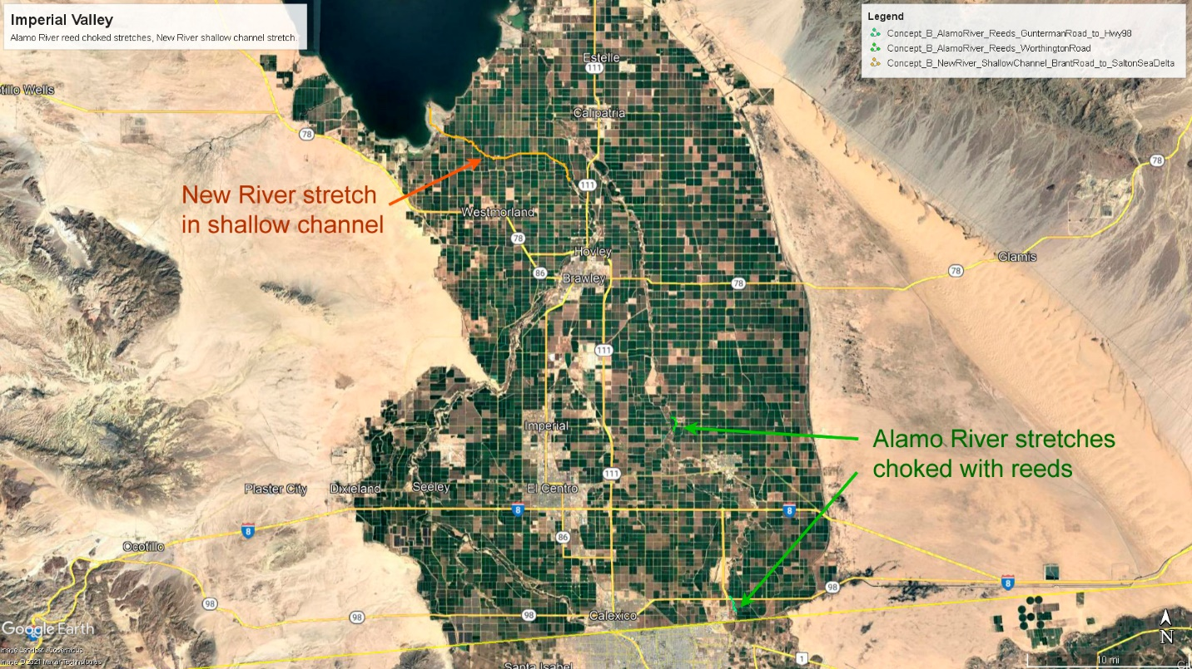
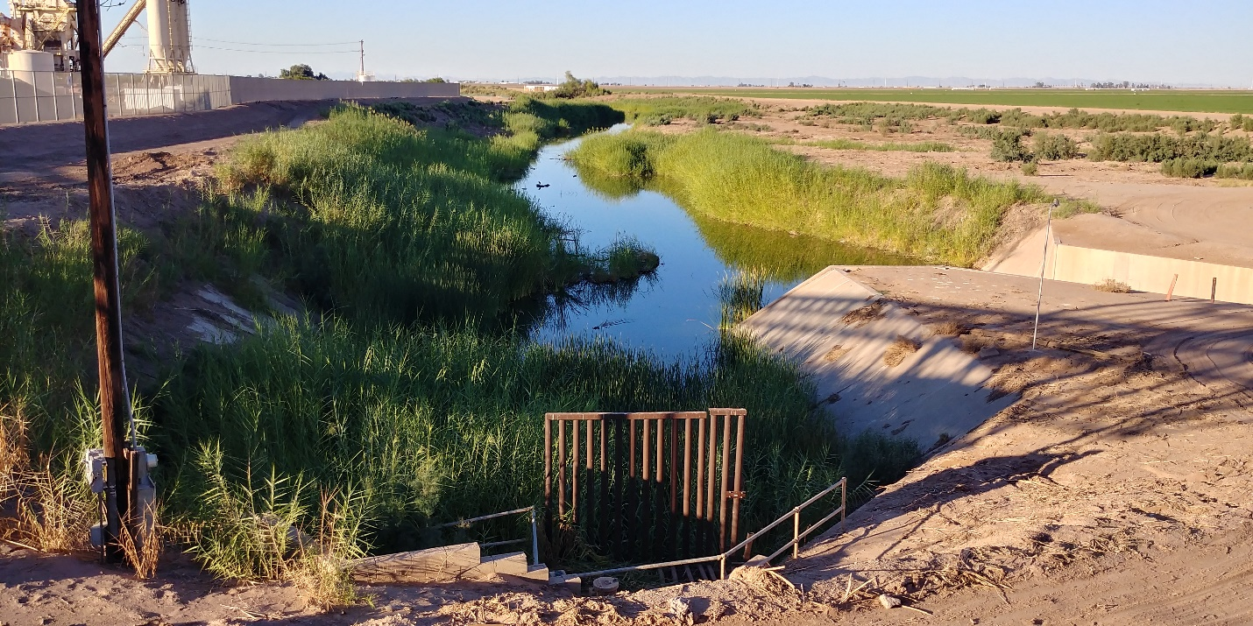
Alamo River at Border Crossing
Easing flow management is the substantial decline in the New and Alamo Rivers since Quantification Settlement Agreement (QSA) water transfers began after 2003 plus the impact of prior water transfers to the Metropolitan Water District of Southern California (MWD). The point of cross border distilled water delivery under Concept B is to restore overall annual flow in the New and Alamo Rivers to pre-2003 levels, thereby restoring inflow to the Salton Sea. On an annual basis, there is excess flow capacity available in the New and Alamo River channels up to that pre-QSA and related water transfer goal.
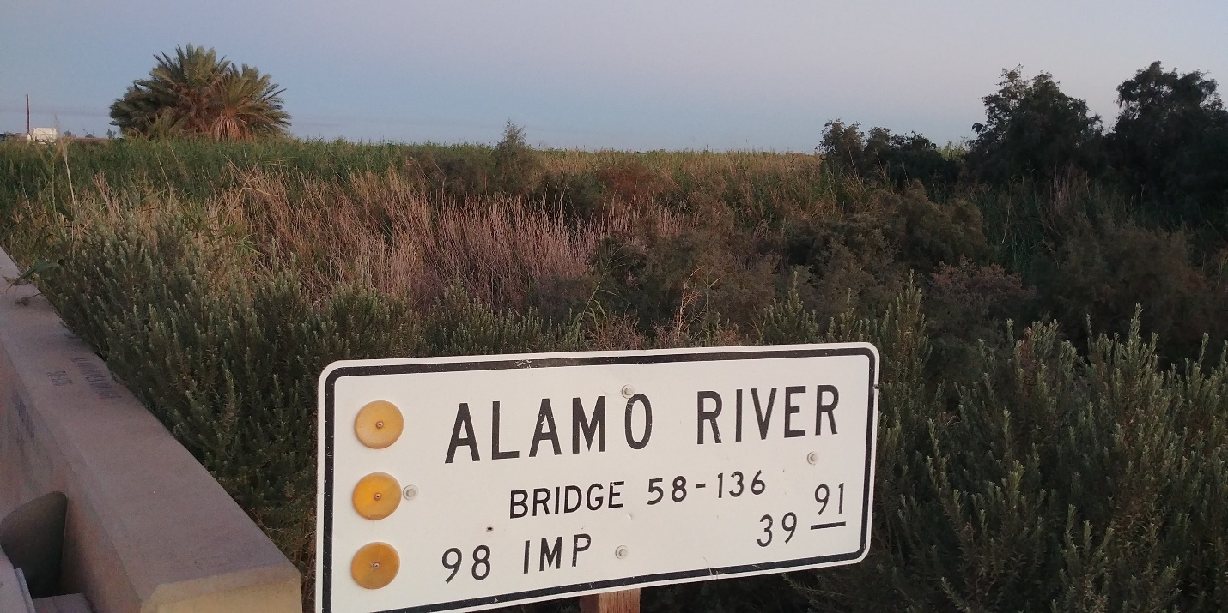
Alamo River choked with reeds at Highway 98 Bridge, 1.3 miles north of U.S. / Mexico border
There are two specific streambed flow management issues in the New and Alamo Rivers noted in the satellite map above. In the Alamo River there are two sections in the upper reaches that are currently choked with reeds. One reed choked section runs from one half mile north of the border crossing for 1.25 miles to where Highway 98 crosses the Alamo River. This section may need clearing of reeds in order to support an increased flow of water across the border.
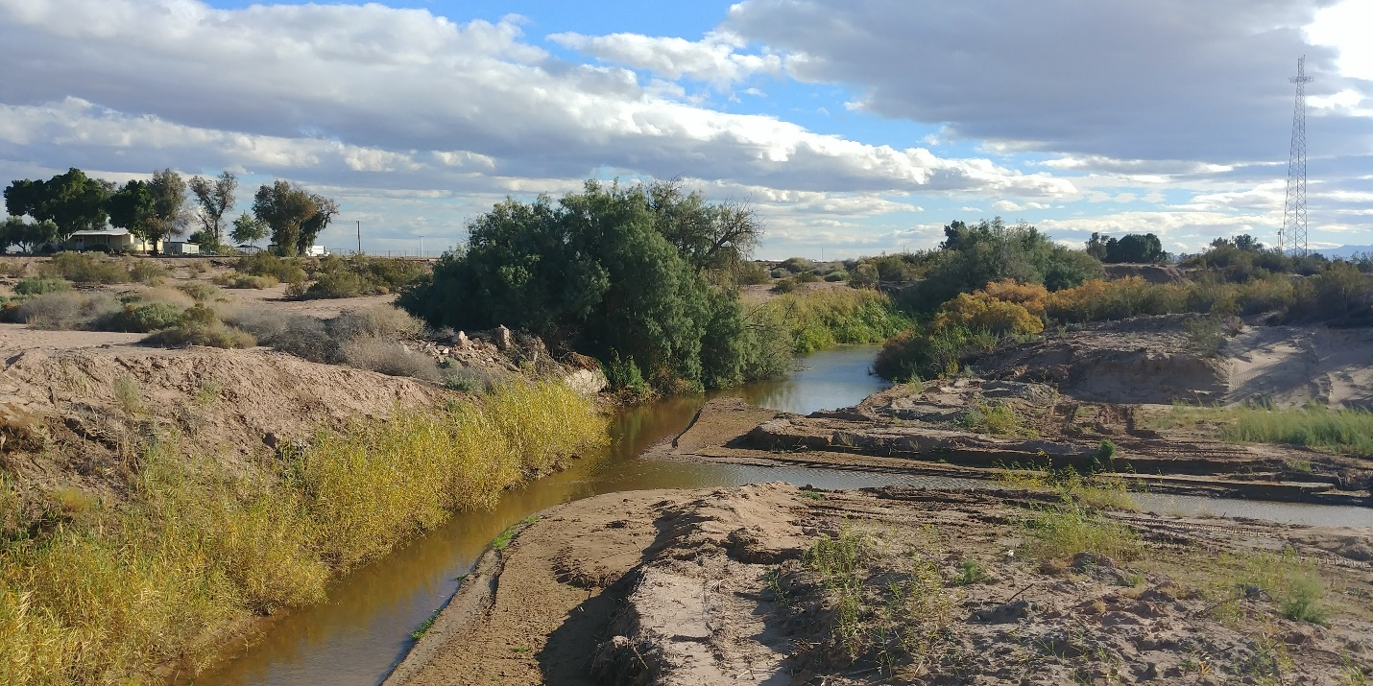
Alamo River channel largely clear of reeds at Heber Road north of Highway 98, fed by a drain
The IID routinely clears reeds from sections of the Alamo River near weirs and other control structures, but not in the Highway 98 section recently. It would handle the flow better if the reeds were cleared. A little way north of the Highway 98 crossing, the Alamo River is mostly clear of reeds and flows in a deeper channel past Heber Road.
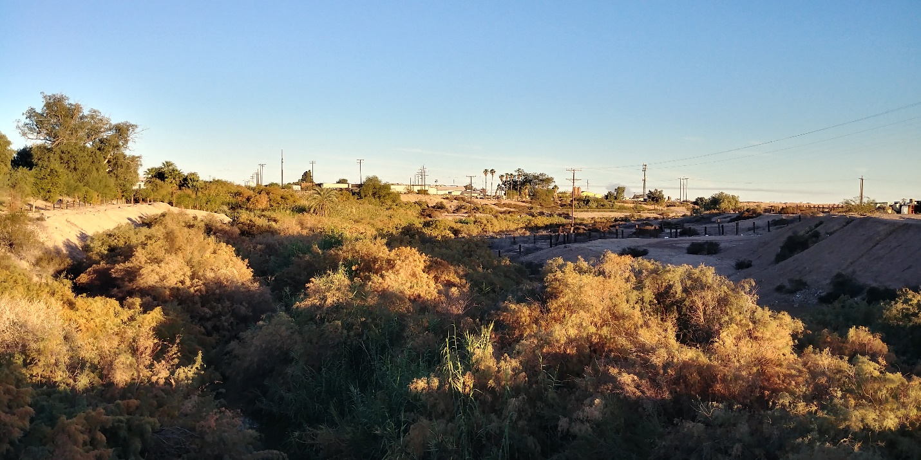
Alamo River channel has reeds and brush but flows in a 30 foot deep channel past Holtville
The channel widens and deepens into a small gorge. The Alamo River meanders north in the gorge, then turns west to the small City of Holtville. The roughly 30 foot deep gorge through Holtville eliminates risk of major impact from too much flow near the town irrespective of whether reeds are cleared or not.
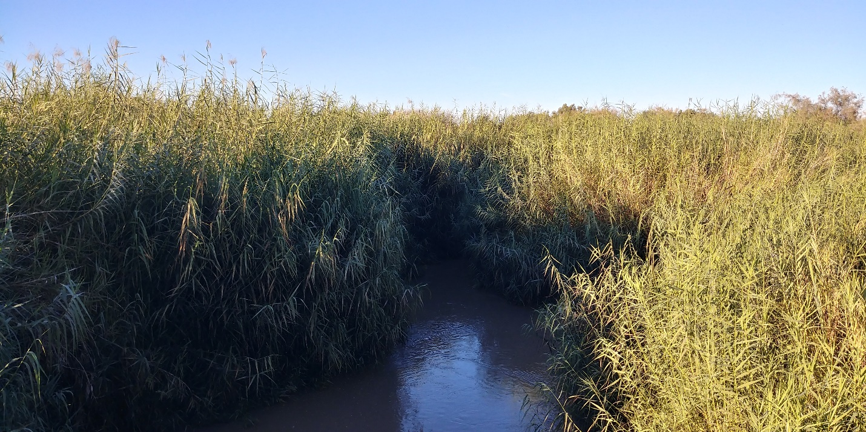
Alamo River choked with reeds at Worthington Road crossing northwest of Holtville
The other reed choked section of the Alamo River runs for 1.1 miles from about 4 miles northwest of Holtville. The Alamo River gorge becomes less deep as the River crosses Worthington Road. This section is heavily choked with reeds and would support more flow if the reeds were cleared. Further down, the Alamo River has been cleared of reeds at the approach to some of the several weirs that regulate flow.
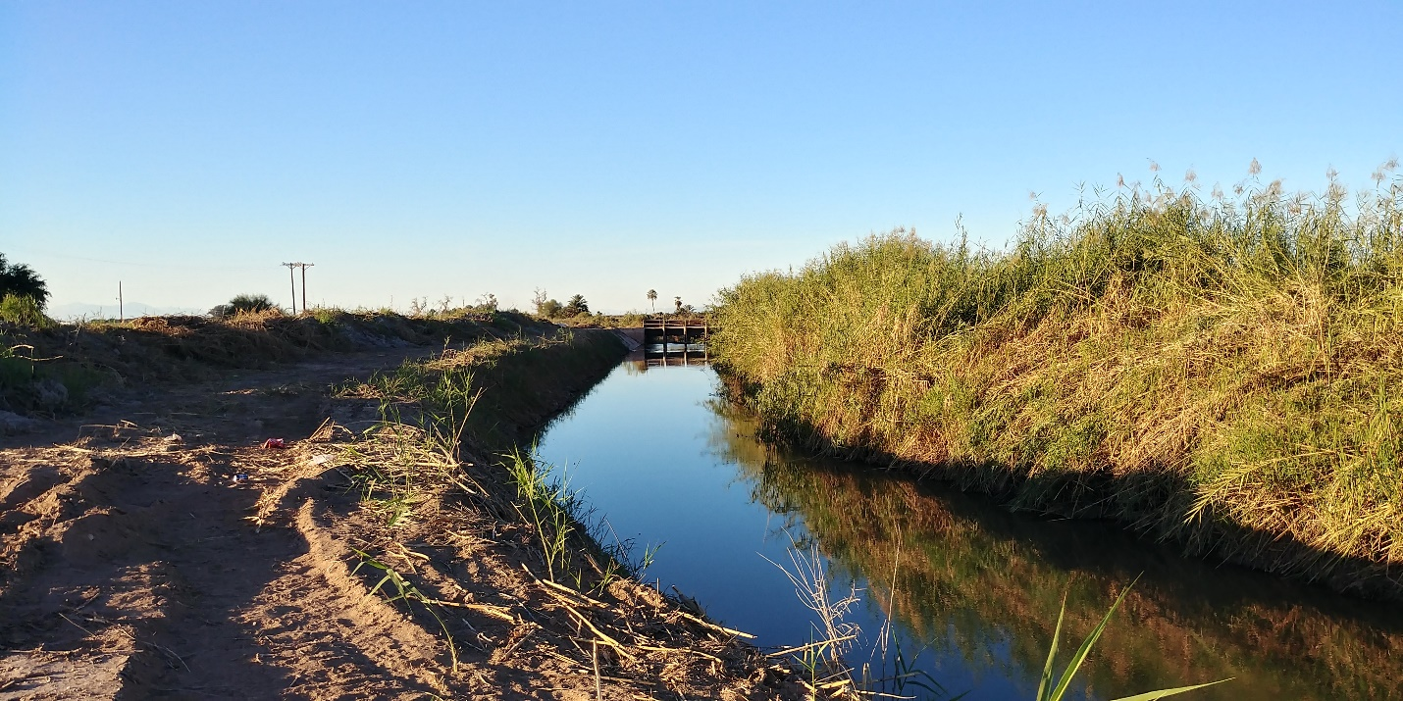
Alamo River partly cleared of reeds approaching an IID weir below Holtville
Irrigation drain water joins the Alamo River at frequent intervals along the route from the border to the Salton Sea. The flow in the River increases as it flows north, eventually gaining most of its roughly 400,000 acre feet per year flow from the many east or west flowing irrigation drains that feed it.
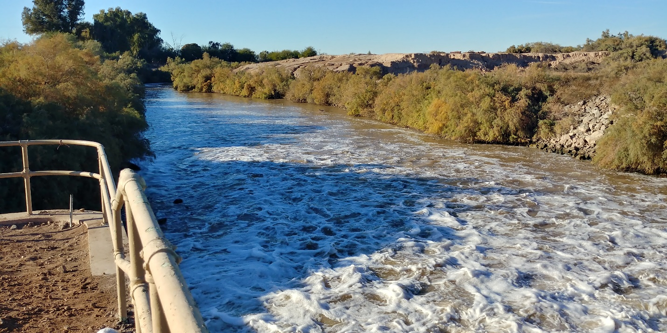
Lower section of Alamo River near Weist Lake, with turbulent flow induced by an IID weir
Below the reed choked section at Worthington Road, the Alamo River flows without natural barriers controlled by several IID weirs down to the Salton Sea just north of Red Hill. There is substantial excess capacity in the lower reaches of the Alamo River because the irrigation drain flow had been reduced by the QSA and prior water transfers.
Flow in the Alamo River can be increased by blending in distilled ocean water on the Mexican side of the border then letting it flow across the border in the existing channel provided care is taken to regulate the flow so the capacity of the Alamo River channel is not exceeded. It would be feasible to increase flow in the Alamo River by up to 50% as an annual average. Distilled water flow would be reduced during periods of high River flow due to seasonal irrigation peaks or heavy rain events. This would enable the Alamo River to deliver roughly 40% of the make-up flow needed to restore Salton Sea elevation and water quality. The balance of make-up flow would use the New River channel.
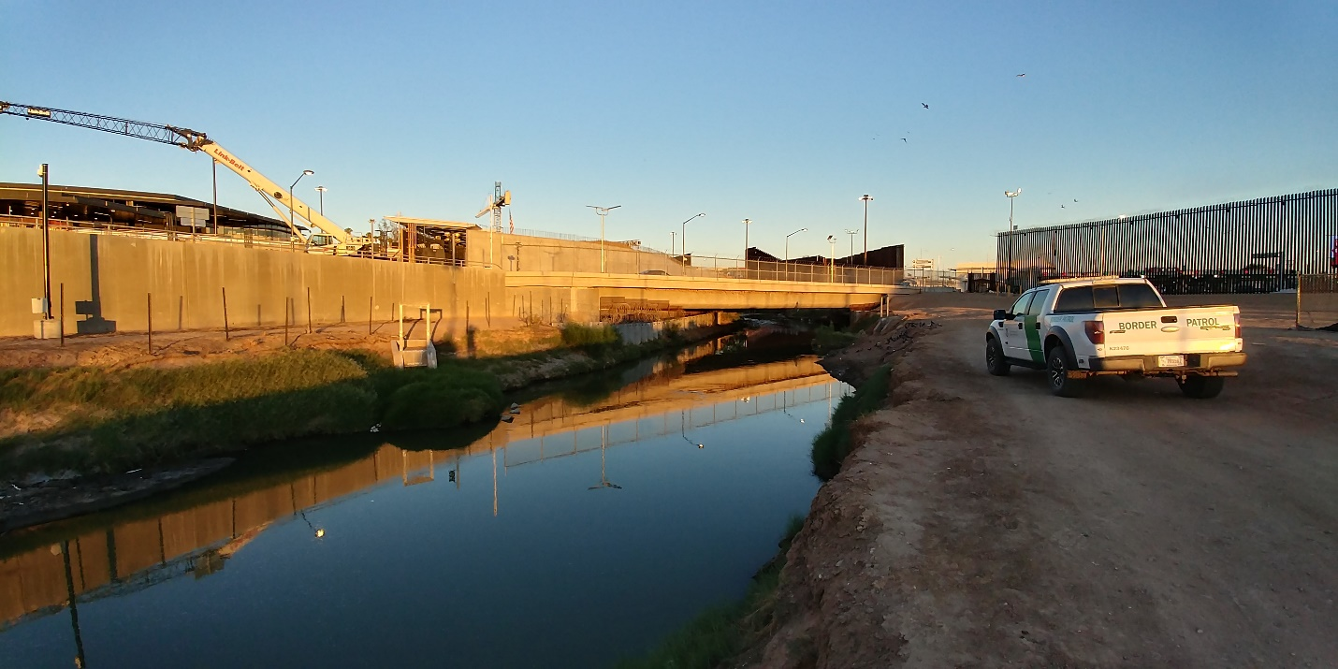
New River at Border Crossing
The New River crosses the border on the west side of the City of Calexico under a bridge that enables vehicle entry into Mexicali. The New River flows through trash screens just north of the border crossing in an open channel running west of Calexico. The New River is polluted as it comes across the border impacting the health of residents nearby. This has prompted a new project to divert the New River into a yet to be built enclosed channel bypassing Calexico, then replace flow in the existing open channel with treated sewage pumped from the Calexico sewage treatment plant. Distilled ocean water added to the New River in Mexico would need to be coordinated with flow capacity in this future mitigation system if it is built. There is capacity for additional flow at the border crossing and in the existing open channel that flows on the west side of Calexico. Distilled ocean water could be added to the New River flow in Mexico to dilute the cross border pollution and also the polluted flow through City of Mexicali, or some or all of it could be delivered across the border separately to dilute the treated sewage from the Calexico plant intended to be delivered to the existing open channel on the west side of Calexico.
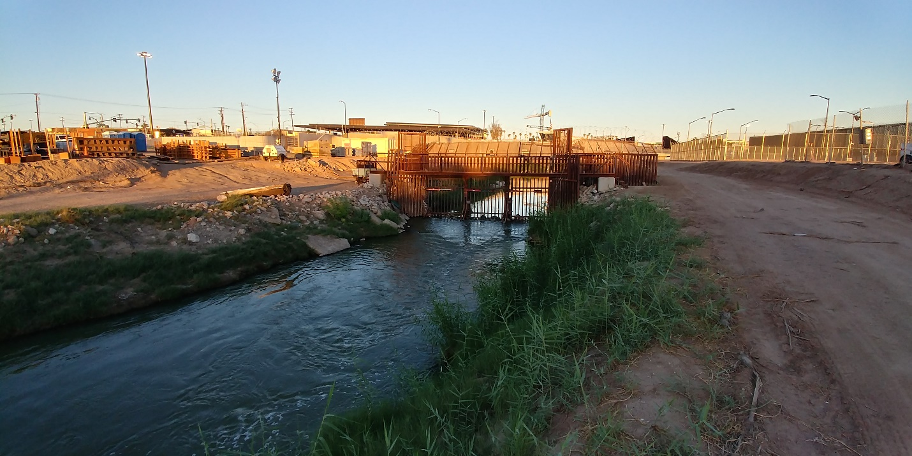
New River at Trash Screen just below and north of Border Crossing
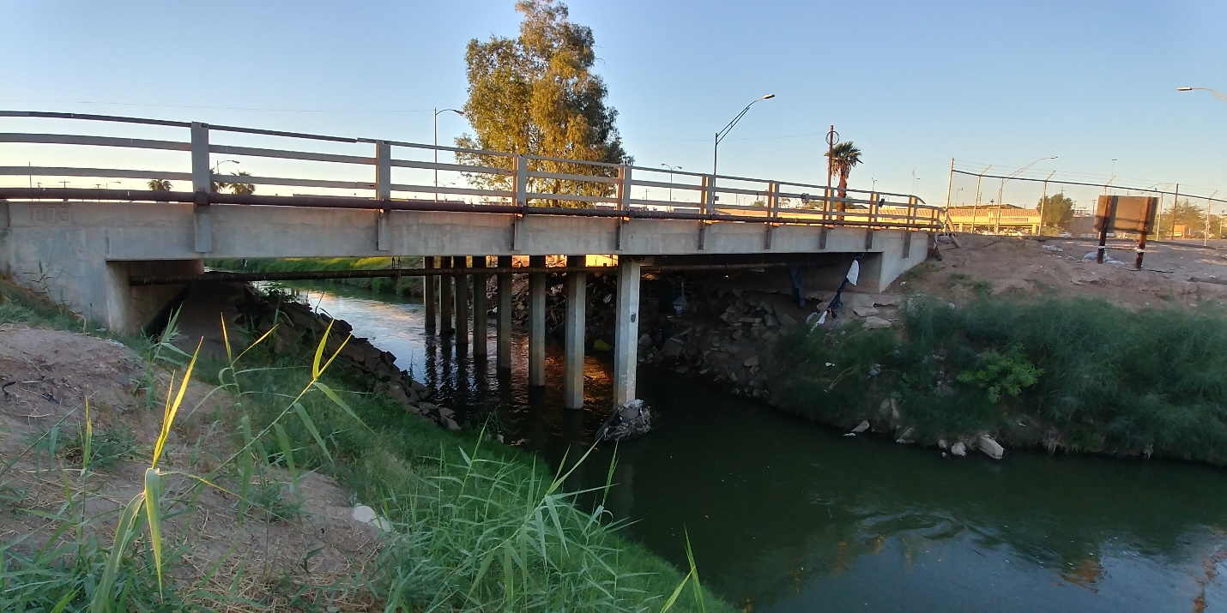
New River in existing open channel west of Calexico
As the New River passes Calexico north and west to Highway 98 it flows in a wide gorge cut by the 1905 Colorado River flood, the most recent of many flooding events that repeatedly filled the Salton Sea basin over thousands of years. This gorge ranges from 20 to 50 feet deep and runs from Calexico ¾ of the route north to the Salton Sea with the current New River flowing within it in a small channel. These upper reaches of the New River in the U.S. have plenty of excess capacity since the River runs through the gorge with minimal development within the gorge that could be impacted.
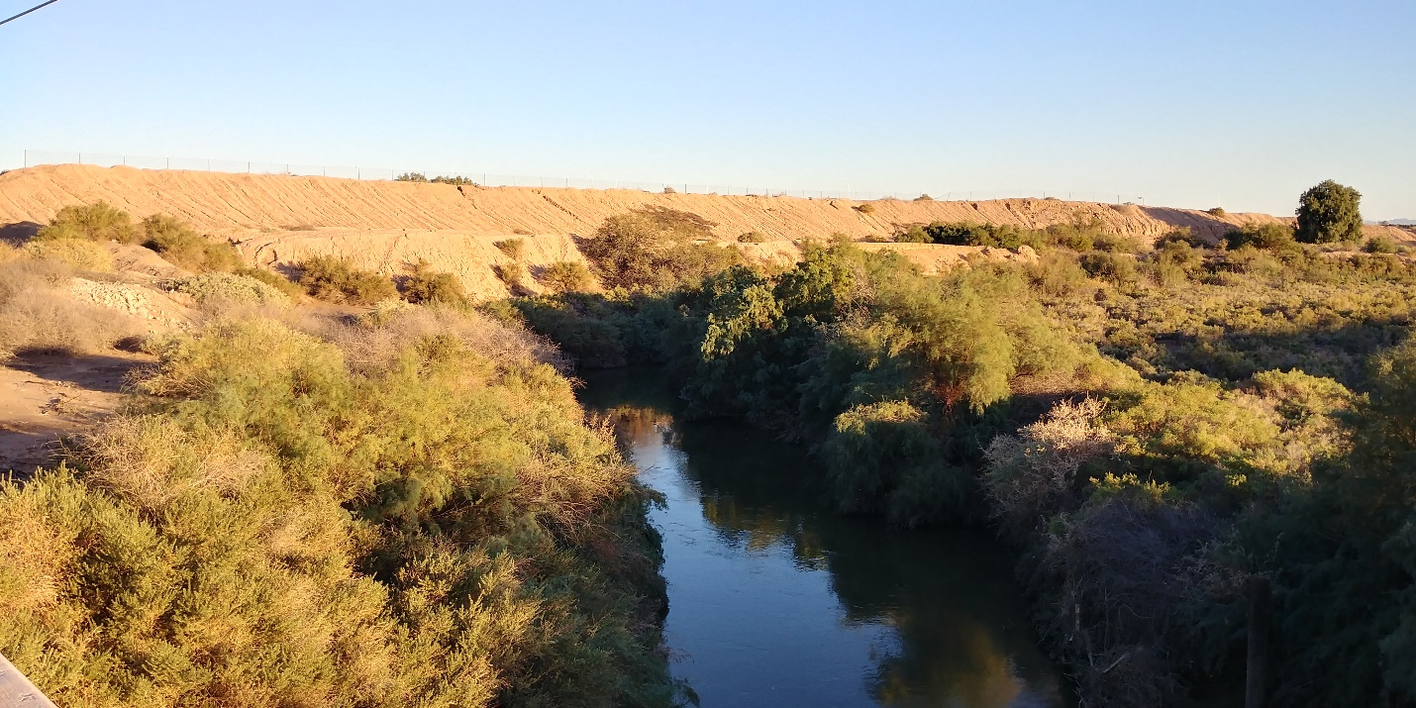
New River in Gorge at Highway 98 crossing
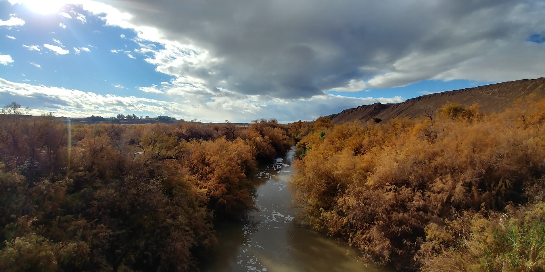
New River in Gorge at Keystone Road crossing
The lower reaches of the New River are where flow needs to be managed to balance seasonal variations in farm drain flow and increased natural flow after heavy rain events. There is a 12 mile section of the New River shown in the satellite map above from Brant Road west then north to the alluvial fan outflow to the Salton Sea where the deep wide gorge flattens out to a more-shallow channel. In this lower section, unmanaged flow adding more than 60% to current flows could cause the New River to rise above the banks impacting adjacent farm fields if distilled ocean water flow were added when seasonal drain flow is high or after rain. This risk is mitigated by the reduction in flow in the lower reaches of the New River as water transfers in the last few decades have diverted irrigation water to coastal cities.
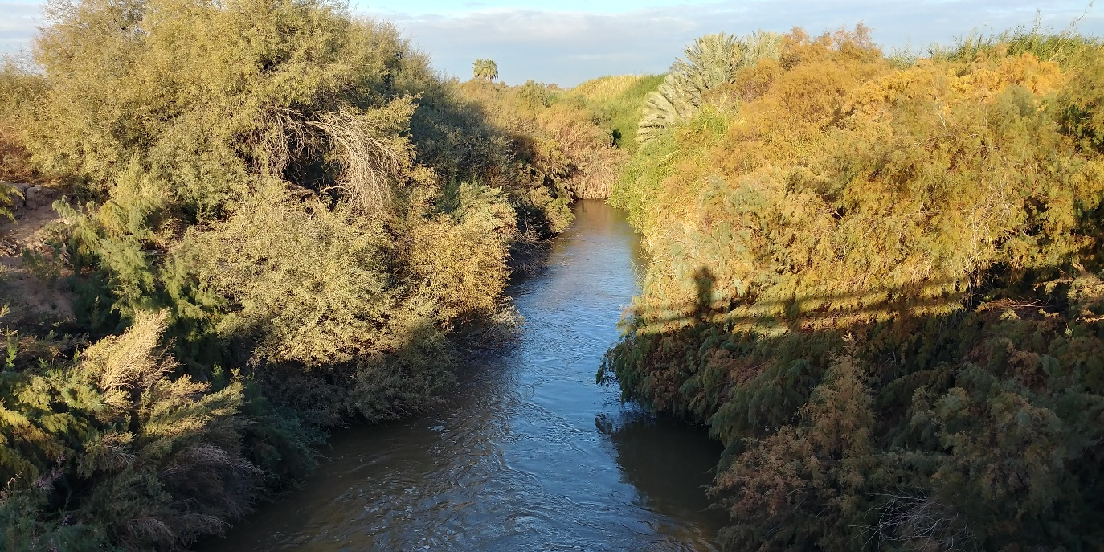
New River at Brant Road crossing looking west
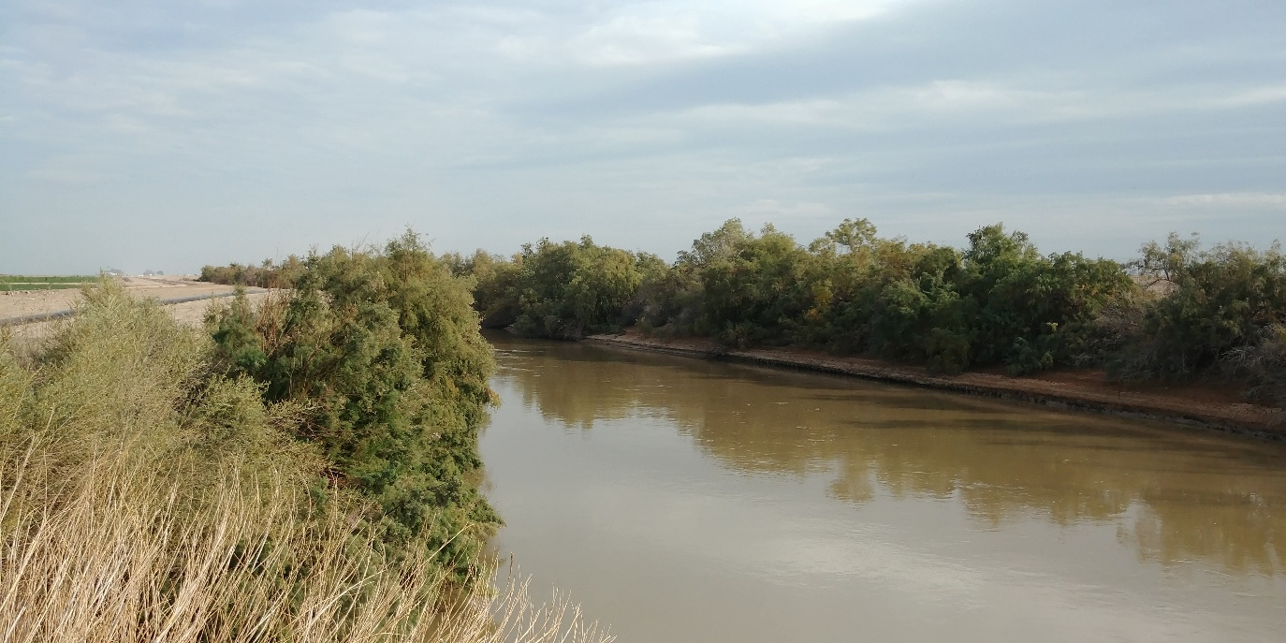
New River approaching alluvial fan near the Salton Sea looking east
The New and Alamo River are within 1.5 miles of each other at Wiest Road well above the Brandt Road New River crossing. It would be possible to connect the New River to the Alamo River by a gated channel or pipeline along an existing canal right of way such as the Rockwood Lateral. Flow from the upper reaches of the New River could be partly diverted to the lower reaches of the Alamo River, or vice versa, to prevent overflow in an emergency.
The lower section of the New River will feed water to the State’s Species Conservation Habitat Project where the New River flows in to the Salton Sea. The New River is the brackish water source for this project, to be blended with hypersaline Salton Sea water for a target salinity between 20 and 40 parts per thousand TDS. Adding distilled water to the New River will improve the water quality delivered to this project by diluting selenium, pesticides, occasional sewage spills, and other contaminants in the New River.
If flow of distilled ocean water across the border from Mexico into the New and Alamo Rivers is well managed and the two River channels are maintained, then the potential downside of flooding from unregulated flow can be avoided yielding water quality benefits to the Rivers and to the Salton Sea.

