Sephton Water Technology, Inc.

Water Import Salt Extraction Revenue
  - Response to Request for Information for Salton Sea Water Importation Projects

Identification of Project Team
The Water Import Salt Extraction Revenue (Project) is structured as a long term public-private partnership wherein private companies develop, design, build, and operate the facilities needed to turn the mix of excess salts, minerals, and nutrients in the Salton Sea that are the source of the Sea’s rapid decline as a fish and bird ecosystem into marketable products of sufficient value to pay for the restoration of the Salton Sea. The public sector is asked to grant the private entities the right to extract large quantities of salt and other minerals, along with excess nutrients, pesticides, and other contaminants because it will provide a public benefit. The private entities must agree to return over 90% of the water taken from the Salton Sea in the process of separating salts, minerals, and excess nutrients as pure water to replenish the Sea and dilute the remaining salts and nutrients. In order to restore and sustain the level of the Salton Sea to protect public health from PM10 dust blowing off the exposed lakebed and revitalize recreational benefits, the private entities will offer to pay government agencies the capital and operating costs to design, permit, build, and operate water import infrastructure and/or new water supply with a capacity sufficient to restore the level of the Salton Sea to a pre-Quantification Settlement Agreement (2003) elevation, or to a lower elevation mutually agreed to.
The private entities will agree to extract enough salt from the Salton Sea, with return of over 90% of the water, in sufficient quantity to revive the fish and bird ecosystem that thrived at the Salton Sea up until the last decade. If the water source is from direct import of ocean water to the Salton Sea, then there will be a very large salt load to extract every year. If freshwater is delivered to the Salton Sea, there will still be a substantial, albeit much smaller, salt load to extract annually.
This is a major challenge akin to that faced at the Aral Sea and the Dead Sea with no solution in sight and, to a smaller degree, at Owens Dry Lake. Over two and a half billion spent by the Los Angeles Department of Water and Power has mitigated the PM10 dust at Owens Dry Lake, but the lake itself was sacrificed a century ago and is still largely a dry lake with very few people willing or able to live near it. We hope to do better at the Salton Sea. The descendants of the Native Americans who lived and fished on the shores of Ancient Lake Cahuilla have watched the Salton Basin fill and decline many times, but the damming and overuse of the Colorado River have eliminated the ancient cycle of flood and drying. Now government agencies and property developers are profiting from diverting Colorado River water to coastal cities. The people and wildlife that live at the Salton Sea deserve better.

Public / Private Partnership Structure, Concept A
Three different concepts for restoring the Salton Sea are proposed. Each has a somewhat different organizational structure. Concept A proposes an ocean water canal from the Sea of Cortez, through Laguna Salada, across the border west of Signal Mountain, then flow down to the Salton Sea with direct delivery of ocean water to restore and sustain the elevation of the Salton Sea up to a pre-QSA level or a lower if elevation chosen by public agencies in the U.S. The public/private partnership organizational structure for Concept A is diagrammed in Figure 1.
Figure 1. Water Import Concept A, Project Organizational Chart

Public Agencies in Mexico for Project Concept A
The upper left side of Figure 1 shows the key public agencies that will be responsible for all operations in Mexico. Concept A requires ocean water from the Sea of Cortez. To secure this, a contract with the Mexican government will be executed for Mexican agencies to design, build, own, and operate the conveyance infrastructure required to collect ocean water from the Sea of Cortez, by regulated tidal flow and filtration or by pumped intakes if preferred by engineers there, to deliver that seawater to the border by lined canal, and possibly pipeline sections, with the pumping infrastructure required to get over a 300 foot high elevation west of Mount Signal. In meetings that members of our team have had with government officials in Mexico, there was a clear objection expressed by the agricultural agency representative about seawater canals near farms in the Mexicali Valley. A Laguna Salada east side canal route avoids that concern as there are no farms anywhere close, nor downstream, in Mexico. The public entity in Mexico responsible for the design, construction, and operation of the conveyance infrastructure could be either the National Water Commission (ConAgua) or the Baja State Water Commission. Both have the engineering and operations staff to do the job and both have long experience designing, building, and operating canals and pipelines in Mexico. The Baja State Water Commission operates the pipeline that supplies Colorado River from Mexicali, pumped over a four thousand foot mountain range, to Tijuana. Either water agency can contract with engineering and construction firms in Mexico to dig canals and install pipelines, tidal gates, and pumping infrastructure. It is expected that both agencies will play an appropriate role, but the assignment of functions is for Mexican authorities to decide.
The canal and/or pipeline construction in Mexico will be financed with public bond funds raised in Mexico that will be repaid by purchase of the water that crosses the border. Revenue from the salt, mineral, and power operations of the private entities in the U.S. will be used to pay the public agencies in Mexico. Either a private entity, or a U.S. public entity will contract to pay either the Mexican National Water Commission or the Baja State Water Commission for each acre foot of ocean water delivered to the border. The amount paid will be sufficient to pay off the bond funds over a 30 year period, plus reasonable operation and maintenance costs, plus a modest allowance for public benefits, estimated at $110 per acre foot delivered. The pay per acre foot delivered model will provide the Mexican agency with an incentive to complete the conveyance infrastructure on schedule and keep it maintained and efficiently operated. The seawater delivery and purchase contract will run for the duration of the QSA water transfers to 2077, with an option to renew.

Public Agencies in the U.S. for Project Concept A
The upper right of Figure 1 shows the public agencies in the U.S. that will be engaged in this public/private partnership. Conveyance of ocean water from the border, down to the Salton Sea, will be contracted with a U.S. Federal or State water agency. The appropriate Federal agency is the U.S. Department of the Interior, Bureau of Reclamation. This agency has extensive experience designing, building, and operating canals, dams, and hydro power infrastructure along the Colorado River, in California, and in all the Western States. The appropriate State agency alternative is the California Department of Water Resources, which also has extensive experience designing, building, and operating dams, canals, pipelines, hydro power, and pumping infrastructure in California. Either agency has engineering, management, and operations staff capable of conducting environmental review, securing permits, and designing and operating the conveyance infrastructure from the border to the Salton Sea. Either or both agencies can contract with U.S. engineering and construction contractors to build the concrete lined canals and hydro power stations that will be needed to convey ocean water from the border to the Salton Sea, recover power from 260 to 530 feet of elevation drop, and deliver that power to the Mexican agency for pumping over the high point in Mexico and across the border.
Similar to the implementation in Mexico, the design, permitting, and construction of conveyance and power infrastructure in the U.S. will be financed with public bond funds raised by the State of California, or allocated by the U.S. Federal Government. The private entities in the U.S. will contract to pay the agency assigned, State or Federal, for each acre foot of water delivered from the border to the Salton Sea with a stipulation that the power derived from the elevation drop will be delivered to the public agency in Mexico for pumping. The amount paid will be sufficient to pay off the construction bond over a 30 year period, plus operation and maintenance costs, plus a small allowance for public benefit in the Imperial Valley, estimated to total $70 per acre foot of water delivered to the Salton Sea. The pay per acre foot delivered model will also apply to the American water agency as an incentive to complete the conveyance infrastructure on schedule, keep it maintained, and operate it efficiently. The conveyance infrastructure will be owned and operated by the public agency, but the bonds will be paid for over time by Project private entities out of revenues from sales of salt, minerals, power, etc. for each acre foot of seawater delivered to the Salton Sea. In essence, the State of California, or the Federal Government, will be paid to help restore the Salton Sea. This north of the border seawater delivery contract will also run for the duration of the QSA water transfers, with an option to renew.

Private Entities for Project Concept A
For implementation of the water treatment and salt and mineral extraction aspects of this Project several private companies will be needed. The tasks include securing rights of way for plants, water pipelines, and product distribution, contracting agreements, construction level design, environmental review and permitting in cooperation with public agencies, construction, operation, and the eventual decommissioning of plant and infrastructure.
The overall mission for the private entities will be to plan and execute a long term restoration project for the Salton Sea by contracting with public agencies in Mexico for the importation of ocean water from the Sea of Cortez to the border, contracting with public agencies in the U.S. for conveyance of that water to the Salton Sea, by extracting millions of tons of salt, along with excess nutrients and contaminants, from the Salton Sea annually, and by the conversion of resources drawn from the Salton Sea, and/or from imported water, into revenue in the form of saleable renewable energy, purified salt, and possibly other minerals and/or aquaculture products. Funds from these revenues will be used to pay off construction bonds, purchase ocean water from Mexico, pay for conveyance of that water to the Salton Sea, and construct and operate water treatment and playa covering infrastructure at the Salton Sea to effect a restoration.
The core business functions that need to be covered by the private entities include: The construction and operation of new brine to energy renewable power facilities, the construction and operation of salt purification facilities, the construction and operation of desalination facilities, the marketing and sales of renewable energy, purified salts, and any other feasible mineral or aquaculture products, the reduction of salinity and management of water quality in the main body of the Salton Sea, and the elimination of dust from the Salton Sea playa by restoring and sustaining a target elevation.

Geothermal Developers
The geothermal developers in the Imperial Valley are an essential part of the collection of companies that can accomplish the long term restoration of the Salton Sea. At a minimum the heat from geothermal steam and the 24/7 renewable power they produce is vital to powering the large scale water treatment and salt extraction technologies proposed for this Project. It will be necessary to purchase large amounts of geothermal steam as heat for seawater distillation and salt concentration plus significant amounts of power to run pumps, plants, and equipment near the southeast shore of the Salton Sea. The quantity required will support development of new geothermal capacity at the Salton Sea Known Geothermal Resource Area (KGRA) at and under the southeast shore of the Salton Sea. Fortunately there is enough undeveloped capacity to support the needs of the Project, more than double what’s currently in use (please see Appendix L: Geothermal Technology at the Salton Sea for more information on undeveloped capacity). Colocation of the desalination and salt extraction plants with geothermal power plants is preferred for proximity to steam for distillation. There is out of production farmland near most of the existing geothermal plants, in some cases owned by the geothermal developers.
In addition being essential power suppliers for this Project, local geothermal developers can play a role as partners in building and operating the plant infrastructure needed. The type of infrastructure, equipment, and operational expertise needed for the water treatment and salt extraction processes proposed for this Project have a lot in common with the construction and operation of a geothermal power or lithium recovery plant. The managers, engineers, operators, and maintenance crew of local geothermal operations could readily adapt their skills to the type of work needed to execute this Project. Some of the local geothermal developers are also well funded by parent companies or partners with deep pocket financing.
CalEnergy Operating Company is now Berkshire Hathaway Energy Renewables, a subsidiary of Berkshire Hathaway. The company owns and operates ten geothermal power plants in the Salton Sea KGRA and holds geothermal leases on large tracts of yet to be developed geothermal resources. The company has plans to develop additional geothermal resources and recently received over $20 million in grant funding to test lithium recovery from geothermal brine in parallel with heat for power. Much of the salt recovery and water treatment technology proposed for this Project was developed at one of their plants under a cooperation agreement and with Federal and State grant funding awarded to Sephton Water Technology, Inc.
Energy Source owns and operates the newest geothermal plant at the Salton Sea built in 2014 by local firm Performance Mechanical Contractors and operating since producing power for off-takers in Arizona and elsewhere. The plant is named after local engineer and inventor John Featherstone who was also hired by the Bureau of Reclamation to advise Sephton Water Technology when starting work at the Salton Sea. Energy Source has completed environmental documents and is ready to construct a lithium recovery plant adjacent to their geothermal plant.
Controlled Thermal Resources is a new geothermal developer that holds a geothermal lease on a large tract of land around Mullet Island within the Salton Sea KGRA. The company is owned by an Australian billionaire and has hired some top local geothermal industry talent to develop their leasehold with a combined lithium/power business model. The company plan to build the largest geothermal plant at the Salton Sea at Mullet Island. Controlled Thermal Resources recently contracted major investment from General Motors for geothermal lithium development.

Local Engineering Firms
JFMPE run by Coachella Valley mechanical engineer John Matthew, has been very active in the design and engineering of improvements on the CalEnergy geothermal plants over decades of work. He was instrumental in the design of the Energy Source geothermal plant and is now doing work with Controlled Thermal Resources to optimize the design of their planned new large geothermal/lithium plant. John Matthew (JFMPE) was the engineer of record for the structural design on two desalination test plants built by Sephton Water Technology at the Salton Sea and can offer a wealth of experience to a range of plant design and engineering challenges.
G.S. Lyon Consultants is a civil engineering and geotechnical consulting firm based in El Centro in the Imperial Valley. The firm has been involved in engineering for geothermal plants, water infrastructure, and earthworks for many years. G.S. Lyon performed pipeline civil engineering work and geotechnical analysis for Sephton Water Technology projects at the Salton Sea. They have deep expertise in resolving design and permitting challenges in Imperial County.

Local Construction Contracting
Performance Mechanical Contractors (PMC) have the experience, qualifications, and capability to execute large complex plant and equipment construction projects. They were the prime contractor on the Energy Source geothermal plant and have done major construction and plant rework jobs for CalEnergy for decades in addition to pressure vessel fabrication and geothermal and chemical process plant construction both locally and throughout the Southwestern U.S. On a recommendation from the Bureau of Reclamation, PMC did the major equipment installation, large pipe fabrication, and geothermal plant tie in work for Sephton Technology’s desalination test plants at a CalEnergy geothermal plant. PMC has the experience and expertise to execute major and complex process plant construction projects like what this Project proposes.

CEQA and Permit Consulting
The Chambers Group is a large environmental consulting firm with decades of experience with projects at the Salton Sea. They performed CEQA analyses for multiple Salton Sea desalination projects for Sephton Water Technology and for many other projects of a wide range of types. The Chambers Group staff have the wide range of expertise needed for complex projects like the large scale salt extraction and water treatment needed for the work proposed.

Water, Salt, and Mineral Process Development, Design and Engineering Team
The process development, design, and engineering team for the concepts proposed was formed in support of two current projects funded by the U.S. Bureau of Reclamation by grants under the 2020 and 2021 Desalination and Water Purification Research program that are continuing a water treatment and mineral recovery technology development program underway at the Salton Sea since November 2004.
- Tom Sephton managed and executed prior testing of Salton Sea distillation using long established Vertical Tube Evaporator (VTE) technology with process innovations to successfully deal with the uniquely challenging water chemistry of the Salton Sea. He also managed a pilot test program that developed a process to pre-treat Salton Sea water by Ultrafiltration and Nanofiltration to separate monovalent from divalent ions, then distill the treated water yielding pure water and commercial salt from the Salton Sea at 92% recovery with guidance and hands on participation from some of the expert consultants listed below.

- Dr. William Bourcier, is a geochemist with decades of experience at Lawrence Livermore National Lab plus several private companies more recently. Based on his extensive experience in chemical separations and lab testing at the Salton Sea, he evaluated options and developed a sequential Ultrafiltration and Nanofiltration process to separate monovalent from divalent ions in Salton Sea water. This was originally for the purpose of making the brine concentrate from Salton Sea distillation suitable for co-injection with geothermal brine returned to the deep aquifer but serendipitously the process separated pure sodium chloride suitable for commercial sale.

- Larry Lien, owner of Membrane Development Specialists (MDS) designed and built commercial reverse osmosis plants and has a long career developing membrane processes for complex separations in industry including a new patented lithium separation process. Larry Lien advised on and dramatically improved the Ultrafiltration and Nanofiltration process to separate monovalent from divalent ions in Salton Sea water.

- Desalination consultant Fritz Alt, owner of Process Engineering, LLC has designed large scale thermal desalination plants, invented and patented improvements to thermal desalination technologies, and published papers on both distillation and membrane desalination. He will advise on process design and plant engineering.

- Dr. Osman Ahmed Hamed is a recently retired researcher from the Saudi Arabian Government’s Saline Water Conversion Corporation Research Center with several papers published on increasing the efficiency of thermal desalination by pretreating with NF and other membrane processes. He will lend his expertise to the integration of membrane and thermal distillation processes proposed for this project.

- Leon Awerbuch is a leader in the desalination field with direct experience in geothermal desalination and a long career in membrane and thermal desalination including dozens of patents and publications. Leon Awerbuch is the founder and President of Leading Edge Technologies, LLC. In his early career he worked for Bechtel engineering large desalination projects. He will provide expert guidance on technology choices and how to implement them.

The primary Bureau of Reclamation grantee and the lead company for adaptation of existing water treatment technologies to the unique challenges of the Salton Sea proposed for this project is Sephton Water Technology, Inc., registered as a California Subchapter C corporation since 2002. For more than fifteen years, Sephton Water Technology has worked on the South shore of the Salton Sea to develop a suite of technologies well suited to leverage the geothermal and solar resources at the Salton Sea to restore the water quality. From a 2001 proposal to the Salton Sea Authority by Dr. Hugo Sephton and three colleagues expert in the desalination field, to a desalination pilot plant permitted in 2004 and installed at a CalEnergy geothermal power plant next to the Salton Sea in 2005 [1], to a geothermal desalination demonstration plant permitted in 2007 at the same location [2], to a Barometric Evaporator Desalination project started in 2013 [3], to the two current projects, Sephton Water Technology has well over a decade of operational experience purifying Salton Sea water and salt with geothermal heat. Sephton Water Technology is the only entity with recent and extensive experience in the unique challenges of extracting Salton Sea water and salts to restore environmental water quality and potentially offset the costs with purified salts and solar energy [4]. Over $2 million in public grant funds from the Federal and State government and over $1 million in Sephton Water Technology funds, donated effort, and equipment has been invested in the work at the Salton Sea to date.

Public / Private Partnership Structure, Concept B
Water Importation Concept B proposes an ocean water canal from the Sea of Cortez, halfway up the sparsely populated southwest side of the Mexicali Valley to the Cerro Prieto geothermal power plants. Seawater would be desalinated at Cerro Prieto using geothermal steam and power. Salt would also be recovered and purified for sale to the International market. The dry commercial salt produced would be shipped by land and sea for export. The pure distilled water from the geothermal desalination process proposed would be re-mineralized to potable water, then conveyed by canal and by existing waterways from Cerro Prieto to Mexicali. Desalinated water would be available for potable use in Mexicali and/or Tijuana. The amount of distilled water needed to sustain the Salton Sea elevation and dilute salinity, excess nutrients, and contaminants would be delivered to the two existing border crossings in Mexicali where the New River and the Alamo River cross under the All American Canal to flow down these two existing river courses to the Salton Sea. The delivery of clean desalinated water to the headwaters of the New and Alamo River will dramatically improve the water quality in those two polluted rivers. It will also simplify the very difficult environmental review and permitting process in California since no new canal or pipeline has to be built on the U.S. side, thus taking years off the preparatory phase of the Project.
Since clean water is being delivered into two existing waterways, the International agreement process should also be simplified. Currently Mexico notifies the U.S. of sewage spills and other changes in cross border flows, but the U.S. has no power to stop those flows from crossing. Delivery of more clean water to these cross border rivers should also require only notification and should not violate the existing treaty and minutes. Care should be taken not to exceed the flow capacity of the New and Alamo River channels or existing channels through Mexicali. Water delivery from the desalination process can be managed to limit flows.
The public/private partnership organizational structure for Concept B is somewhat simpler than for Concept A without the need for canal infrastructure in the U.S. The organizational structure is diagrammed in Figure 2.
Figure 2. Water Import Concept B, Project Organizational Chart

Public Agencies in Mexico for Project Concept B
The upper left side of Figure 2 shows that the key public agencies that will be responsible for all operations in Mexico are essentially the same as for Concept A. Concept B still requires ocean water from the Sea of Cortez. A contract with the Mexican government will be executed for Mexican agencies to design, build, own, and operate the conveyance infrastructure required to collect ocean water from the Sea of Cortez, by regulated tidal flow and filtration or by pumped intakes, and to deliver that seawater to the Cerro Prieto geothermal plants about 40 feet above mean sea level. Likewise a contract will need to be negotiated with the Mexican Government to deliver potable water north to Mexicali and to the New and Alamo River border crossings. Since Mexicali and Baja State are experiencing a significant water shortage [5] and will benefit from new low priced desalinated water supply, there should be an incentive to agree. The public agencies in Mexico responsible for the design, construction, and operation of the conveyance infrastructure would be either the National Water Commission (ConAgua) or the Baja State Water Commission or both.
The Cerro Prieto Geothermal Plants are owned and operated by a Mexican Federal government entity, the Comisión Federal de Electricidad (CFE). The Project team will have to negotiate an agreement with CFE to increase both steam and electric production to supply the heat and power needs of the Project and thereby to supply water, jobs, and revenue to the Mexicali Valley. The salt and water treatment plants would preferably be collocated next to each of the three large geothermal power plants at Cerro Prieto to be close to the steam source. There is no shortage of open land between the geothermal wells and plants.
The seawater canal and/or pipeline construction in Mexico will be financed with public bond funds raised in Mexico that will be repaid by purchase of the water that crosses the border. Revenue from the salt, mineral, and power operations of the private entities will mostly be produced in Mexico by operations at Cerro Prieto. These revenues will be used to pay the public agencies in Mexico. The amount paid will be sufficient to pay off the bond funds over a 30 year period, plus reasonable operation and maintenance costs, plus a modest allowance for public benefits, estimated at $110 per acre foot delivered. The potable water delivery and purchase contract for both cross border flows to the Salton Sea and for potable water for Mexico will run for the duration of the QSA water transfers to 2077, with an option to renew.

Public Agencies in the U.S. for Project Concept B
The upper right of Figure 2 shows the lesser Concept B role of public agencies in the U.S.
The U.S. Bureau of Reclamation may still have a role in a NEPA process. The California Department of Water Resources, may still have a role in a parallel CEQA process. Even with freshwater being delivered to the Salton Sea, smaller salt extraction infrastructure will still be needed at the Salton Sea to remove excess salts and nutrients from agricultural drainage.

Private Entities for Project Concept B
Implementation of the water treatment and salt and mineral extraction aspects of this Project will still use the same private companies for the smaller operation at the Salton Sea. Some will also need to work with CFE and private firms in Mexico to support the similar, but larger operation there. The mission for the private entities will be the same, to plan and execute a long term restoration project for the Salton Sea including the desalination of ocean water from the Sea of Cortez, the conveyance of desalinated water to the Salton Sea, the extraction of tens of millions of tons of salt from the Sea of Cortez water plus 3 to 4 million tons from the Salton Sea annually, and the conversion of saltwater resources into revenue in the form of renewable energy, purified water, purified salt, and possibly other minerals and/or aquaculture products.

Geothermal Developers
The geothermal developers in the Imperial Valley will still be needed to supply steam and electricity for the extraction of 3 to 4 million tons of salt from the Salton Sea annually. The quantity of geothermal steam required can be supplied by a single new large geothermal power plant the size of the planned and formerly permitted CalEnergy Blackrock plant. Local geothermal developers can still play a role as partners in building and operating the plant infrastructure needed.

Local Engineering Firms
JFMPE mechanical engineer John Matthew, can provide design and engineering work for plants and pipelines in either Mexico or the Salton Sea, but will need to collaborate with engineers licensed in Mexico. Likewise for G.S. Lyon Consultants.

Local Construction Contracting
Performance Mechanical Contractors (PMC) can do the plant and pipeline work at the Salton Sea and fabrication work for vessels and equipment to be used in Mexico. Mexicali has a much larger industrial base than the Imperial Valley, so much of the fabrication and construction work in Mexicali and Cerro Prieto would likely be contracted with Mexican firms. However PMC’s expertise and bilingual crews would be helpful for cross border collaboration.

CEQA and Permit Consulting
The Chambers Group will be useful for CEQA analyses and permitting for the plant and equipment needed at the Salton Sea.

Water, Salt, and Mineral Process Development, Design and Engineering Team
Several of the development, design, and engineering team working with Sephton Water Technology have extensive experience working internationally, mostly in the Middle East where desalination is a major industry. The same team will work on the Project on both sides of the border, but contacts have been made with experienced engineering talent in Mexico that will be needed for the work at Cerro Prieto.

Public / Private Partnership Structure, Concept C
Water Importation Concept C proposes to buy a continuing supply of Colorado River water from water rights holders that are not using all of their allocations. This may be challenging with the Colorado River in a long term structural drought. Nevertheless the Federal government of the U.S. has identified that 22 Native American tribes have rights to Colorado River water quantified at 2.9 Million Acre-Feet per Year (MAFY) and have only been using a little over half of their allocation in recent years [6] (Appendix M has a summary of the cited August 2021 Federal report that describes the tribal allocations). If agreements can be made to buy allocated, but unused Colorado River water from these tribes, then it may be possible to buy enough water to restore and sustain the elevation of the Salton Sea. Tribe to tribe water transfers and sales are allowed. The public/private partnership organizational structure for Concept C is somewhat simpler than for Concepts A and B without the need for new canal infrastructure in the U.S. or in Mexico. The organizational structure is diagrammed in Figure 3.
Figure 3. Water Import Concept C, Project Organizational Chart

Public Agencies in the U.S. for Project Concept C
The upper right of Figure 3 shows the Concept B role of Federal and State public agencies in the U.S. The U.S. Bureau of Reclamation will have a role in managing Colorado River water transfers and deliveries to the All American Canal and may have a role in a NEPA process. The California Department of Water Resources, may have a role in a parallel CEQA process. Even with freshwater being delivered to the Salton Sea, smaller salt extraction infrastructure will still be needed at the Salton Sea to remove excess salts and nutrients from agricultural drainage.
The Upper left shows a simplified diagram of the essential tribal entities involved. Concept C is based on a local tribe with deep ancestral and current land ownership connections to the Salton Sea, the Torres Martinez Desert Cahuilla Indians buying water in tribe to tribe sales/transfers from other tribes in the Colorado River basin States. The Torres Martinez tribe would then deliver the water to the Salton Sea in sufficient quantity to restore and sustain the elevation and to dilute the excess salts, nutrients, and contaminants in the Sea. Initially, the Torres Martinez tribe would ask the State Natural Resources Agency to pay them for the water delivered to the Salton Sea. When the salt extraction and other revenue generating endeavors by the private entities working at the Salton Sea are in operation, then the burden to pay the Torres Martinez tribe for continued delivery of restoration water to the Sea would shift to the private entities.
The California Tribal Chairperson’s Association is beginning to discuss this restoration strategy with Colorado River Basin tribes with water rights allocations greater than their current use. If enough Colorado River Basin tribes agree, then they would sell unused water rights allocations to the Torres Martinez tribe at an agreed upon price for an extended period of time, preferably for the duration of the QSA. Whether these sales/transfers can be negotiated, and what prices can be agreed to are yet to be determined.
The other public entities involved are needed to physically deliver the Colorado River water to the Salton Sea. The Imperial Irrigation District (IID) controls canal infrastructure capable of conveying the water delivered to the All American Canal to the Salton Sea as was done with Salton Sea mitigation water for the first 15 years of the QSA. This water will not be part of the over 3 MAFY IID allocation, but IID will likely levy a wheeling charge to convey the water to the Salton Sea. This could be paid by the State directly or by the Torres Martinez tribe.
Similar to IID conveyance, restoration water could be delivered to the Coachella Canal, which is running below capacity. From there the Coachella Valley Water District (CVWD) could physically deliver the water to the Salton Sea through existing storm channels and/or drains. The CVWD would likely charge a wheeling fee for each acre foot of restoration water delivered.

Private Entities for Project Concept C
Implementation of the water treatment and salt and mineral extraction aspects of this Project will still use the same private companies for the smaller operation at the Salton Sea to extract 3 to 4 million tons of salt from the Salton Sea annually to collect revenue in the form of renewable energy, purified water, purified salt, and possibly other minerals and/or aquaculture products. In the long term these revenues will be needed to pay for the continued delivery of Colorado River water to the Salton Sea.

Geothermal Developers
The geothermal developers in the Imperial Valley will be needed to supply steam and electricity for the extraction of 3 to 4 million tons of salt from the Salton Sea annually. The quantity of geothermal steam required can be supplied by a plant the size of the planned and formerly permitted CalEnergy Blackrock plant. Local geothermal developers can play a role as partners in building and operating the plant infrastructure needed as well as their needed role as suppliers of power and heat.

Local Engineering Firms
JFMPE mechanical engineer John Matthew, can provide design and engineering work for plants and pipelines at the Salton Sea. Likewise for G.S. Lyon Consultants for civil engineering and geotechnical work.

Local Construction Contracting
Performance Mechanical Contractors (PMC) can do the plant, pipeline, and fabrication work at the Salton Sea.

CEQA and Permit Consulting
The Chambers Group will be useful for CEQA analyses and permitting for the plant and equipment needed at the Salton Sea.

Water, Salt, and Mineral Process Development, Design and Engineering Team
The same team will work on the Project as with Concepts A and B, but the scope will be limited to the Salton Sea salt extraction and water quality restoration without any work in Mexico.

Narrative Description of the Project Concepts
This Water Import Salt Extraction Revenue concept will pay to import a large volume of water to restore elevation in the Salton Sea, improve water quality, and eliminate playa dust. Even if freshwater is delivered to the Salton Sea there will still be an accumulation of salt in the terminal lake due to drainage of saline buildup from farms irrigated by moderately saline Colorado River water. To manage salinity in the Salton Sea hypersaline Salton Sea water will be extracted and separated into distilled water, purified salt, and mixed salt brine. Because the Salton Sea is hypersaline, the volume of saltwater extracted can be substantially less than the volume of water imported. This reduces treatment costs dramatically with the combination of membrane and distillation technology proposed. The extraction of hypersaline water from the Salton Sea for treatment will serve as the only required outflow, other than natural evaporation and seepage. It will remove excess nutrients, pesticides, and other contaminants in addition to removing millions of tons of excess salts annually. The quantity of hypersaline water extracted will be designed to reduce salinity, nutrients, and contaminants in the Salton Sea to a level suitable for a restored aquatic ecosystem capable of supporting fish and fish eating birds as well as a wide range of benthic and pelagic invertebrates needed for a diverse food chain, up to and including a return of recreational fishermen.
Three alternative water import concepts are described in this Water Import Salt Extraction Revenue (WISER) proposal. Each of the three concepts is feasible from a technical and engineering perspective because all three propose to use existing tidal gate, canal, pipeline, pumping, and/or hydro turbine energy recovery technology designed and implemented on other projects by public agencies with the requisite expertise, or just use existing infrastructure. All three use revenue from the extraction and sale of salt and other minerals, and the production and sale of renewable energy, to fully offset the capital and operating costs of the project to achieve financial feasibility. In addition to technical, engineering, and financial feasibility, there is political feasibility, which is the hardest to assess. Each of the three concepts has very different political implications and requirements. Thus, if one of the three alternative water import concepts is considered to be politically infeasible, there are two others to consider.

Import Concept A: Ocean Water Conveyance from the Sea of Cortez to the Salton Sea
This ocean water import concept will provide a sustained supply of both water and salt over the long term while also sustaining a managed level and water quality in the Salton Sea. An ocean water import canal, with lift stations and hydro-energy recovery, is envisioned that will collect and sustainably filter water from the Sea of Cortez near San Felipe for transport north through Laguna Salada to the U.S. Mexico border west of Signal Mountain, then downhill to the Salton Sea. There are a few reasonable route options illustrated in Figure 4.
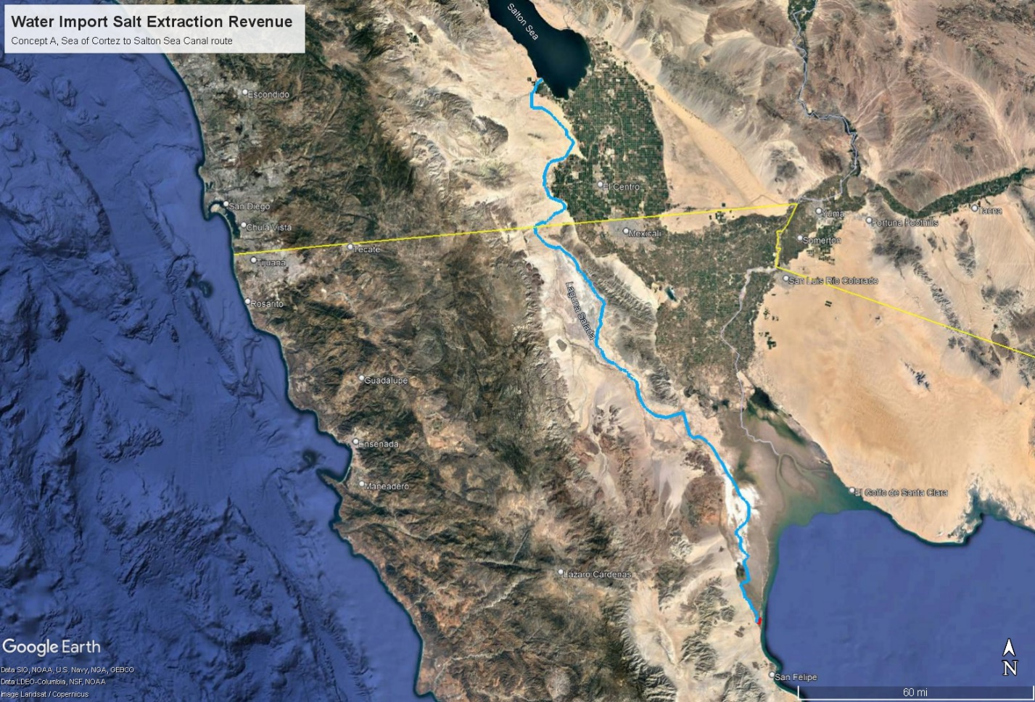
Figure 4. Option A, Route for Cross Border Water Import from the Sea of Cortez to the Salton Sea
The conveyance design capacity for planning purposes is 900,000 acre-feet per year (AFY), or up to 900 KAFY delivered to the Salton Sea. Sea of Cortez water will be sand filtered with the support of tidal action on the grounds of a former salt works a few miles north of San Felipe on the northwestern side of the Sea of Cortez. The slow sand filtration method will separate seawater from debris and biological materials without harm to sensitive marine organisms present in the Sea of Cortez. The filtered seawater will flow north between the coast and Baja Mexico Highway 5 to the Coyote Canal The canal will be lined with marine mix concrete along most of its length to conserve water and prevent saltwater intrusion into adjacent groundwater in areas where that is a concern. Siphon pipelines will be used for undercrossing existing roads and waterways. Sections of pipeline may also be used for pumped conveyance in uphill sections of the route depending on the pump type selected in each location. To the extent feasible, energy for uphill pumping of ocean water will be recovered by hydro-turbines installed in drops on the downhill sections. There will be a net downhill flow between 238 feet and 257 feet depending on project start time and Salton Sea inflow conditions. Taking pump and turbine efficiencies into account and resistance to flow, some canal alignment options will generate a small net positive power output after pumping, while others will have a modest deficit.
All alignment options considered in this concept option are directed at an efficient one way delivery of 500 KAFY to 900 KAFY of ocean water from the Sea of Cortez to the Salton Sea with no return flow to Mexico. After initial filling of the Salton Sea to a desired elevation, for this analysis targeted at close to the pre-QSA elevation, but can be a lower elevation, the inflow would be reduced to 500 KAFY, or a higher flow as required to maintain the target elevation of the Salton Sea to balance future inflow reductions. Aside from natural outflows to evaporation and seepage, the only built outflows will be to water and salt treatment facilities that will process the hypersaline Salton Sea water, return pure water to the Salton Sea or adjacent habitat, and covert the salts in brine to commercial products with both economic and Sea restoration benefits.
For the first several years, delivery of 500 KAFY to 900 KAFY of sand filtered ocean water by canal to the Salton Sea will dilute salinity in the Salton Sea, now in excess of 74 g/liter TDS and likely to be much higher when ocean water import can actually be agreed to, permitted, constructed, and commence. However, while at roughly half the current salt content of the Salton Sea, 500 KAFY of seawater from the Sea of Cortez will bring in about 22.8 million metric tons of total dissolved solids, mostly salt with other minerals, every year. After several years the dilution effect will taper off then reverse, and salinity in the Salton Sea will rise again. By that time it will be necessary to cost effectively remove salt from the Salton Sea including the 22.8 million metric tons of imported salt plus some of the excess salt already in the Sea and the 3 to 4 million metric tons coming in annually from farm drainage.
A suite of water and salt management technologies, some developed over more than a decade of work at the Salton Sea by our team, will be employed to remove more salt than is annually entering the Salton Sea, while recovering more than 90% of the water drawn from the Salton Sea as pure distilled water. The distilled water will be delivered to habitat along the shoreline to more effectively manage habitat salinity and selenium with outflow to the Sea or else can be directly returned to the Sea. These water and salt management technologies will be entirely driven by local renewable geothermal and solar energy. There will be no discharge of brine to the environment. All outputs from the water and salt management technologies will be put to use to cover the costs of the restoring the Salton Sea. More detail on the technologies proposed will follow in subsequent sections of this proposal and supporting documents.

Import Concept B: The All Mexican Canal

Ocean Water Conveyance from the Sea of Cortez to Cerro Prieto, Freshwater to the Salton Sea
This ocean water import concept will provide a sustained supply of seawater to the Cerro Prieto geothermal area in the Mexicali Valley over the long term. Expanded development of the Cerro Prieto geothermal field supported by improved aquifer recharge will supply power and heat to extract commercial salt from the seawater and distill most of the seawater to potable quality to support current and future water needs in the Mexicali Valley and Tijuana. Geothermally powered desalination facilities at Cerro Prieto will produce 500 KAFY of distilled water that will be delivered the border by a new freshwater canal in the Mexicali Valley, and across the border to the Salton Sea using existing natural or manmade conveyance.
In meetings members of our team have participated in with Federal (ConAgua), State (Baja State Water Commission), and local (Agriculture and Economic Development) government officials in Mexicali, there has consistently been a stated willingness among Mexican officials to cooperate with a Salton Sea restoration, but the question has always been “what’s in it for Mexico”. This All Mexican Canal option answers that question clearly, new desalinated potable water supply for drought challenged Baja State, commercial salts and minerals to sell, and more renewable power to support cleaner air and economic development in Mexicali.
In meetings members of our team have participated in with State (Water Quality Control Board), and local (Salton Sea Authority, Imperial Irrigation District) government authorities and politicians in the United States, objections have been raised to the concept of restoring the Salton Sea with imported water. One objection raised by an official is that “The Salton Sea is a waste of water…” leading to an argument that the Sea should be entirely dried up and replaced with a terraformed desert the likes of which the Salton Sea basin has never been [7]. Other officials and politicians on the U.S. side of the border have raised the objection that it is impossible to make a deal with Mexico. Over 75 years of history with the 1944 U.S. – Mexico water treaty, including dozens of Minutes (amendments) agreed to and an active Boundary and Water Commission on both sides of the border meeting regularly to work out solutions seems to belie that attitude among some U.S. officials. When the Imperial County Board of Supervisors voted in a resolution to support ocean water import as an option to restore the Salton Sea in 2015, the Pacific Institute was quickly hired by government authorities to use straw man arguments in a video designed to squash support for the concept that was distributed to all regional government officials [8]. Others have argued that restoring the Salton Sea is too costly and should not be attempted [9]. Several local politicians and leaders in non-governmental organizations continue to repeat the catch phrase “Ocean water import is a distraction”. A distraction from what is rarely stated. Presumably a distraction from short term mitigation strategies and longer term projects like a Perimeter Lake pushed by the Salton Sea Authority and it’s contractor. Political opposition in the U.S. to Salton Sea restoration by water import, or by any means, is likely to continue.
The All Mexican Canal water import option seeks to bypass that opposition, and some of the U.S. side political, permitting, and legal roadblocks that will be used to block Salton Sea restoration, by doing the great majority of the work on the Mexican side of the border, while enabling enough volume of higher quality water to flow to the Salton Sea to sustain the elevation and dilute the salts and pollutants in the New and Alamo River inflows. Most of the jobs, renewable energy, and revenue benefits will remain in Mexico where they are needed. The only product that will cross the border is 500 KAFY of pure water. Revenue from salt sales and new renewable power sales in Mexico will offset the cost of desalinating ocean water for delivery across the border. Since some U.S. officials and citizens oppose restoration of the Salton Sea, they will not be asked to pay for it. Neither will the compliance of U.S. officials be assumed in granting permission to accept 500 KAFY of pure desalinated water to sustain the Salton Sea. If necessary, pure water can be delivered to the New and Alamo River channels on the Mexican side of the border and simply flow across to the U.S. side and down to the Salton Sea without any International agreement, since some U.S. officials would oppose such an agreement. The environmental and public health impacts would be beneficial as the polluted water of the New and Alamo River will be dramatically improved by dilution with pure distilled water as will the water quality in the Salton Sea.
The All Mexican Canal water import option envisions an ocean water import canal that will collect water from the Sea of Cortez for transport north to the Cerro Prieto geothermal field about 40 feet above mean sea level. One reasonable route option is illustrated in Figure 5.
The seawater canal considered in this concept option is designed to provide an efficient one way delivery of up to 900 KAFY of ocean water from the Sea of Cortez to the Cerro Prieto geothermal field with no brine, nor any other, return flow to the Sea of Cortez. All 900 KAFY will be used delivered to water and salt treatment facilities and to geothermal aquifer recharge. Water and salt treatment facilities will separate monovalent and multivalent ions in the seawater to produce commercial salt and mineral products for sale to the International market with residual salts used to collect and store solar energy. Up to 400 KAFY of seawater can be desalinated for potable use in Baja State, which has a water shortage, in addition to the 500 KAFY to be sent to sustain the Salton Sea.
Sea of Cortez water will be sand filtered at a former salt works a few miles north of San Felipe using a slow sand filtration method that will prevent harm to sensitive marine organisms. From there the filtered seawater will be delivered to Cerro Prieto by canal with pumped lift stations to bring the water from sea level to the 40 feet above mean sea level elevation at Cerro Prieto. The seawater canal will run east of Baja Mexico Highway 5 closer to the shore up to the Rio Hardy, then will parallel existing canal routes north to Cerro Prieto. The seawater canal will be lined with marine mix concrete along its length to conserve water and prevent saltwater intrusion into groundwater in the agricultural areas it passes. Siphon pipelines will be used for undercrossing existing roads and waterways in the southern Mexicali Valley at the few points required.

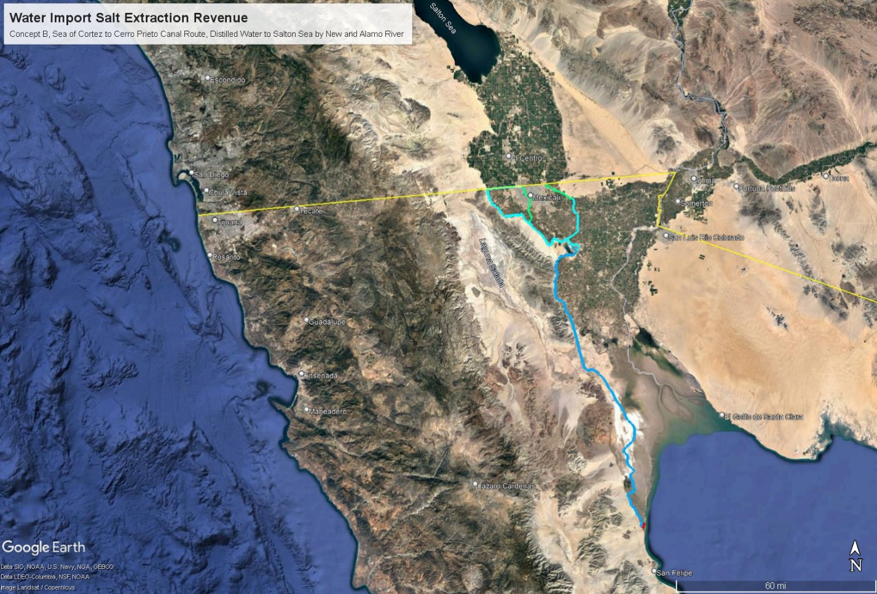
Figure 5. Option B, Routes for seawater from the Sea of Cortez to Cerro Prieto, freshwater to the border
At Cerro Prieto new geothermal development supported by untapped capacity in the geothermal field will be used to supply power and heat for advanced hybrid membrane and distillation technologies that separate water, salt, and other minerals at high efficiency with no brine discharge to the environment. These technologies are explained in later sections of this proposal. A 2016 study supported by the Mexican government showed the Cerro Prieto beta reservoir geothermal resource has a 90% certainty that an additional 411 MWe of capacity can be developed, and 1,397 MWe at a lower 50% certainty [8]. The equivalent of 411 MWe of capacity in a combined electric and direct thermal use would be enough to support the proposed high efficiency desalination at the 500 KAFY Salton Sea supply proposed. The other 400 KAFY of seawater may also be useful as a recharge source if not all needed for potable water in Baja State. The Cerro Prieto geothermal aquifer is thought to be a product of mixing of Colorado River water with deep oceanic brine deposits [9]. The geothermal reservoir water chemistry is much lower in sulfate and magnesium than seawater due to chemical reactions with rock at the 300°C+ reservoir temperature [10], but it is of seawater origin before exploitation. Natural recharge with groundwater has largely sustained the aquifer since exploitation began in 1973 although moderate cooling has been observed [11]. The main challenge to sustained production from the Cerro Prieto resource is scaling and corrosion of well casings and scaling of other plant components, mostly with silica, requiring costly rework or replacement of close to 10% of the geothermal wells each year [12]. The cost of geothermal steam and power is significant, so high thermal and electrical energy efficiency such as that described in this proposal is critical for cost effective geothermal powered desalination.
To supply the Salton Sea, and potable water needs in Mexicali and Tijuana, a west side potable water canal will be built northwest from the Cerro Prieto geothermal area and run parallel to existing irrigation canals along the western edge of the developed Mexicali Valley for 32 miles until it joins the Acueducto Rio Colorado Tijuana water treatment and pumping facility. Water needed for potable use in Mexicali will join the Mexicali/Tijuana water system there. A substantial portion of the 500 KAFY annual Salton Sea restoration water will flow east along an existing canal from the Acueducto Rio Colorado Tijuana water treatment and pumping facility along the Mexican side of the border to Fronteriza, then through a two mile culvert under the street Aguascalientes and into the New River just south of the Calexico West Port of Entry, where it will flow across the border.
A second portion of the annual 500 KAFY of desalinated Salton Sea restoration water will flow from Cerro Prieto along existing canals north into the headwaters of the New River near Cerro Prieto, then continue north to the outskirts of Mexicali, where it will flow in existing culverts under the key Mexicali roadway Boulevard Rio Nuevo to the border crossing where the desalinated seawater will join the flow from the west and cross into the U.S., then down to the Salton Sea replacing agricultural drain flows lost to the QSA water transfers with better quality water and diluting the high level of pollutants in the current New River cross border flow.
To balance the flows within the capacity of existing New and Alamo River channels, a third portion of the annual 500 KAFY of desalinated Salton Sea restoration water will flow from Cerro Prieto north and east in a new potable water canal built along the right of way of existing irrigation canals to join the headwaters of the Alamo River near San Agustine and then flow across the border in an existing channel under the All American Canal one mile east of the Calexico East Border Station. Some potable water in excess of the annual 500 KAFY for the Salton Sea may be drawn from this canal to serve local needs on the East side of Mexicali.
Rather than deal with any flow capacity limitations of the New or Alamo River border crossing and channels, it could be practical to deliver the 500 KAFY of potable water to the All American Canal at the border so the water quality would benefit agriculture by diluting Colorado River salinity. The canal infrastructure in the Imperial Valley can handle the capacity as it previously delivered enough water to farms and through the drain and river system to sustain the Salton Sea at a higher elevation before QSA water transfers began. The Imperial Irrigation District (IID) manages the canal system and could be paid a wheeling fee to deliver 500 KAFY of blended canal water to the Salton Sea. The challenge is that the IID has adamantly opposed ocean water import as a long term Salton Sea solution, preferring to shrink the Sea into a hypersaline brine lake ironically marketed as a “Smaller Sustainable Sea”.
While adding 500 KAFY of potable quality water to the inflows of the Salton Sea will fully offset the combined losses of 480 KAFY of QSA and Metropolitan Water District of Southern California (MWD) water transfers away from the Imperial Valley, thus balancing Sea elevation, there will still be 3 to 4 million metric tons per year of salt flowing into the Salton Sea from agricultural drainage plus industrial and human waste from Mexicali as well as excess fertilizer and agricultural chemicals. This needs to be removed on a continuing basis to balance salinity as well as elevation and to remove excess nutrients and contaminants. While the obvious approach may be to remove salts, nutrients, and contaminants from the multiple drain and river inflows, the more cost effective approach to this is to extract salt, nutrients, and contaminants directly from the Salton Sea. Salt in particular is at high concentration in the Salton Sea (exceeding 74 g/liter TDS and rising every year) while brackish drain and river water is at much lower concentration (2-4 g/liter TDS, see Appendix K for chemical analysis data). Therefore the volume of saltwater that needs to be extracted, treated to remove salts and contaminants, then returned to the Sea is roughly 20 times less per ton of salts removed if extracted directly from Salton Sea water. The technologies to accomplish this cost effectively are described in later sections in this proposal and in supporting documents.

Import Concept C: New Restoration Water through the All American Canal

Colorado River Water Conveyance to the Salton Sea by Existing Canal Infrastructure
Water Importation Concept C circumvents all of the U.S. political opposition to importing water from Mexico. It is an all American water import concept based on buying Colorado River water from water rights holders that are not using all of their allocations to restore pre QSA inflows to the Salton Sea. In 2014, the U.S. Bureau of Reclamation initiated a “Ten Tribes Study” to quantify water rights allocated to ten Colorado River basin tribes [6]. The study identified 2,012,971 AFY of settled water rights plus 785,273 AFY of unsettled claims to water rights totaling 2,798,244 AFY. The same tribes were using 1,473,356 AFY of water leaving 539,613 AFY of settled water rights allocated, but unused. That is enough Colorado River water to fully offset the lost inflow to the Salton Sea from the QSA and earlier water transfers. The unused water rights could reach 1.3 MAFY if all claims were settled in the favor of the ten tribes. Most of the unused tribal water rights are in the upper basin States.
An August 2021 Congressional Research Service report noted that 22 Native American tribes have rights to Colorado River water quantified at 2.9 MAFY, but were only using a little over half of their allocation in 2015 [6]. See Appendix M in this proposal for a summary of the report that describes the tribal allocations. If agreements can be made to buy allocated, but unused Colorado River water from these tribes, then it may be possible to buy enough water to restore and sustain the elevation of the Salton Sea. Tribe to tribe water transfers and sales are allowed. This may be challenged by other water rights holders on the River, particularly with the Colorado River in a long term structural drought. Environmental restoration is a beneficial use under California law, but is not defined as such under the Federal “Law of the River”.
Water Importation Concept C envisions a process likely to take a few years, wherein tribal leaders discuss and negotiate a series of agreements to sell restoration water to replenish and sustain the Salton Sea, preferably for the duration of the QSA water transfer agreements. To provide full restoration, the amount agreed to would have to be enough to offset all the loss of inflow since 2003 due to the QSA and other factors. However a even lesser but substantial amount on the order of one or two hundred thousand AFY would make a positive difference in slowing the decline of the Salton Sea.
The Chairman of the California Tribal Chairperson’s Association, Rincon Tribe Chairman, Bo Mazzetti, is beginning to explore this concept as a way to restore the Salton Sea. Transferring Colorado River water allocated to basin tribes to restore the Salton Sea would have to be done through tribe to tribe transfers. That requires a receiving tribe at the Salton Sea that would buy Colorado River water from tribes up the River with unused allocations and promise to put that water into the Salton Sea. The Torres Martinez Desert Cahuilla Indians have a deep ancestral connection to the Salton Sea basin and own thousands of acres of land next to and underneath the Salton Sea on the north end. As a landowner, the Torres Martinez tribe faces potential public health liability if PM10 dust blows off their land when exposed. Liability aside, the Torres Martinez tribe have a history of actively working to restore wildlife habitat on their land at the Salton Sea. The Torres Martinez tribal Chairman, Thomas Tortez has agreed to work with Bo Mazzetti to explore this Concept C as the receiving tribe that would purchase the restoration water from other tribes.
The restoration water would need to be paid for. While a price per acre foot has yet to be negotiated, the quantity required for full restoration of the Salton Sea is probably much more than the Torres Martinez could possibly pay for. If a price per acre foot can be mutually agreed upon between the tribes, then the Torres Martinez tribe can ask the State Natural Resources Agency to pay them slightly more than that price for restoration water delivered to the Salton Sea. The Torres Martinez tribe would then deliver the water to the Salton Sea in sufficient quantity to restore and sustain the elevation at a level the State Resources Agency and the tribe agree on. The restoration water would also dilute the excess salts, nutrients, and contaminants in the Sea. Later, when salt extraction, mineral recovery, solar power generation from mixed salts, and any other private sector revenue generating activities proposed by this Project are operating and profitable, then the privately generated revenue can pay the Torres Martinez tribe for continued delivery of restoration water to the Salton Sea.
For physical delivery of restoration water to the Salton Sea, the IID and/or the CVWD would probably require wheeling fees to convey the Colorado River restoration water from the All American Canal to the Salton Sea. Neither IID nor the CVWD publish wheeling rates. The CVWD has a recent agreement to pay MWD over $300 per acre foot to wheel Colorado River water to the CVWD. The distance involved is longer and involves pumping cost to MWD, but the cost of wheeling can be substantial. No new canals or pipelines would be needed for Water Import Concept C, existing infrastructure will suffice.

Narrative Description of the Salt Extraction Revenue Concept
While distilled water could be sold to outside water agencies to offset costs and reduce the demand for water transfers over and above the QSA, this Project does not propose to sell any desalinated water within the U.S. All of the saltwater that can be recovered from desalination processes with Salton Sea water, over 90%, will be given to habitat and recreation projects at the Salton Sea, or delivered directly to the Sea for dilution. Some purified salt will be shipped for sale to the regional market within the limits of gradually rising demand, while some may be sold to support local salt using industries, such as food processing, leather tanning, and chemical processing. The balance of salt extracted, but not purified and sold, will be concentrated mixed salt in brine useful for brine to energy processes. Initially, salinity gradient solar ponds are an established technology that can provide an environmentally safe depository for millions of tons of mixed salt while generating revenue from solar power and process heat and potentially covering thousands of acres of dust emitting playa in areas of the shoreline that do not have any fresh or brackish water supply. In time other brine to power technologies currently in lab or pilot development may supplant the solar ponds, for example using dry salt for solar heat storage [15].
Figure 6. Basic Water Import Salt Extraction Revenue Concept
The concept basics are illustrated in Figure 6. The commercial products from extracting salts from the Salton Sea, renewable power, purified salt, and purified water, will provide the economic engine to pay for the importation of water.

Salt Extraction and Water Treatment Process
Salt in the Salton Sea is predominantly, but not exclusively, sodium chloride. The Salton Sea contains much higher sulfate and magnesium levels than ocean water. Unlike sea salts from the ocean, Salton Sea water cannot be simply crystallized in evaporation ponds and sold as a product. The Salton Sea is close to 7% total dissolved salts. By the time this restoration concept can be implemented, the salinity of the Salton Sea will be much higher. In a way, the high salinity is an advantage for salt extraction, as the volume of water to be separated from salt is much less per ton of salt extracted. The salt extraction process planned is capable of purifying slightly over half of the salt content in Salton Sea water to the two higher commercial grades of sodium chloride (vacuum pan salt and solar salt) and put them out for sale on the regional market to offset the capital, operation, and energy costs of the salt extraction and distillation process.
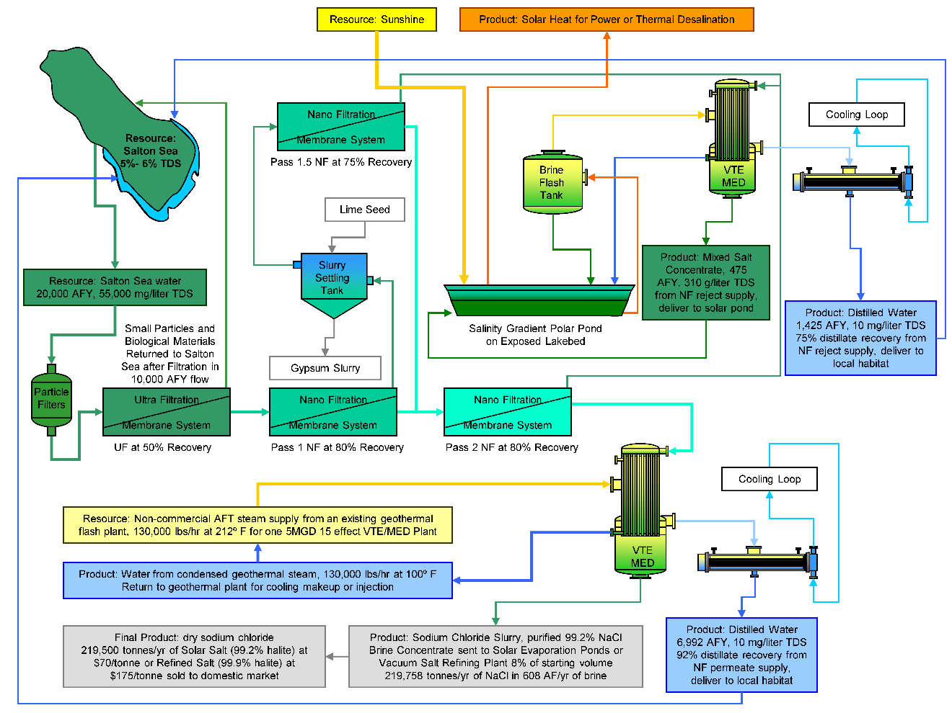
Figure 7. Salt Extraction and Purification Process Developed at the Salton Sea
The basics of the salt extraction and water treatment process are illustrated in Figure 7 on a small commercial scale. This process was developed in testing done at the Salton Sea in 2009-2010, under a grant from the U.S. Bureau of Reclamation to Sephton Water Technology. A follow up grant to optimize this process and dramatically improve seawater distillation efficiency was recently contracted. Salton Sea water will be filtered to remove particles down to 100 microns. Ultra-Filtration (UF) will be employed to remove bacteria and all suspended solids down to 0.1 micron in order to prevent scaling of the Nano-Filtration membranes (NF) membranes by eliminating anything that could seed precipitation. The UF step will be run between 50% and 90% recovery with the small particle and organic enriched return flow delivered to the Sea after settling and algal digestion of the nutrients. To prevent formation of calcite scale, the water will be de-carbonated by adjusting the pH from the typical pH 8 in the Salton Sea to 6.5 prior to Ultrafiltration. Clear, de-carbonated, particle free Salton Sea water at pH 6.5 will be fed to NF membranes shown in tests to reject more than 99.8% of sulfate and magnesium. Two passes of NF was shown to reduce all ions but sodium and chloride to very low concentrations.
The UF/NF process shown in Figure 7 will provide a net recovery from both NF passes of 95%. The first NF pass is driven to 80% recovery. Reject from that pass is seeded with lime particles to force precipitation of the 5 fold supersaturated gypsum. After a settling, the clear supernatant is filtered with an NF element at 75% recovery. 80% permeate plus 75% of the 20% reject recovered as permeate yields 95% recovery of Salton Sea water as a purified sodium chloride permeate.
Permeate from 2 passes of Nano-Filtration will have TDS slightly over half that of the Salton Sea source water with 99% of the dry weight consisting of sodium chloride. The permeate will be concentrated in a high thermal efficiency VTE-MED plant to the saturation point of sodium chloride, then further evaporated and crystallized to sodium chloride slurry. The slurry can be sun dried to yield commercial grade Solar Salt, or dewatered by centrifugation and fluid bed drying. Recrystallization by standard vacuum pan evaporation methods will yield a food grade or high purity industrial product. 92% of the water in the NF permeate was recovered as distilled water in the 2010 tests and the same or better is expected at commercial scale.
Reject from the 2 passes of Nano-Filtration will have a TDS higher than the Salton Sea source water with a mix of salts including elevated concentrations of sulfate and magnesium compared to the Salton Sea. The NF reject will be concentrated in a VTE-MED process to saturation. Scale will be controlled in the NF reject concentration process by the Dispersed Seeded Slurry Evaporation (DSSE) method patented by Dr. Hugo Sephton that has been effective in evaporating Salton Sea brine to high concentrations in testing. About 75% of the water in the NF reject was recovered as distilled water in a 2010 test. After removing the suspended solids, the concentrated NF reject brine will be well suited for use in the bottom layer of a salinity gradient solar pond to directly collect and store solar heat for use as needed generating electricity or driving a thermal desalination process.
The mixed non-marketable Salton Sea salts rejected as concentrated brine after the salt separation and distillation process will be delivered to salinity gradient solar ponds built on exposed playa similar to the Ormat plant at the Dead Sea shown in Figure 8. The brine will be contained in plastic pond liners with transparent floating covers to reduce evaporation loss by 75% and sequester the various low level contaminants in concentrated Salton Sea water from the environment. Built out incrementally over the life of the QSA water transfer agreements (through 2077), these salinity gradient solar ponds can indefinitely cover thousands of acres of exposed playa and can be located anywhere that windblown dust is critical. They will not depend on a freshwater supply. Only access to water from the Salton Sea is needed.
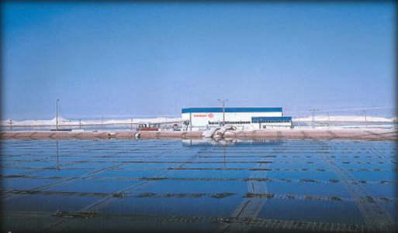
Figure 8. Ormat Salinity Gradient Solar Pond at the Dead Sea
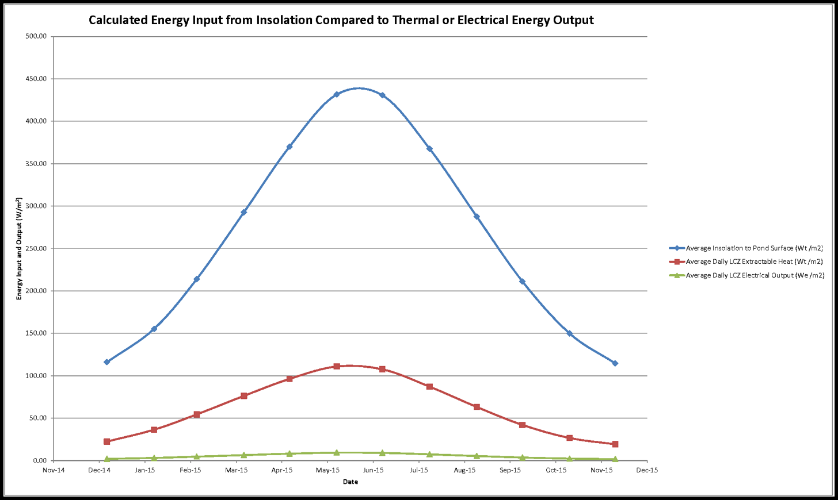
Figure 9. Monthly Salinity Gradient Solar Pond Input and Outputs Calculated for the Salton Sea
The salinity gradient solar ponds will capture and store heat from the sun that can be converted to electricity at any time of day or night, or used directly as heat to drive a distillation process. The solar ponds proposed will operate on average 75% for electrical generation and 25% as heat for distillation, to provide their own sustained supply of water and salt from the Salton Sea, plus additional purified salt for the regional market. These ratios will be adjusted seasonally to meet variations in solar availability and power and water demand.
Electrical generation from the solar ponds can initially be supplied for project use, separating salts and pumping water. As more solar ponds are built out, excess power will be sold through the grid to California utilities seeking to meet new renewable portfolio standards beyond the 50% by 2030 requirement. With continued growth in both markets, production of electricity and purified salt by the salinity gradient solar ponds will fully offset their capital and operating costs.

Implementation of Water and Salt Treatment Facilities
For all three Water Import Concepts A, B, and C the salt and nutrient extraction and water treatment at the Salton Sea and/or at Cerro Prieto will be implemented by installing five types of water and salt treatment facilities incrementally as modular plants and solar ponds that work together to provide the four fold benefits of clean water for habitat and potable use, dust coverage on playa, Salton Sea salinity management, and renewable energy development to boost the local economy in the Imperial and Coachella, and potentially in the Mexicali Valley. The five types of water and salt treatment facilities are:
Facility Type 1. Vertical Tube Evaporator (VTE) Multi-Effect Distillation (MED) Plants will be driven by geothermal heat purchased as steam at up to 200°C (394°F) to separate pure water from all other contaminants in the Salton Sea by distillation. The VTE-MED Plants will be built in 20 MGD modules composed of twelve cylindrical vacuum vessels containing five effects each in a vertical stack for a total of 60 effects enabling very high thermal efficiency from purchased geothermal steam. Alternatively a modular horizontal 60 effect configuration will be evaluated. The recent availability of novel high temperature polymer composite evaporator tubes with thermal conductivity similar to metal tubes, but with a very high resistance to scaling, fouling, and corrosion helps to make this performance improvement possible. These evaporator tubes have been developed by Technoform Kunststoffprofile GmbH in Germany. For Water Import Concept A, 24 VTE-MED plants will be built at the Salton Sea at a pace of two per year adjacent to new geothermal power plants that will supply both heat from geothermal steam and power for pumping. Contracts to buy all the heat and power from the new geothermal plants over a 30 year plant life will enable the Salton Sea geothermal industry to expand to meet this new demand. For Water Import Concept B the 24 VTE-MED plants would be built at Cerro Prieto and only 6 would be needed at the Salton Sea. For Water Import Concept C only the 6 VTE-MED plants at the Salton Sea would be needed to remove excess salts from agricultural drainage.
Facility Type 2. Filtration and Salt Separation Plants using particle filters and ultrafiltration (UF) membranes to remove particles and biological materials, followed by nano-filtration (NF) membranes to separate larger more highly charged ions from sodium and chloride ions. The Salt Separation Plants will be built in 6 million gallon per day (MGD) modules and in 1 MGD satellite modules. These Plants will be similar in construction to a Reverse Osmosis (RO) desalination plant with stacks of membrane housings, pumps, and other filtration equipment in a building or container. However the NF membranes used have a pore size ten-fold larger than RO membranes making it feasible to treat hypersaline water from the Salton Sea. They will placed on the Southern shore of the Salton Sea adjacent to other Project facilities. Eight of the 6 MGD plants will be built per year, adjacent to the first two 20 MGD VTE-MED plants to feed their 99% pure sodium chloride permeate product to the VTE-MED process for salt concentration and distilled water recovery.
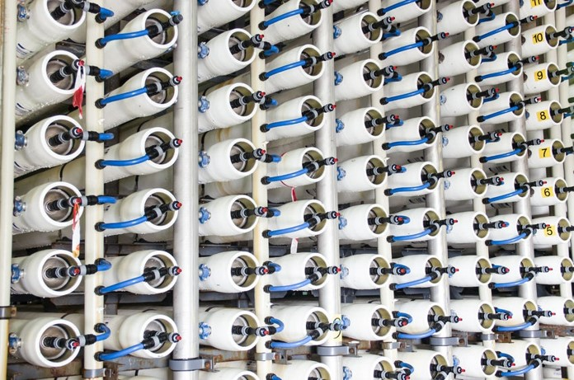
Figure 10. Array of Pressure Vessels Typical for NF Plant, Facility type 2
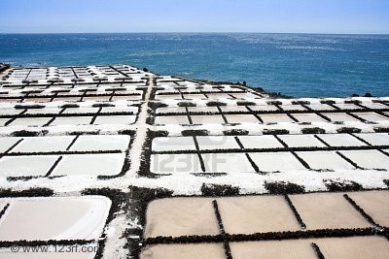
Figure 11. Solar Salt Evaporation Ponds, Facility type 3
Facility Type 3. Solar Salt Evaporation Ponds take 99% purified sodium chloride brine concentrated to near saturation in the VTE-MED plants and crystallize the salt in shallow ponds built on exposed Salton Sea playa. The crystallized salt will be harvested, washed, dried, and sorted by traditional methods. Similar ponds are in use in coastal areas all over the world, including at the Sea of Cortez. These evaporation ponds will be built out gradually as needed eventually covering up to 710 acres of exposed playa at the Salton Sea for Water Import Concept A or 222 acres for Water Import Concepts, B and C.
Facility Type 4. Vacuum Salt Refining Plants will take 99% purified sodium chloride brine concentrated to saturation in the large 20 MGD VTE-MED plants and crystallize the salt in small VTE-MED evaporators driven by low temperature geothermal steam, removing remaining impurities by precipitation and drawing off the liquor, to achieve the 99.9% purity of refined salt used for food processing and a range of chemical process industries The refined salt crystals will be dewatered by centrifugation and fluid bed hot air drying, then milled and sorted for sale. These plants will be built in 250 metric ton per day production units and located near VTE-MED plants that supply the concentrated brine and near geothermal plants that will supply geothermal steam to heat the vacuum evaporation process and supply electric power.
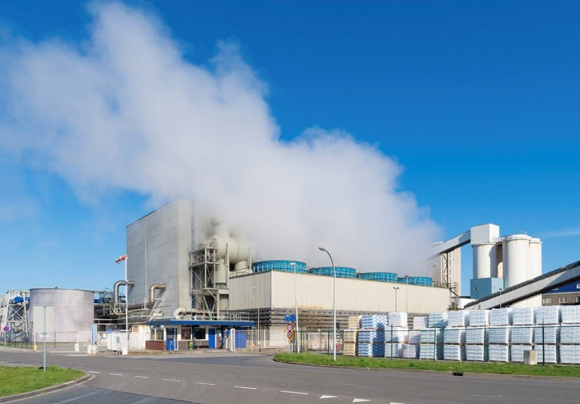
Figure 12. Vacuum Salt Refining Plant, Facility type 4
Facility Type 5. Salinity Gradient Solar Ponds will be built out gradually on exposed Salton Sea playa to cover dust in emissive areas. The solar ponds will take non-marketable mixed salts in brine concentrated to saturation by the 20 MGD VTE-MED Plants and by other solar ponds. A salinity gradient layer created above the concentrated brine will trap heat from the sun in the dense brine layer at the bottom of the solar pond. This heat will be used to drive turbine-generators to make power for use within the project powering a 1 MGD salt separation unit at each solar pond complex and to drive a 5 effect low temperature VTE-MED distillation process to maintain the salinity gradient and to make more salt for sale. Power in excess of local project needs will be delivered to the grid for sale to customers. The electrical power capacity is on the order of 9.3 MW per section of land and varies seasonally, but can be extracted at any time of day or night as salinity gradient solar ponds store the heat of the sun for weeks. Before the end of the QSA water transfer agreements in 2077, power produced by the salinity gradient solar ponds will be sufficient to replace all that lost by the decommissioning of the San Onofre nuclear power plant. Generation from the San Onofre plant was replaced by fossil fuel natural gas plants. As those plants are retired after a typical 30 year life, 24/7 baseload generation from the salinity gradient solar ponds will become available to replace that with renewable power.
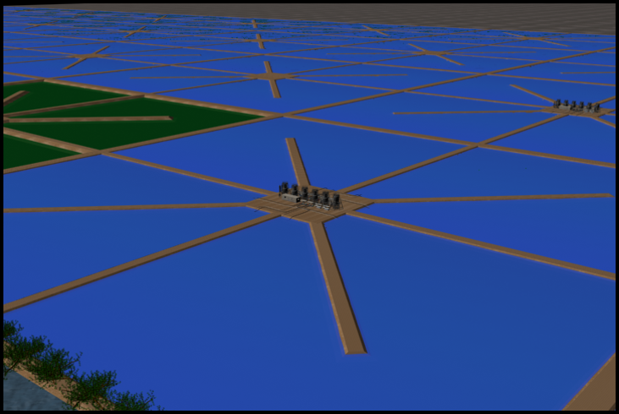
Figure 13. 40 Acre Salinity Gradient Solar Pond Unit Designed for the Salton Sea, Facility type 5
Combined with the level rise from ocean water import, the build out of salinity gradient solar pond acreage can help to cover all exposed playa above the target elevation for Salton Sea restoration chosen by the public agencies. With transparent floating evaporation reduction covers, the salinity gradient solar ponds will be 75% more water efficient than aquatic habitat or shallow flooding dust mitigation strategies and equally effective. While not directly useful as habitat, the solar ponds will supply a modest amount of pure selenium free distilled water to any nearby habitat ponds for selenium dilution and, with pond water heat exchangers installed, they can be used to keep habitat ponds above the fish mortality temperature on the cold winter nights where that threat may be imminent.

Benefit to the Lake 1: Elevation Management, Water Import Concept A
The reduction of inflows to the Salton Sea from QSA water transfers, related on farm water efficiencies, reduction in cross border flows, increased IID storage, and other factors has been causing a substantial reduction in surface elevation at the Salton Sea since the 2003 QSA agreement went into effect. The level decline has accelerated now that QSA mandated mitigation flows to the Salton Sea have stopped. This has caused both the exposure of potentially dust emissive playa and the retreat of the shoreline from areas of human and wildlife use. On the human side there is the loss of use of community shorelines, boat docks and ramps, fishing piers, beaches, and shoreline parks. Key impacts on wildlife include the cutoff of access by the dominant fish, Mozambique tilapia, to protected harbors and inlets used for spawning, the exposure of critical nesting habitat such as Mullet Island and nesting trees along the shoreline to ground predators, and the dramatic change of river estuaries.
The import of up to 900 KAFY of ocean water to the Salton Sea with Water Import Concept A, will raise the elevation of the Salton Sea dramatically over just a few years because it will exceed the loss of inflows attributable to the water transfers significantly. After the level is restored to an agreed target surface elevation the ocean water inflow can be cut back to maintenance import on the order of 450 KAFY to 500 KAFY.
Figure 14. Impacts of QSA and Water Import Concept A on the Surface Elevation of the Salton Sea
The chart of past and predicted reductions to Salton Sea surface elevation in Figure 14 compares a gradual loss of inflow to the Salton Sea from non-QSA changes in farming practices, climate change, cross border flow changes, and possibly other factors estimated by the dark blue plot with the loss of level when QSA water transfers and some recent storage measures are included, shown in the dark red plot, partly hidden by the blue line. The elevation declined substantially from 2010 to 2018 and is declining at a faster rate now since 2018 and will continue without intervention to 2050 as mitigation water no longer offsets some of the inflow loss. The loss of level slows around 2050 as the Sea’s surface area shrinks reducing the evaporation rate. The light blue plot in figure 14 shows how Water Import Concept A would restore the elevation of the Salton Sea if a cross border seawater canal were operational in 2035 after a dozen years of working through politics, agreements, financing, permitting, and finally construction.
Figure 15 shows a plot of the Salton Sea surface area under QSA water transfers in dark red behind light blue. The curve shape is similar as the change in surface area acts on the elevation and vice versa because the largest factor influencing the elevation change after inflows is evaporation loss, which is directly related to surface area. Both surface area and elevation increase slightly after 2048 because the QSA water transfer to the Coachella Valley Water District (CVWD) is scheduled to be cut by half from that year forward.
Figure 15. Impacts of QSA and Water Import Concept A on the Surface Area of the Salton Sea
These predictions are based on water and salt balance equations explained in some detail in Appendix A and calculated in annual increments in spreadsheets included as Appendix B. Since the official Salton Sea hydrology tool, SALSA 2, is specific to non-water import solutions, it was necessary to create an alternative water and salt balance model to analyze the impacts and potential benefits of ocean water import and salinity management at the Salton Sea. This is not a Monte Carlo simulation or other range of uncertainty model, but rather a simple result of water volume balance and salt mass balance equations applied to the available data on historic and predicted inflows to the Salton Sea, Salton Sea evaporation losses based on the Alex M. Sturrock, Jr. 1969 study (U.S. Geological Survey Water-Supply Paper 2053) supplemented with data for higher salinity in the Sea now, and volume to elevation to surface area relationships calculated from bathymetry data in the Paul Weghorst 2000 Salton Sea Accounting Model study for the U.S. Bureau of Reclamation.
Figures 14 and 15 show the impact of an initial five year 900 KAFY infusion of ocean water into the Salton Sea starting in 2035, then dropping back to 450 KAFY of ocean water inflow direct to the Salton Sea in the light blue plot. This amount is roughly equal to the fully implemented QSA water transfers with the preexisting 105 KAFY transfer to the Metropolitan Water District of Southern California (MWD) included. An arbitrary assumption is made that it will take three years for a decision on where to go with the Salton Sea in the long term plus a decade of bi-national negotiations, right of way acquisition, environmental review, and permitting, plus two years of construction to have imported water infrastructure ready to go in 2035, so ocean water import starts then. By 2035, the Salton Sea elevation will be reduced by ten feet, from -238 feet below mean sea level now to -248 feet then. The increase in level and surface area from the added ocean water will be rapid and dramatic, quickly reversing the decline starting in 2035 and rising at a gradually declining rate in the following years. By 2040, the Salton Sea elevation will have stabilized at about -232 feet below mean sea level.

Benefit to the Lake 1: Elevation Management, Water Import Concepts B and C
Water Import Concepts B and C both accomplish restoration of the surface elevation of the Salton Sea with delivery of imported water, but rather than deliver a 900 KAFY five year delivery of seawater, then cut the flow in half as with Concept A, they both deliver a more modest and steady 500 KAFY supply of freshwater.
This amount is roughly equal to the fully implemented QSA water transfers and MWD transfers. For Water Import Concept B, eight years are assumed in Mexico for right of way acquisition, environmental review, permitting, and construction to commence water delivery to the Salton Sea in 2030. It may take longer. Simultaneously, but independently, a much smaller salt extraction and water treatment infrastructure would need to be built at the Salton Sea. For Water Import Concept C, the same time frame is assumed to reach water rights transfer agreements and wheeling agreements. Delivery of Colorado River restoration water to the Salton Sea is also assumed to start in 2030 in the same 500 KAFY quantity. For both Concepts B and C, the increase in Salton Sea elevation will be apparent shortly after water delivery starts, reversing the elevation decline starting in 2030 and rising at a gradually reduced rate in the following decades. By 2060, the Salton Sea elevation will have stabilized at about -228 feet below mean sea level as plotted in Figure 16. The delivery of freshwater water can be reduced if a lower target elevation for the Salton Sea is preferred by the public agencies in charge.

Figure 16. Impacts of QSA and Water Import Concepts B or C on the Surface Elevation of the Salton Sea

Benefit to the Lake 2: Air Quality Improvement by Playa Coverage, Concept A
The major threat to human health is breathing in PM10 dust on windy days. This will be exacerbated by exposure of the dry lakebed. Playa PM10 dust coverage benefits will be obtained by three mechanisms. The mechanism with the largest and most immediate effect will be the elevation rise shown in Figures 14 for Concept A and 16 for Concepts B and C. As shown in Figure 17, raising the lake surface elevation, or level, by importing 900 KAFY of ocean water starting in 2035, as envisioned in Water Import Concept A, will cover thousands of acres of exposed playa very rapidly.
The second mechanism is by creating solar salt evaporation ponds on playa where saturated brine sourced from the hypersaline Salton Sea and purified to 99% sodium chloride will be evaporated by the sun to precipitate salt, then harvested, leaving a few inches of solid salt crust. A normal sea salt works would refill and reuse these ponds, but playa coverage can be accelerated while urgent by leaving the salt crust dry and creating a new evaporation pond downslope to accept more purified saturated brine. Revenue from the sea salt harvested will pay for the evaporation pond construction, and for the salt purification and concentration. Construction of solar salt evaporation ponds could begin well before 2035 if playa land access rights can be bought.
The third mechanism for playa coverage is to deliver the non-purified mixed salt brine, rejected from the NF salt separation process and concentrated to saturation in a VTE-MED system, to salinity gradient solar ponds built on the playa and lined with high temperature plastic or compacted clay. The solar ponds will cover playa, permanently store non-marketable salts removed from the Salton Sea, and pay their own construction and operation cost by capturing and storing the heat of the sun to generate electricity and distill Salton Sea water.
Figure 17. Impacts of QSA and Water Import Concept A on Exposed Playa at the Salton Sea
The dark red plot behind the blue line in Figure 17 shows the amount of playa exposed year by year with QSA water transfers compared to a no QSA transfer scenario with the dark blue line. Playa exposure will exceed 60,000 acres by 2035 then level out and decline a bit after 2048 if diversions to the CVWD are reduced on schedule. If 900 KAFY of ocean water import started in 2035 the exposure of playa would quickly reverse. Playa would be re-covered reaching a pre QSA zero point in 2037. Water Import Concept A as proposed manages playa exposure by gradually covering the shoreline with solar salt evaporation ponds and salinity gradient solar ponds starting as early as a decade ahead of the completion of the seawater canal, then by importing a larger 900 KAFY flow from the completed canal for five years starting in 2035. All three mechanisms for playa coverage are employed to begin to reduce playa exposure well ahead of the start of ocean water import as shown in the light blue plot in Figure 17. The playa coverage is then modified by reusing solar salt evaporation ponds and by taking build out of any new salinity gradient solar ponds off the playa to open ground on the sparsely developed east side of the lake north of Bombay Beach or by switching to a less land intensive brine to energy technology if one is developed to a reliable and cost effective level of maturity by 2035.

Benefit to the Lake 2: Air Quality Improvement by Playa Coverage, Concepts B and C
Water Import Concepts B and C will reduce playa exposure very similarly. Both rely primarily on getting freshwater import to the Salton Sea as soon as possible by bypassing some of the time consuming barriers of international agreements and obtaining land use rights and permits in the permit and litigation challenged environment in California. Neither Concept would build large amounts of infrastructure in California, just enough for the long term extraction of salts and nutrients from the Salton Sea. Figure 18 shows the rapid playa coverage benefit of importing 500 KAFY of freshwater to the Salton Sea as soon as possible, assuming a start in 2030.
Figure 18. Impacts of QSA and Water Import Concepts B and C on Exposed Playa at the Salton Sea

Benefit to the Lake 3: Salinity Management, Water Import Concept A
The reduced brackish water inflows to the Salton Sea resulting from the QSA water transfers is reducing the volume of the Salton Sea rapidly now that mitigation water has stopped. This is causing a concentrating effect that is pushing salinity up more rapidly than would have occurred without the QSA water transfers. This is illustrated by the dark red plot behind the blue line in Figure 19. Salinity under the QSA water transfers will reach 125 g/liter well above the salinity tolerance of the endangered desert pupfish or any other fish species in the lake.
Ocean water import of 900 KAFY starting in 2035 will have an immediate dilution effect as shown in the light blue plot in Figure 19. But, the dilution effect will reverse within ten years as the higher salt loading from ocean water accumulates in the lake, causing the salinity to rise again. That, and elevation management, are both reasons to cut back delivery of seawater to 450 KAFY after the first five years. The salinity rise will also be curtailed in the years ahead of 2035 as salt and water treatment plants are built out. Salinity will be rapidly reduced in the years right after 2035, declining within five years to a level below 50,000 parts per million (ppm) TDS that previously supported large fish populations, then declining slowly and steadily thereafter allowing fish to repopulate the Salton Sea over time with a likely expectation of reestablishing the fish and bird ecosystem in the Salton Sea.
Figure 19. Impacts of QSA and Water Import Concept A on Salinity in the Salton Sea

Benefit to the Lake 3: Salinity Management, Water Import Concepts B and C
Water Import Concepts B and C both propose to deliver 500 KAFY of freshwater to the Salton Sea by 2030. By starting earlier, they will achieve the benefit of reducing lake salinity with less water. By using freshwater, Concepts B and C dramatically reduce the amount of salt that needs to be extracted from the Salton Sea on a long term ongoing basis. As illustrated in Figure 20, freshwater import of 500 KAFY starting in 2030 will have an immediate dilution effect as shown in the light blue plot. Salinity will be continue go down in the decades following 2030, declining in about ten years to a level below 50,000 ppm TDS that supported large fish populations, then declining slowly and steadily thereafter allowing fish to repopulate the Salton Sea. A necessary part of salinity management under Water Import Concepts B and C is the extraction of the 3 to 4 million metric tons of mixed salts that enter the Salton Sea annually. This is accomplished by a much smaller footprint of salt extraction and water treatment plants and infrastructure than is needed with direct seawater import to the Salton Sea under Water Import Concept A, but it is necessary even with freshwater import because the Salton Sea is a terminal lake. The 3 to 4 million metric tons of salts flowing in from agricultural drainage have nowhere else to go.
Figure 20. Impacts of QSA and Water Import Concepts B and C on Salinity in the Salton Sea

Business Plan
The Salton Sea’s Water Import Salt Extraction Revenue Project will be owned and operated as a public/private partnership between private stakeholders and a few public agencies. For Water Import Concept A and B public agencies in both Mexico and the U.S. will be involved. For Water Import Concept C, only U.S. based public entities will be involved.

Private Business Entities for Water Import Concepts A, B, and C
Sephton Water Technology, Inc.is leading the early phase planning, design, and technology development for this Project in collaboration with Membrane Development Specialists, Leading Edge Technologies, LLC, Process Engineering LLC, JFMPE, and individual experts contributing expertise. Sephton Water Technology, Inc. is a California corporation with more than fifteen years of experience developing the suite of technologies proposed for this Project and essential to overcoming some of the unique water quality challenges at the Salton Sea. Sephton Water Technology has well over a decade of operational experience purifying Salton Sea water and salt with geothermal heat. The Company is the only entity with recent and extensive experience in the unique challenges of extracting Salton Sea water and salts to restore environmental water quality and offset the costs with purified salts and solar energy. Sephton Water Technology has forged working relationships with engineering, contracting, and geothermal development firms at the Salton Sea in that carrying out that work including Berkshire Hathaway Energy Renewables over many years and Controlled Thermal Resources for a shorter time.
Sephton Water Technology, Inc. is a small company. If any of the three Water Import Concepts proposed were to move forward past planning and development into final design and construction, it would be appropriate to partner with a larger firm that has the staff and deep pocket financial resources to execute a large project like the restoration of the Salton Sea. Local geothermal developer would be a good choice. The managers, engineers, operators, and maintenance crews of local geothermal companies are capable of taking on the salt and nutrient extraction, energy development, and water treatment aspects of this Project. These functions are designed to be revenue generating and profitable so they are appropriate for private companies to undertake. Some of the local geothermal developers are well funded by parent companies or business partners as well.
CalEnergy Operating Company is a subsidiary of Berkshire Hathaway Energy Renewables, in turn a subsidiary of Berkshire Hathaway. Much of the salt recovery and water treatment technology proposed for this Project was developed at one of their plants under a cooperation agreement with Sephton Water Technology, Inc.
Controlled Thermal Resources is a new geothermal developer owned by an Australian billionaire The company is now designing the largest geothermal plant at the Salton Sea. Controlled Thermal Resources has a major investment from General Motors for geothermal lithium development.
Energy Source owns and operates the newest geothermal plant at the Salton Sea built and is ready to construct a lithium recovery plant adjacent to their geothermal plant.
Ormat Nevada, Inc. owns local geothermal power plants south of the Salton Sea and is developing a well field to the west of the Salton Sea. Ormat is a subsidiary of a large international firm, Ormat Technologies, Inc., which operates in 30 countries around the world in power and originally in turbines.
Any of these geothermal developers could be well suited to take on the lead role among the private firms working on the revenue generating aspects of the Water Import Salt Extraction Revenue Project.

Mexican Government Entities for Water Import Concepts A and B.
One or more government agencies in Mexico will own and operate the conveyance infrastructure there and be responsible for the design, permitting, and construction of that infrastructure and for all operations in Mexico. The Mexican Government agency, or agencies, will be contracted to deliver ocean water to the border by a lined canal west of Mount Signal. Either ConAgua (the Mexican National Water Commission) or the Baja State Water Commission are the logical agencies with staff and resources capable of doing the job. The Mexican Government will select the agency, or agencies, responsible.
The construction in Mexico will be financed with public bonds, or other instruments, raised in Mexico and sold to investors from either side of the border or internationally. Either the lead private entity, or a U.S. Government agency will contract to pay the selected agency in Mexico for each acre foot of ocean water delivered to the border. The amount is estimated at $110 per acre foot delivered. The ocean water purchase contract will run for the duration of the QSA water transfers, with an option to renew.
For Water Import Concept B a critical partner and supplier will be the Mexican Federal power utility CFE, which owns and operates the Cerro Prieto geothermal power plants. For Concept B, the private U.S. entities would need to contract with CFE to be allowed to build and operate desalination and salt purification plants adjacent to the CFE geothermal power plants and would contract to buy steam and power from the CFE plants. If the lead private firm for the Water Import Salt Extraction Revenue Project, Concept B is a geothermal developer with interests at the Salton Sea, then this will be a good fit enabling an exchange of expertise and a common understanding of the business.

U.S. Government Entities, Water Import Concepts A, B, and C
For Water Import Concept A, conveyance of ocean water from the border to the Salton Sea, will be contracted with a Federal or State government agency. The U.S. Department of the Interior, Bureau of Reclamation is the appropriate Federal agency. The appropriate State agency is the California Department of Water Resources. Either agency has the engineering, management, and operations staff capable of conducting environmental review, securing permits, and designing and operating any conveyance infrastructure from the border to the Salton Sea and either can contract with U.S. engineering and construction contractors to build the lined canals, pipelines, and hydro power infrastructure needed. The infrastructure designed, built, and bond funded by a State or Federal agency will be owned and operated by that agency, unless the agency decides to pass operation control and/or ownership to a different public agency.
The design, permitting, and construction of conveyance and power infrastructure in the U.S. will be financed with public bond funds raised by the State of California, or other suitable entity. The lead private entity of the Water Import Salt Extraction Revenue Project will contract to pay the State or Federal agency for each acre foot of ocean water delivered from the border to the Salton Sea. The State or Federal agency will responsible for delivering power derived from the elevation drops to the selected agency in Mexico for pumping. The amount paid to the State or Federal agency is estimated at $70 per acre foot of any ocean water delivered to the Salton Sea. The conveyance infrastructure in the U.S. will be owned and operated by the public agency in the U.S. This ocean water conveyance contract will run for the duration of the QSA water transfers, with an option to renew.
For Water Import Concept B the State and Federal agencies in the U.S. will have a more limited role. The U.S. Bureau of Reclamation may be involved in a NEPA process and the California Department of Water Resources may be involved in a CEQA process. There will be State, and Federal environmental documents and permits required for the Salton Sea salt extraction and water treatment plants and pipelines.
For Water Import Concept C, the U.S. Bureau of Reclamation will be deeply involved in the negotiations with Tribal Governments to sell and transfer unused allocations of Colorado River water to the Torres Martinez Tribe. The Tribes own the water rights, but the U.S. Bureau of Reclamation manages the Colorado River system and their cooperation will be needed to move release specific amounts of water from dams and deliver the water to the All American Canal.

Tribal Government Entities, Water Import Concept C
Each Tribal Government represents an independent sovereign nation within the U.S. and each that is willing and able to supply water will have to negotiate agreements between the Tribes. The following is a business structure that was proposed to the principal Tribal Chairmen working on this Concept, Bo Mazzetti with the Rincon, and Thomas Tortez with the Torres Martinez:
Short term (1 to 5 years):
1. The State may agree to buy up to 500,000 acre-feet per year (AFY) of Colorado River water from the Torres Martinez Desert Cahuilla Indians at $200 per AF or whatever price the State and Tribe agree to. That would provide $100 million in revenue to the Tribe. The Torres Martinez Tribe agree deliver virtually all of that water into the Salton Sea until the level is restored to the 2003 elevation, or some other elevation agreed to. Delivery would use existing canal infrastructure in the Imperial and Coachella Valleys that have the excess capacity required. There may be a modest wheeling rate applied by the Imperial Irrigation District and/or by the Coachella Valley Water District. Continue to raise the Salton Sea elevation for 5 years. The Colorado River water delivered will also dramatically reduce salinity and dilute other contaminants, thus restoring water quality in several years.
2. The other up to 22 Native American Tribes with water rights in excess of their current use (Rincon etc.) agree to sell up to 500,000 AFY of Colorado River water to the Torres Martinez Tribe at a price of about $180 per AF or whatever price is agreed to with the Torres Martinez tribe for the first 5 years. The $180 per AF example would be a $90 million per year cost to the Torres Martinez Tribe and $90 million in annual revenue to the Tribes selling the water less wheeling charges. The rights holding Tribes agree to sell 500,000 AFY after the Salton Sea elevation target is reached at a yet to be agreed price through the expiration of the QSA in 2077.
3. The rights holding Tribes agree to invest some substantial, yet to be determined, portion of their water sales revenue into Water Import Salt Extraction Revenue Project to start building out the infrastructure needed to extract salt from the Salton Sea and convert it to commercial salt, power, and other minerals of value, while returning the distilled water to the environment. Purified salt from the Salton Sea, extracted with geothermal and solar power, has enough value to pay for the purification process and also for the water needed to sustain the Sea. This joint enterprise will eventually buy the Colorado River water from the selling Tribes at a higher price that the State will pay, substantially increasing their annual revenue and also share profits with the rights holding Tribes. Over time, this joint enterprise will pay for the long term restoration of the Salton Sea and provide a large long term revenue source for all the Tribes supplying Colorado River water to sustain the Salton Sea.
Long term (6 to 50 years)
1. The Torres Martinez Tribe agree to purchase 500,000 AFY of Colorado River water from a Consortium of rights holding Tribes at an agreed upon price (between $180 to $250 per AF). The Torres Martinez Tribe agree to put 500,000 AFY of Colorado River into the Salton Sea to sustain the elevation through the 2077 expiration of the QSA.
2. The Consortium of rights holding Tribes agree to sell 500,000 AFY of Colorado River water at an agreed price between $180 and $250 per AF to the Torres Martinez Tribe through 2077.
3. The private entities that comprise the Water Import Salt Extraction Revenue Project will remove saltwater from the Salton Sea in an amount sufficient to balance the annual salt load from agricultural runoff and other inflow (3 to 4 million metric tons per year). The Water Import Salt Extraction Revenue Project will convert most of the salt to commercial salt and other commercial minerals, and sell solar or osmotic power or salt for heat storage from the remaining salt. The water removed from the Salton Sea will be purified by distillation using geothermal and solar heat, then returned to the Salton Sea to sustain the ecosystem.
The private entities that comprise the Water Import Salt Extraction Revenue Project will agree to pay the consortium of rights holding Tribes between $200 to $250 per AF for the 500,000 AFY of Colorado River water delivered to the Salton Sea and share the profits from the sales of salt, minerals, and power.

Revenue Basis: Marketable Products from the Concept
This Water Import Salt Extraction Revenue proposal is conceived as a public benefit business enterprise supporting public health and the environment, but also able to benefit private investors making it possible to raise equity capital to get the work started. The private entities that comprise the Water Import Salt Extraction Revenue Project will implement energy and cost efficient processes to desalinate high salinity water resources from the Salton Sea while converting the concentrated salts to useful products. The products from implementation of the Water Import Salt Extraction Revenue concept will be pure distilled water, purified sodium chloride sold as solar salt (99.0% purity) and as refined salt (99.9% purity), and solar power. Other minerals will also be products if cost competitive separation processes and markets are proven. Initially, the solar power produced will be used internally by this Salton Sea restoration project or other projects in need of 24/7 renewable power for pumping. When these power needs are exceeded by production, the additional power will be delivered to the regional grid for sale to utilities in California seeking to expand their renewable portfolio.
The pure water and salt produced will be sourced from the Salton Sea. The solar energy will be captured and stored in the non-purified mixed salt brine that would otherwise be a waste product.
The Salt Extraction Revenue aspect of the concept will produce a gradually rising quantity of solar salt for sale, initially sourced from purified brine concentrated in the 20 MGD VTE-MED plants, then later also from purified brine produced by the salinity gradient solar ponds, all dried and crystallized in dust elimination ponds at the periphery of the Salton Sea. The rate of solar salt production is shown in Figure 21 by the dark grey plot. The 99% purity solar salt product had a market value of $120 per metric ton FOB in the 2020 U.S. domestic market according to USGS mineral market data (Appendix C) with a gradually rising demand over the last three decades.
Vacuum process refined salt will be produced for sale at the required 99.9% purity by vacuum crystallization of 99.0% purified brine concentrate sourced from the salt separation and VTE-MED process using Salton Sea water as feed. The rate of vacuum refined salt production is shown in Figure 21 by the light grey plot. The vacuum refined salt product had a market value of $215 per metric ton FOB in the 2020 U.S. domestic market according to USGS data (Appendix C). Production projections are limited to 30% of the gradually rising market demand trend-line to avoid flooding the regional salt market. To the extent feasible, the Water Import Salt Extraction Revenue Project will work to build partnerships with local and regional industries that can use purified salt in manufacturing to reduce the price impact on the domestic market and boost the regional economy. Examples of partnerships may include food processing, leather tanning, and the chloralkali chemical process, as well as other industrial processes.
Sephton Water Technology is already starting work with a company developing processes to use waste salt from agricultural drain and other saltwater desalination for storage of heat at solar thermal power plants to continue to produce power at night.
Figure 21. Solar Salt (dark grey) and Refined Salt (light grey) Production, Concept A

Target Market, Salt
The Project will serve the bulk solar salt and refined salt market in the Western United States. This market is mature but has grown in the last few years due to high demand and supply shortages in other parts of the Nation.
As shown in Figure 22, domestic production reported by the USGS of all salt grades rose from 35 to 43 million metric tons from 1991 to 2017 with apparent domestic consumption rising from 40 to 50 million metric tons over the same time period, the difference being made up by salt imports. The U.S. has consistently been a net salt importer from 1991 through the present, with imports at 23% in the most recent USGS report covering 2017. Salt exports have been consistently low throughout that time frame.
Market volatility in recent years has been caused by unusually cold winters in the Eastern U.S. depleting supplies of road de-icing salt that are typically supplied by mined rock with reduced demand in subsequent warmer winters. Municipalities typically purchase road salt with long term contracts to stabilize prices, but unusual weather has destabilized that market recently. Higher grades of salt may be purchased by municipalities when road salt supplies are depleted.

Figure 22. Comparison of Domestic Salt Consumption, Production, Imports, and Exports 1991-2020
Solar salt and vacuum pan refined salt have made up 7% to 11% each of the total salt used domestically from 1991 to 2020 according to USGS data. The solar salt and vacuum pan refined salt are used in a wide range of industries from food processing, to water softening, to chemical manufacturing. Figure 23 compares domestic consumption of solar salt and vacuum pan refined salt to overall domestic salt consumption. The domestic demand volatility of these two higher grade salt products is less than the overall salt market with a modest impact on the higher grade consumption from overall salt market demand fluctuations and only a slight rising trend in domestic demand for solar salt and refined salt from 1991 to the present.
Figure 24 compares the prices of rock salt, vacuum pan refined salt, and solar salt from 1991 to 2020 based on USGS domestic salt market data. At recent market pricing, only the two higher grades of salt are economic to produce and ship using the desalination and extraction process proposed at the Salton Sea. The price of all three salt grades shown has a rising trend in spite of price fluctuation over one or more years. The price rise trend is faster for the higher priced salt grades. The rising price of refined salt exceeds the average rate of inflation.
The trend line price rise of $4.35 per year with a 2020 trend line starting price of $205 is used in the project revenue estimates for sales of vacuum pan refined salt calculated in the Appendix D spreadsheets. For solar salt, the trend line price rise of $2.94 per year with a 2020 trend line starting price of $102 is used in the Project revenue estimates in Appendix D.
Figure 23. Comparison of Refined and Solar Salt to the Overall Domestic Salt Market 1991-2020
After limited sales to the local agricultural and water softening market, the Project will ship the majority of the two salt products to regional markets over an existing Southern Pacific rail link connecting the production area to Los Angeles and Phoenix and on to the Nation. Rail loading facilities exist within ten miles of the proposed plants, but one or more dedicated rail spurs may be more cost effective if large quantities of dry salt are produced in a centralized location near a large geothermal plant.

Marketing and Sales, Salt
Higher grade refined salt and solar salt are marketed to consumers and industry for a very wide range of uses. Sea salt from various sources and other specialty salts are successfully marketed at premium prices, often disconnected from the actual production cost and quality. An example is Himalayan Sea Salt, a relatively impure mined product sold for food and bathing at a premium price with a pink color and a good story. While the Project private entities’s product purity will be high and the environmental story is a good one, the marketing effort to consumers will have to be carefully crafted as the Salton Sea has a negative reputation as a polluted body of water among the small percentage of people in Southern California who even know it exists. Due to that “ick” factor, the products will not be marketed to consumers for food use in Southern California. In the first years when the scale of production is limited, the products will be marketed to U.S. consumers and small business for non-food uses such as water softening, animal feed, and de-icing with an environmental protection story and brand naming such as ‘Envirosalt’ or ‘Sustainable Solar Salt’.
Figure 24. Comparison of Refined and Solar Salt to the Overall Domestic Salt Market 1991-2020
As production increases, the focus of sales and marketing will have to shift to the larger industrial market serving a wide range of uses including chemical production, pulp and paper production, leather tanning, textile treatment and dye processes, and drilling fluids for oil, gas, and geothermal exploitation. The Project private entities can competitively sell some industrial products locally for use in agriculture and geothermal drilling fluids. Selling large amounts of product into the broader U.S. industrial market would put the Project private entities in direct competition with the major domestic salt producers Morton (now owned by K&S), Cargill, and Compass Minerals. A strategic alliance can be sought to supply product to one of those competitors at a price sufficient to sustain profitability and growth. Such an alliance would leverage the extensive marketing, branding, and distribution networks already established by each company. While Cargill, Morton, and Compass Minerals have extensive domestic production capability, none has a production operation in Southern California. The one significant solar grade salt manufacturer in Sothern California, South Bay Salt Works, competes directly with Morton’s branded products in consumer solar salt sales for water softening by substantially undercutting the price. Regional price competition is an option if neither Cargill nor Morton will form an alliance, but it is a problematic strategy.
An alternate sales strategy is to bring a major salt using industry to the Imperial Valley where land, labor, and energy are relatively cheap by U.S. standards. Existing rail and highway routes provide access to the Southwestern U.S. and to industry in Northwestern Mexico. Such industries could include leather tanning, food processing and packing, or chemical production. Several of the other raw materials are locally produced and shipped out. With such industries as local customers, the Project private entities would be well positioned as the lowest cost supplier of salt products.

The Competition, Salt
Three large vertically integrated companies dominate the salt production industry in the U.S. Morton Salt (now owned by the German firm K&S) is an established brand that owns salt mines, evaporation ponds, and salt refining operations and controls product distribution to industries and store shelves. Cargill owns the Diamond Crystal and several other brands and purchased the well known Leslie Salt in 1978. Cargill operates the largest California salt production facilities in San Francisco Bay producing 500,000 tons of salt annually from 12,000 acres of evaporation ponds. Cargill also operates salt mining and production facilities around the country. Compass Minerals operates salt evaporation ponds at the Great Salt Lake, mines salt, and operates vacuum refining plants in Canada, the Midwest and the Great Lakes. United Salt Corporation operates salt mining, refining, and evaporation plants in Texas, New Mexico, and Virginia. The South Bay Salt Works near Chula Vista, California is the geographically closest competitor. This small operation has existed since the late 1800’s and produces a steady 75,000 tons of salt annually from 1,000 acres of land designated as a historic site. Several small U.S. producers compete in niche markets including Real Salt in Utah.
The largest salt production competitor is Exportadora de Sal, owned 51/49 by the Mexican Government and Mitsubishi. This seawater evaporation facility is in Mexico’s Baja State at Guerrero Negro about 375 miles to the south on the Pacific coast. It is the world’s largest salt works, producing several grades of salt totaling nearly 7.5 million tons annually for export around the world and for sale in Mexico and to the United States. The production site is environmentally sensitive for grey whales and birds. Expansion plans in the late 1990’s were halted by environmental opposition in Mexico. This provides a regional market opportunity for environmentally beneficial salt production at the Salton Sea. Salt produced in the Mexicali Valley under the Concept B, All Mexican Canal option could be effectively marketed by the Mexican government through Exportadora de Sal to salt importing countries around the world with shipment by sea from Baja California ports.

Competitive Advantage, salt
Traditional solar salt production by evaporating ocean water requires large areas of flat land. Coastal land in Southern California is in very high demand and is extremely costly making expanded coastal solar salt production uneconomic in the region. All major existing California salt operations are in environmentally sensitive areas also restricting expansion. The three fold environmental benefits of the concept, suppression of a the public health risk from Salton Sea lakebed dust, clean water for habitat, and salinity management of the Salton Sea ecosystem, may serve to grant access to an expanding publicly owned land resource as the Sea recedes at very low cost.

Production, Solar Power
The Water Import Salt Extraction Revenue Project will produce a steadily rising output of solar power from the salinity gradient solar ponds shown in Figure 25. By 2070 this will exceed the 2,000 MW capacity of the San Onofre Nuclear Power plant forced to shut down a few years ago.
Figure 25. Baseload Solar Power Production for Local Use or Sale over Time
Because they store solar heat for weeks and even months, power from the salinity gradient solar ponds can be dispatched on an on-demand basis or generated 24/7 similar to baseload electricity supplies. The heat available for power production does vary seasonally being significantly higher in the summer months (see Figure 5) when demand is also high. The pricing model within this concept is based on renewable energy rates in California projected by a Statewide study at $74 per MWh. Actual prices will vary and only be locked in at the time a Power Purchase Agreement is signed.

Target Market, Solar Power
As salinity gradient solar ponds come online and exceed local needs, the Project private entities will sell renewable solar energy to customers on the Southern California grid. Power is normally sold under long term Power Purchase Agreements (“PPA’s”) typically ranging from 15 to 25 years. Potential customers include Southern California Edison, San Diego Gas and Electric, and the Imperial Irrigation District (IID).
The California State Legislature has acted on a plan to convert the State to 50% renewable energy use by 2030 with a likely policy of going to 100% renewables in time. If this goal continues to hold political support, the demand for renewable energy in California will rise substantially as happened during the last round of Renewable Portfolio Standards implemented in the State. Other solar providers will face a challenge because the intermittent availability of most solar technologies cause problems managing supply and demand on the grid. The salinity gradient solar pond technology is uniquely capable of inherent capture and storage of solar energy as heat that can be converted to power and sold to the grid on demand at any time needed, day or night without the cost and losses of battery storage.

The Competition, Renewable Power
A large number of small to large companies compete in the renewable energy and particularly in the solar energy market. In the Imperial Valley region, Silver Ridge Solar (formerly AES solar), First Solar, Tenaska Solar Ventures, Imperial Valley Solar Project 2, Centinela Solar Energy LLC, Regenerate Power LLC, and 8 Minute Energy have built, or are building, utility scale Photovoltaic (“PV”) solar plants on leased or purchased farmland in the last several years. Power from these PV plants is sold to San Diego Gas and Electric and other regional utilities. These PV solar plants have the key disadvantage that they can only generate during daytime hours when the sun is shining. The salinity gradient solar ponds planned under this concept can fill the high demand niche in the early evening when the sun sets, but when households and some business are still at peak power use.
Three geothermal companies currently exploit the regional geothermal resource, CalEnergy Generation, Ormat, and Energy Source. All three supply baseload renewable power to California and Arizona markets. A fourth, Controlled Thermal Resources, has leased a large area of land at Mullet Island from IID and is drilling exploratory wells for a large new geothermal plant. These companies are seen as key suppliers and possibly partners rather than as competitors. Sephton Water Technology has partnered with CalEnergy Generation as a steam and facility provider for the last decade to develop the water/salt/power co-generation process proposed here.

Competitive Advantages, solar power
The Salton Sea region is a prime location for solar energy as year round sunshine is typical. The locality also has one of the world’s largest geothermal resources with proven reserves over 75% larger than the currently exploited capacity. The geothermal resource supports the solar resource by supplying the initial heat required to concentrate Salton Sea water to the saturated brine needed in the salinity gradient solar ponds and possibly for other future brine to energy technologies. The unique integrated process developed by Sephton Water Technology for this concept makes efficient use of the available land, water, solar, and geothermal resources while protecting the environment and enabling cost competitive production of salt, on demand solar power, and clean water.

Marketing and Sales
Power produced by the salinity gradient solar ponds may initially be supplied to the Project private entities’ internal salt and water production operations. As enough solar ponds come on line to justify external power sales, PPA’s will be sought with regional public utilities including the Los Angeles Department of Water and Power, and possibly with the local utility IID. PPA’s will also be sought with California investor owned utilities such as Southern California Edison, San Diego Gas and Electric, and Pacific Gas and Electric. All of these utilities are likely to face rising requirements to purchase renewable power and each would benefit from renewable solar power that can be supplied whenever needed, not only when the sun shines. Pricing will be based on market rates for renewable power at the time the PPA’s are negotiated with a premium for on demand delivery. If the recently legislated 50% renewable standard for California utilities is the law at the time, renewable power prices are likely to rise from current levels. Ideally phased in PPA’s will be sought to sell annually increasing amounts of generating capacity in step with the steady build out of solar ponds as concentrated brine and dry lakebed land become available. While a phased in PPA is not the standard model, IID has negotiated such an agreement to support a new technology geothermal Project.

Planning and Design Process of Project

Project Engineering Feasibility

Import Concept A: Ocean Water Conveyance from the Sea of Cortez to the Salton Sea
The proposed ocean water import canal will be similar in dimensions and capacity to the lined section of the Coachella Canal completed in 2006, but will use a marine mix concrete for lining.
Coachella Canal 2006 Lined Section
(basis of cost estimation for Ocean Water Import canal)
Length of 2006 concrete lined section | 35 | miles
Water Depth first 16.1 miles | 10.4 | feet
Water Depth second 32.2 miles | 12 | feet
Bottom width | 16 | feet
Top width | 150 | feet
Slope of sides | 1.5 | to 1
concrete lining thickness | 3 | inches
Lined channel capacity | 1,300 | CFS
Annual flow capacity | 941,157 | AFY
Prior annual seepage | 32,350 | AFY
Cost to build | $119,700,000.00
Cost per mile | $3,420,000.00
inflation rate 2006 to 2021 | 1.36
Cost per mile 2018 | $4,275,000.00

Canal cost estimates are detailed in Appendix E based on the 2006 concrete lined Coachella Canal project. The 900,000 AFY capacity is similar to what is needed for the Salton Sea. The actual flow is typically below capacity as seen in the photo in Figure 26. This canal construction was a project led by cooperating public agencies and completed on time and at reasonable cost. It provides the model for the canal development proposed by this Project.
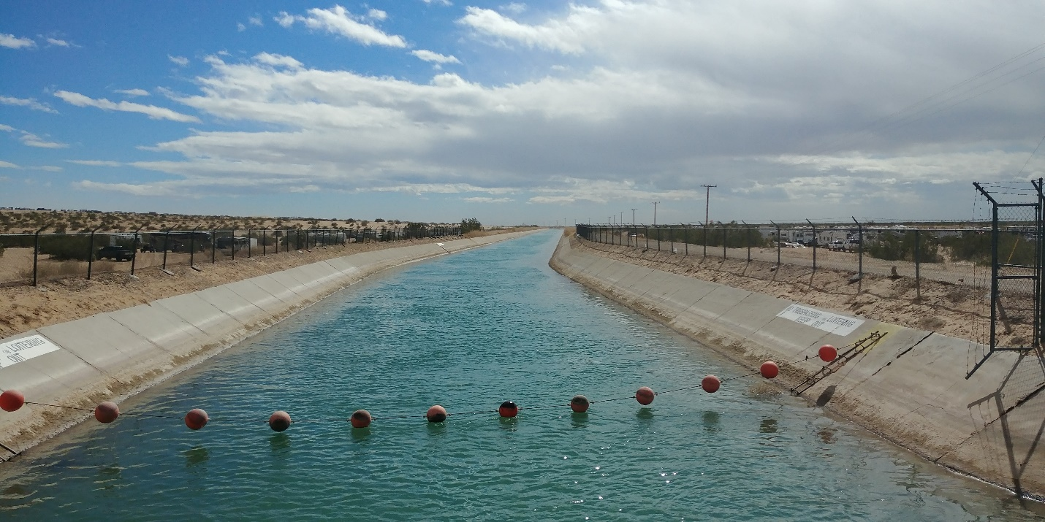
Figure 26. Concrete lined Coachella Canal in 2021, basis for canal cost estimates
Please see Appendix F for specifications, lift, flow, and cost calculations for the Archimedes screw pumps and hydro-turbines suggested for the Water Import canal. This type of pump handles the high flow low head pumping needs of this Project very efficiently and the same is true when configured as a hydro-turbine. These are recommendations at this point, as the water agencies on the U.S. and Mexican side of the border that will own and operate each section of the canal will make equipment selections and design decisions according to their standards and preferences, but it provides a reasonable basis for costing.

Salt Evaporation Ponds
Salt evaporation ponds have been used for thousands of years to convert seawater into dry salt. The use of successive evaporation pond cells also has a long history and very wide use. The proposed application differs only in that brine will be delivered to the evaporation ponds at eight fold higher concentration than seawater and pre-purified by membrane filtration. This eliminates several of the initial evaporation steps, reducing cost, and conserves most of the water. Sea salt pond management and salt harvesting is done on an industrial scale in Baja California. Similar methods can be used on a smaller scale at the Salton Sea.

Vacuum Salt Refining
Salt refining to food and chemical industry grade by precipitation of contaminants and controlled crystallizing evaporation is also well established and practiced at an industrial scale around the world. Established salt refining methods will be applied to a 99% pure sodium chloride brine separated and concentrated from Salton Sea water, similar to the feedstock for other salt refining operations.

Salinity Gradient Solar Ponds
Salinity gradient solar ponds are a natural thermal phenomenon in a few brine lakes around the world. They have been developed as a controlled solar thermal technology since the 1950’s. The largest commercial application was a 5 MW plant built by Ormat at the Dead Sea in Israel. While there is a long research and development history, there have been very few commercial facilities because the cost of electricity produced by solar ponds has not been competitive with electricity produced from fossil fuels. The cost per megawatt is in line with locally produced renewables that have 24/7 availability. Salinity gradient solar ponds offer multiple benefits at the Salton Sea: night and day solar heat for pure water and salt recovery, 24/7 or on demand solar thermal electricity, self-funding playa dust coverage, long term safe storage of thousands of tons of salts and other contaminants extracted from the Salton Sea per pond acre. These benefits make this old technology well suited to local needs. Please see Appendix J for more information on the technology.

VTE-MED Distillation
Vertical Tube Evaporators (VTE) are well established technology for concentration of juices, brine, and other solutions. Use of multi-effect vertical tube evaporators VTE-MED for efficient seawater distillation was well known technology by the 1960s. See Appendix G and H for a more in depth discussion. The application of geothermal steam as heat source to distill hypersaline Salton Sea water is a unique application of the VTE-MED technology that has been demonstrated at a pilot scale on the South shore of the Salton Sea starting in 2006 [2].
The VTE-MED technology proposed for this Water Import Salt Extraction Revenue concept is high temperature, high performance, Multi-Effect Distillation (MED) using Vertical Tube Evaporators (VTE) with a novel scale control method. A system capable of low to zero net liquid discharge to the environment is targeted. Stacking of vertical effects within practical limits is also proposed to reduce capital and pumping costs.
MED is an established thermal desalination technology wherein heat from any available source is introduced to effect 1, typically in the form of heating steam. The heating steam condenses on a heat transfer surface, typically the outside or inside of evaporator tubes, transferring its heat of condensation to saline water on the other side of the heat transfer surface. The saline water evaporates to steam in a mass quantity near equal to the heating steam that condensed in effect 1. To recover heat energy from effect 1, the steam evaporated there is introduced to effect 2, where it condenses on a second heat transfer surface, typically 2°C or more cooler than the steam from effect 1, evaporating a near equal mass of saline water to that evaporated in effect 1. This heat energy recovery process can be repeated in effect 3, 4, etc., adding a mass of evaporated water near equal to that condensed in effect 1 with each successive effect. The temperature of the evaporated water will reduce with each successive effect by about 2°C or more until a minimum temperature is reached sufficiently above the temperature of available cooling water to condense steam from the last effect. The thermal performance is limited by system losses and by the number of effects, which in turn is limited by the temperature range between the heating steam to effect 1 and the cooling water temperature.
By using an effect 1 temperature of 200°C or higher an MED system can employ 60 or more effects with a performance ratio of up to 56 kg of distillate per kg of heating steam or up to 56 lbs of distillate per 1,000 BTU. This very high number of effects has not been employed in any commercial MED system, mostly because high temperatures increase the rate of mineral scaling when evaporating seawater, or many other naturally occurring saline waters, to unacceptable levels. The Project team has developed a Salton Sea water pre-treatment process that will control the mineral scaling at high temperatures. We are also testing novel evaporator tube materials that support the same goal.
Vertical Tube Evaporators (VTE) have been in use for decades for brine concentration and for the concentration of liquids for beverage and industrial applications. VTE systems differ from the Horizontal Tube Evaporators (HTE) typically used for MED systems not only in the vertical versus horizontal orientation of the tubes, but also in that steam is condensed on the outside surfaces of an evaporator tube bundle while saline water is evaporated in the inside. This makes physical cleaning of the saline water contact surfaces inside the tubes practical with hydro-blasting, brushes, or other methods. Mineral scale bridging between adjacent tubes in a bundle is not a problem as it is with HTE systems. Efficient evaporation is accomplished by causing the saline water to flow in a thin annular layer on the inside surface of the evaporator tubes.
The VTE system proposed is a multi-effect falling film evaporator with as many as 60 effects in a forward feed configuration where saline source water is preheated and fed to effect 1 at just under 200°C, getting progressively cooler and more concentrated with each effect down to about 50°C at the last effect. Steam from the last effect (number 60 or higher) is condensed with saline source water at ambient temperature in a standard shell and tube condenser. A concentration factor of 12 or higher is proposed for a distillate recovery of 92% of saline source water from reduced salinity Salton Sea water. A lower concentration factor will be used while the Salton Sea is extremely hypersaline. Please see Appendix H for peer reviewed data on VTE distillation work at the Salton Sea.
A capital cost estimate at just under $50 million for the proposed commercial 60 effect VTE-MED plant with a production capacity of 20 MGD is based on a 4 fold scale up of a plant design and cost estimate made a few years ago for a 15 effect 5 MGD capacity commercial plant designed to use non-commercial geothermal steam at 100°C in the first effect. The 60 effect design uses 12 evaporator stacks in 80ft high cylindrical vacuum/pressure vessels with 5 effects in each stack having multiple bundles of 3” evaporator tubes 10ft long with brine/vapor separation spaces between. The vertical stacked configuration reduces costs for vessels, piping, and brine recycle pumps within reasonable height limits for similar industrial structures. Vessels and interconnecting structures are steel with an inner cladding on 316 stainless steel. Aluminum and copper alloy evaporator and condenser tubes are used for costing, but thermoplastics may be used.
The 60 effect VTE-MED plant is estimated to have a performance ratio of 56 lbs of distillate per 1,000 BTU of heat from steam supplied at 200°C. This is based on performance data from pilot testing of an existing VTE plant with geothermal steam supplied at 100°C in a 15 effect configuration that yielded a performance ratio of 14.0 lbs/1,000 BTU [1]. The heating steam required for effect 1 was estimated at 120,000 lbs/hr for the 15 effect 5 MGD plant. The thermal requirement to effect 1 for 60 similarly sized effects will be the same, equivalent to 29,327 KW_{t} at 200°C. For 20 MGD of production that gives a thermal requirement of 9.3 KWh_{t}/m³.
Amortizing the capital cost over 30 years at 8.3% interest gives a capital cost of 17 cents per m³ of distillate. Estimating the cost of electricity for pumping at an $85/MWh wholesale rate from local geothermal plants, the cost of solar thermal heat at $0.01/KWh_{t}, and the cost of crew, anti-scalants, and supplies gives $7,865,000 in annual O&M costs. Amortized capital cost plus O&M costs over a 20 MGD production at 95% plant availability gives a cost of distilled water of $0.47 per m³.
Any conventional MED system distilling seawater, or most other naturally occurring high salinity source waters, at temperatures close to 200°C or at concentration factors approaching 12 fold would be rapidly impacted by mineral scaling on the heat transfer surfaces. Substantial scale formation would severely reduce net heat transfer across the evaporator tubes causing a major degradation of the MED plant’s thermal efficiency and distillate output capacity.
The planned scale control method is made possible by the recent availability of novel polymer composite evaporator tubes with thermal conductivity similar to metal tubes, but with a very high resistance to scaling, fouling, and corrosion. These evaporator tubes have been developed by Technoform Kunststoffprofile GmbH in Germany. They use a thermally conductive filler of graphite particles and fibers oriented in a special extrusion process to preferentially transfer heat across the tube wall. Heat transfer characteristics of these polymer composite evaporator tubes are similar to stainless steel and titanium, however corrosion resistance is superior and tests show more than 13 fold improvement in resistance to scaling by calcium salts and a 6 fold reduction in scaling by magnesium salts. Recently the company has created polymer composite evaporator tubes rated for use with seawater brine up to 200°C. Installation of these tubes in a VTE-MED system will enable evaporation of seawater and similar brines at first effect temperatures of 200°C for high thermal performance and brine concentration much higher than typical for seawater MED systems enabling distillate recovery to be increased from the typical 50% to 90% or higher with a major reduction in brine discharge.

Salt Separation Process
The salt separation process used to extract 99% pure sodium chloride from the mix of salts and organic materials in the Salton Sea is novel, but it uses ultrafiltration (UF) and nanofiltration (NF) technology and equipment that has been in commercial use for two decades or more. The salt separation process was developed at the Salton Sea in 2009 and 2010 on a pilot scale. See Appendix J Project Feasibility for a discussion of both the VTE-MED and the salt separation process development at the Salton Sea.

Water Source Identification
The water source for Water Import Concepts A and B is the Sea of Cortez on the northwestern shore just north of San Felipe. These are coastal waters of the nation of Mexico. The Mexican Federal government holds and enforces complete rights to regulate the use of this water for commercial fishing, recreation, environmental protection, and any other uses. Nations all over the world hold an inherent right to draw ocean water on their coastline for desalination plants, salt evaporation ponds, marine aquaculture, and other uses, and to grant permission for private entities to use that ocean water under whatever regulatory scheme the nation wishes to impose on its coastal waters.
There is nothing in International law that can prevent the Mexican Government from drawing water from the Sea of Cortez. The Mexican Government will, of course, have to comply with or modify its own laws if there is any impediment within Mexican law.
Neither Sephton Water Technology, Inc. as the concept creator nor any lead private corporation such as a geothermal developer as the implementer would expect or need to obtain a water right to the Sea of Cortez. Instead, the Water Import Salt Extraction Revenue Project will purchase ocean water from the Mexican Government on a per acre foot basis delivered at the border with payment to fully compensate all costs and impacts incurred by the Mexican Government and/or Baja State Government in delivering that water and mitigating any impacts as the nation of Mexico sees fit.
The delivery of ocean water across the border with the U.S. will require a minute amendment to the 1945 Mexico-U.S. water treaty, but that does not involve conveying a water right, just conveying water.
For Water Import Concept C, the water source is the Colorado River. Rights to Colorado River follows a legal system unto its own commonly referred to as “The Law of the River” composed of several historical documents and legal rulings. Generally it follows a ‘first in time, first in line’ priority scheme wherein the first entity to put the water to “beneficial use” has the senior right. In some cases history therefore puts certain Native American tribes first in line.
A Congressional Research Service report noted in August 2021 that 22 Native American tribes have rights to Colorado River water quantified at 2.9 MAFY, but were only using a little over half of their allocation in 2015 [6]. See Appendix M in this proposal for a summary of the report that describes the tribal allocations. Agreements will be needed to buy allocated, but unused Colorado River water from these tribes. That could make it possible to buy enough water to restore and sustain the elevation of the Salton Sea. Tribe to tribe water transfers and sales are allowed. Legal challenges may be made by other water rights holders on the River. There may be public or government water agency opposition with the Colorado River in a long term structural drought. While environmental restoration is a beneficial use under California law, is not under the Federal “Law of the River”.

Land Use

Project Canal Route Alignment and Land Use Status, Concept A
For Water Import Concept A, The seawater intake proposed is on the grounds of an abandoned salt works adjacent to and just north of a still active salt works as shown in Figure 27. The location is a few miles north of San Felipe. One of the Project team members had a long discussion with the owner of the salt works over glasses of very smooth tequila and later visited the active salt works, see Figure 28. The land is about 13 feet above mean sea level with high tides that often reach that elevation. The abandoned salt works was apparently fed by a tidal estuary just to the north, Figure 27.
The concept is to dig down and build up three redundant tidal receiving ponds (Figure 29) that will fill through intake pipes transiting the bottom of the northern berm on each pond when the tide is rising, Figure 30. Bar grates in the intake pipes will prevent adult fish or porpoises from swimming in to the ponds during a rising tide. When the tide ebbs, tidal gates on the inlet pipes will close holding the high tide within the ponds. One pond at a time will be allowed to drain through a meter thick bed of fine sand with gravel below then flow out gated pipes on the south side of the pond to a filtrate collection pond. The permeability and thickness of the sand is designed to work with the hydraulic head of a high tide to let a pond drain in roughly the 12 hours between tides. Before a pond drains down to the sand surface level, outlet gates will be closed and a marine life return channel back to the adjacent Sea of Cortez will be opened. The sand filtered seawater will be collected in the filtrate collection pond (Figure 29 left pond) and then pumped up out of the pond and into the seawater canal (Figure 31) to flow north parallel to Highway 5 toward Laguna Salada.
The canal route north between Highway 5 and the Sea of Cortez shoreline (Figure 31) is about 10 feet above mean sea level. Several pump stations with a 10 foot lift will employed to sustain flow north to the point where the Coyote Canal crosses Highway 5. There the seawater canal will turn west and follow the course of the Coyote Canal.
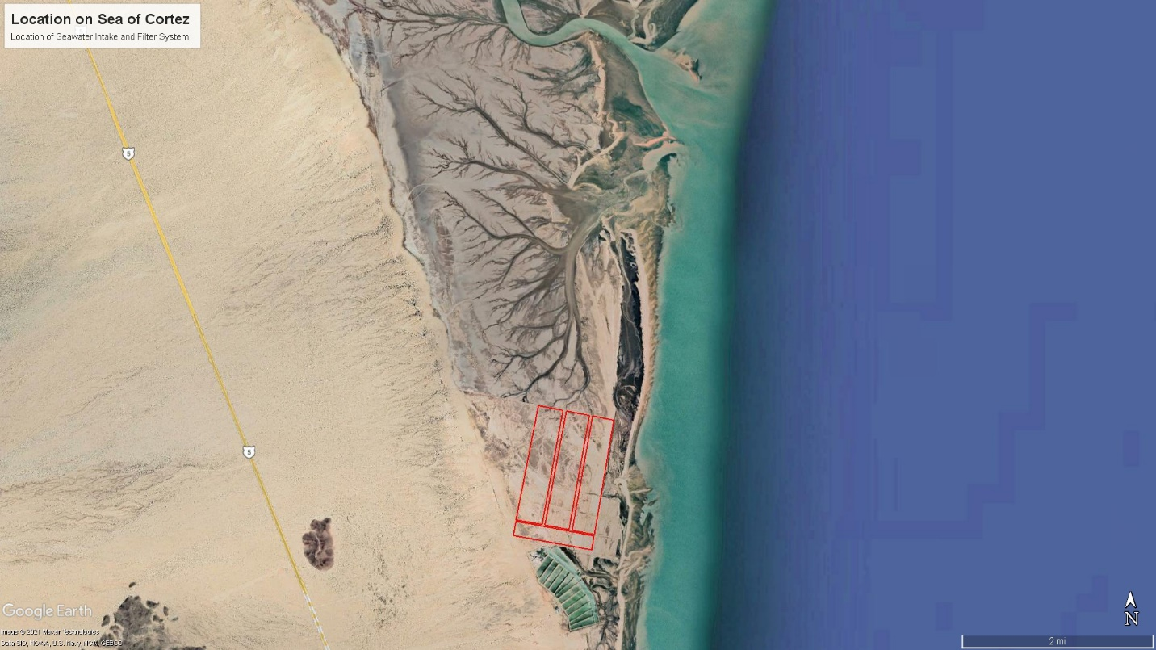
Figure 27. Location of Proposed Seawater Intake and Slow Sand Filter System next to a salt works
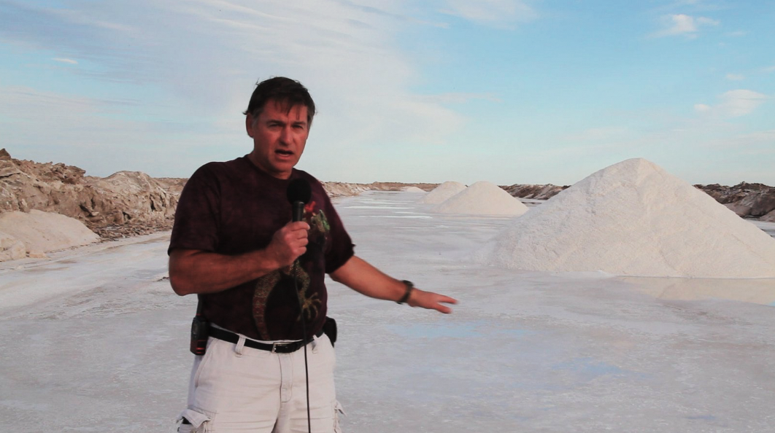
Figure 28. The Active Salt Works Just South of the Proposed Seawater Intake
Figure 29. Plan View of the Proposed Tidal Sand Filter Seawater Intake
Figure 30. Closer Views of the Proposed Tidal Sand Filter Seawater Intake
The seawater will flow in a marine concrete lined canal from the intake north to the east of Highway 5 as shown in Figure 31 to a refurbished Coyote Canal then pass under Highway 5 through existing channels under existing bridges. A series of flow regulating reservoirs would be needed west of Highway 5 with tidal gates to convert the intermittent tidal flow to a sustained flow through the western section of the Coyote Canal and down into Laguna Salada. The section of the Coyote Canal from a half mile west of Highway 5 into the south end of Laguna Salada is in fair condition and is of sufficient capacity to carry the required continuous flow. It will need to be cleared of vegetation at the bottom and may need to be lined if salt water intrusion into the already salt laden ground or seepage loss is considered to be of concern.
The ocean water will be brought to the main section of the Coyote Canal west of Highway 5 by pumped canals from the San Felipe area outside the Biosphere Reserve. Ocean water will flow through a refurbished Coyote Canal by gravity west and then north into Laguna Salada.
The large central section of Laguna Salada is below sea level and extends to 5 ½ miles south of the Mexico-U.S. border. Decades ago it was filled with seawater from occasional extreme high tides until an elevated section of Highway 5 was built across the south end connection with the Sea of Cortez. Barnacle shells are still visible on the rocks of the eastern edge at sea level. It has periodically flooded with fresh, brackish, and saline water since then from flood diversions, some tidal flows, and rain from the surrounding mountains. Currently, central Laguna Salada is a dry playa, mostly flat, with very little vegetation and little or no human habitation. The western side, above sea level, has a military base, an abandoned olive plantation, and several ejidos that engage in farming and sheep ranching supplied by a few sweet water wells on the east side.
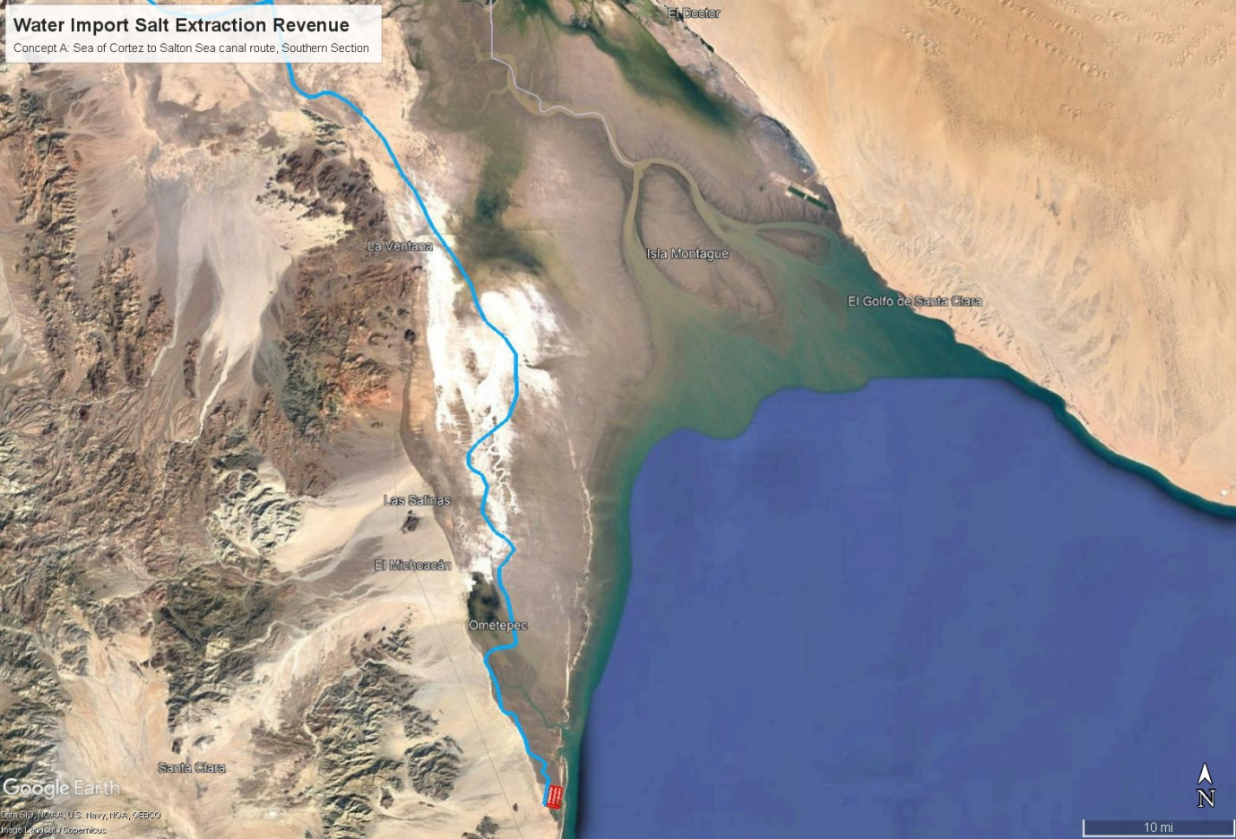
Figure 31. Concept A and B, Canal Route North from the Seawater Intake to Laguna Salada
There is a rustic hot spring resort in the mountains on the west side fed by a moderate temperature geothermal resource that extends across Laguna Salada from the Sierra de Juarez on the west to the Sierra de los Cucapah on the deserted east side. The eastern half of Laguna Salada is owned by the Native American Cucapah Community based at El Major on the Rio Hardy. The land was deeded by the Mexican Government in compensation for more developed lands taken in the past. The Cucapah are fishermen by tradition and previously fished their Laguna Salada territory when it was wet, but have no economic activity or residents there now that it is dry.
The lowest cost way to convey ocean water from south to north through Laguna Salada would be to simply flood the ephemeral lake from the Coyote Canal at the south and pick up the saltwater at the north to pump across the border. This would have the benefit of creating a large saline water habitat that could replace a substantial portion of the fish and migratory bird habitat value now being lost at the Salton Sea and could provide recreational lake benefits to the million plus residents in the nearby city of Mexicali. This approach was welcomed by some local officials and residents in Mexico, but was opposed in a meeting with officials at ConAgua, who see the several decades of brackish groundwater collected under Laguna Salada as a potential future water resource. To get around this issue, a concrete lined canal is proposed along the sea level contour at either the eastern or western edge of Laguna Salada with enough drop toward the below sea level center to ensure sufficient flow and 10 foot lift pump stations at several locations. The canal route distance along the eastern edge is 26 miles and is all on undeveloped Cucapah land up to the northern terminus, Figure 32. An alternative canal route on the western edge crosses undeveloped land owned by several ejidos with a similar route length.
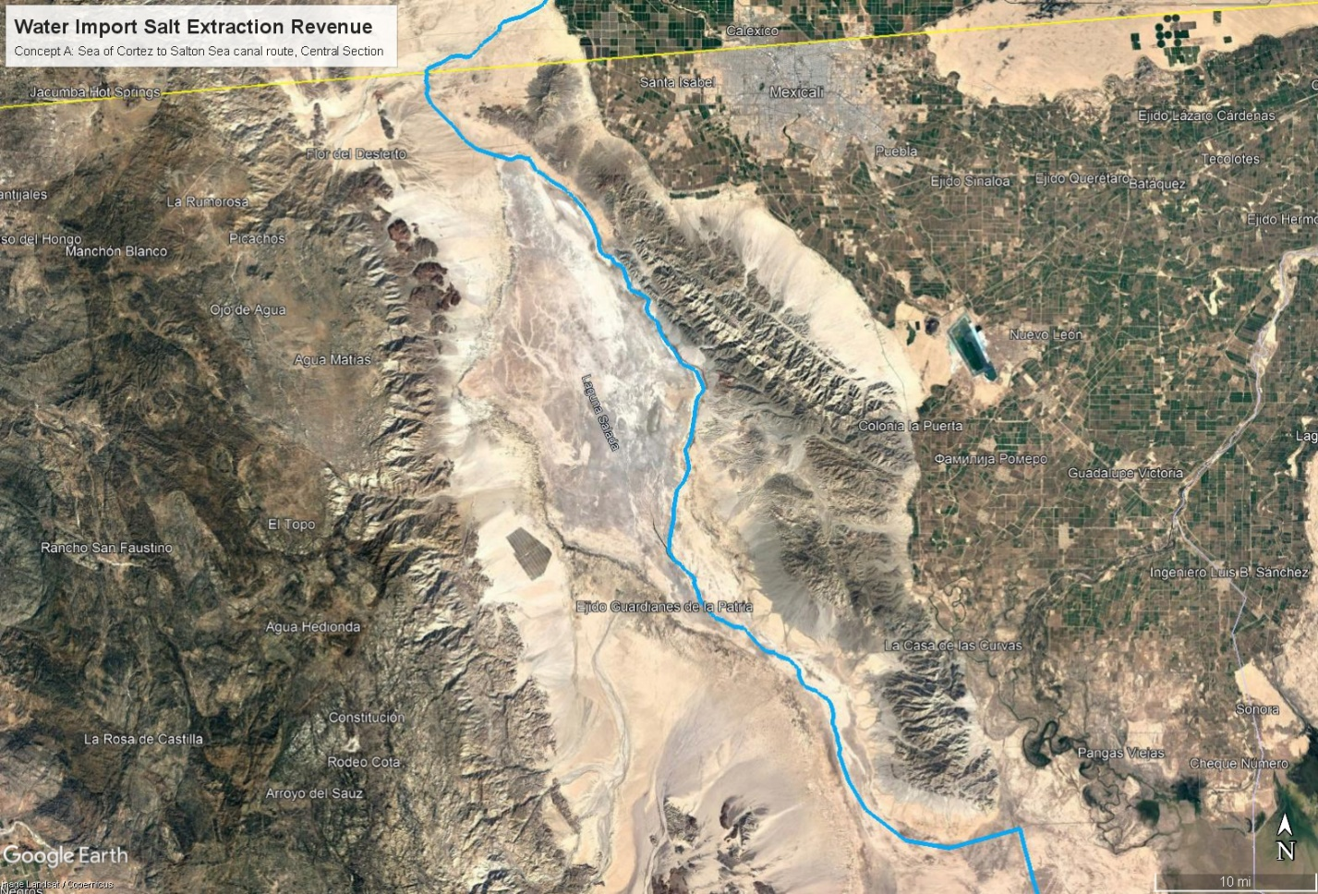
Figure 32. Concept A, Canal Route through Laguna Salada’s east side to the U.S. border
Either the proposed eastern, or a western route, Laguna Salada canal would terminate at the same point on Mexican Federal land just south of Mexican Federal Highway 2D that runs from the outskirts of Mexicali to Tijuana about 5 ½ miles south of the border with the U.S. It will be up to officials in Mexico to choose the conveyance route that best meets the interests of Federal and State governments and the local landowners consisting of half a dozen ejidos, the Cucapah Community, and the Mexican Federal Government itself. With either Laguna Salada canal option, a flow regulating reservoir would be useful at the north end of Laguna Salada before the ocean water is pumped over a ridge, then down across the border. Depending on the size and construction, this reservoir could provide some marine recreational benefits near Highway 2D within a half hour drive from Mexicali.
From the north end of Laguna Salada ocean water will need to be pumped over either a 305 foot above sea level rise in the saddle west of signal mountain or over a 195 foot above sea level pass in the ridge just south of the pass that carries Mexican Federal Highway 2D to the southeast of Signal Mountain. It will be up to a public water agency in Mexico to choose the route, select the equipment, and execute the design, construction, and operation of the pumping and conveyance infrastructure in Mexico. For Concept A, this Project is costing the route west of Signal Mountain due to concerns raised by agricultural officials in Mexico about routing a seawater canal near the highly developed northern part of the Mexicali Valley.
The route to the border west of Signal Mountain (Figure 32) is a long gentle upward slope through 6 ½ miles of mostly sandy soils from sea level up to the apex of the saddle at 305 feet above sea level, then down 1 ¼ miles to the Mexico-U.S. border in the Yuha Desert at 262 feet above sea level. The conveyance will have to cross under Mexican Federal Highway 2 with a siphon and under or over the buried freshwater pipeline supplying water from Mexicali to Tijuana. A series of Archimedes screw pumps at 25 rises of 12 to 14 foot each with graded canal connections between are recommended and estimated based on good 85% mechanical efficiency, low maintenance, long pump life of 20-40 years, and documented minimal impact on fish for the Archimedes screws and support infrastructure. These pumps are well suited to the gentle upward slope. A similar scheme can be used on the downward slope to the border with three Archimedes screw turbines and lined canals between each drop to recover some of the pumping energy on the Mexican side of the border.
The canal route on the U.S. side of the border (Figure 33) will pick up on the west side of Signal Mountain. From there the route will descend into the Yuha Desert south of Interstate Route 8 east of Plaster City. The canal will have to under-cross State Route 98 and Interstate Route 8 with siphons. From there it will flow north and east staying west of the IID’s West Main Canal by a wide margin to avoid the risk of any spillover. The canal will flow generally north until it nears the Salton Sea near Kane Spring. Nearly all of this route is BLM managed land. The canal will undercrosss State Route 86 at San Filipe Creek, a dry wash except after heavy rain, and flow next to that channel between private farmland into the Salton Sea.
The outflow to the Salton Sea will fan out over a portion of the San Felipe Creek delta with a series of lateral spreading channels that overflow and step down to the Salton Sea. The Salton Sea elevation will rise many feet within a few years of starting seawater inflow, so a low cost sacrificial outflow will be employed. The lateral spreading channels will step down to the Salton Sea shoreline flowing over from one to the next. They will be lined with a layer of polyethylene pond liner sheet covered by a thin layer of gravel, then by rocks or rip rap. This will facilitate aeration of the seawater inflow, which will be helpful to organisms in the sometimes low dissolved oxygen Salton Sea water. See Appendix Q for dimensions and costing of the sacrificial outflow. Some of the flow may be diverted to support the New River West saline habitat complex (SCH West) six miles south with seawater in place of extremely hypersaline water pumped up from the Salton Sea by channeling with a floating salinity curtain along the shore.

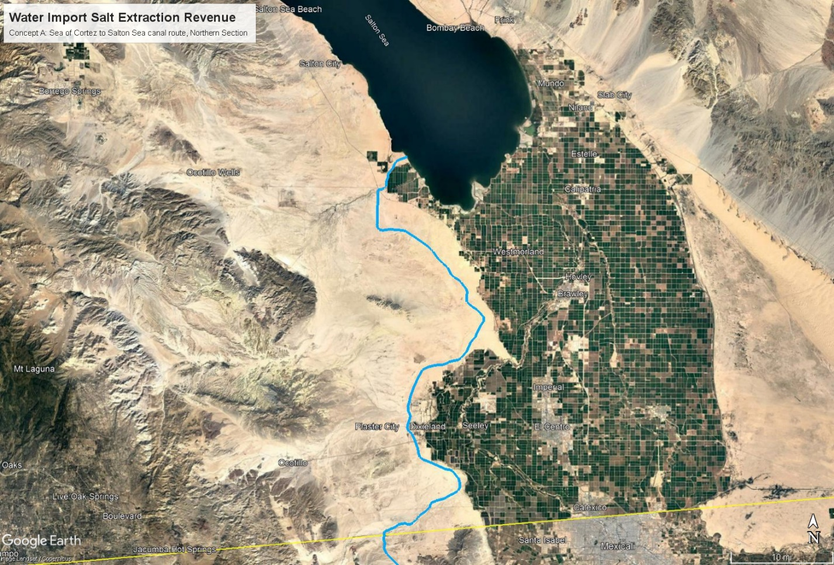
Figure 33. Concept A, Canal Route from U.S. border to the Salton Sea at San Felipe Creek

Project Canal Route Alignment and Land Use Status, Concept B
For Water Import Concept B, The seawater intake and canal route to the South end of Laguna Salada at the point where the Coyote Canal crosses Highway 5 will be identical to that described above for Water Import Concept A. However, for Water Import Concept B, the seawater canal will cross under the Coyote Canal by siphon, then continue north into the Southern Mexicali Valley. The seawater canal route will follow the eastern base of the Cucapah Mountain Range along a gently rising elevation staying mostly west of the Rio Hardy, see Figure 34. As it flows north into the Mexicali Valley, the seawater canal (Figure 35, darker blue line) will skirt the western edge of the farmed areas staying west of the irrigation canals that supply them until it nears Cerro Prieto in the central Mexicali Valley, where it will turn east skirting farmed areas and flow into the Cerro Prieto geothermal field. There it will split flow into smaller canals to supply sand filtered seawater to each of the three existing geothermal power plants at Cerro Prieto, or to new geothermal power plants built by CFE to supply the Project with steam and power. The elevation at Cerro Prieto is about 40 feet above mean sea level and is the high point in a saddle in the central Mexicali Valley. A few pump lift stations will be needed to get seawater up to the geothermal plants at Cerro Prieto. Flow north from Cerro Prieto is downhill all the way to the Salton Sea.

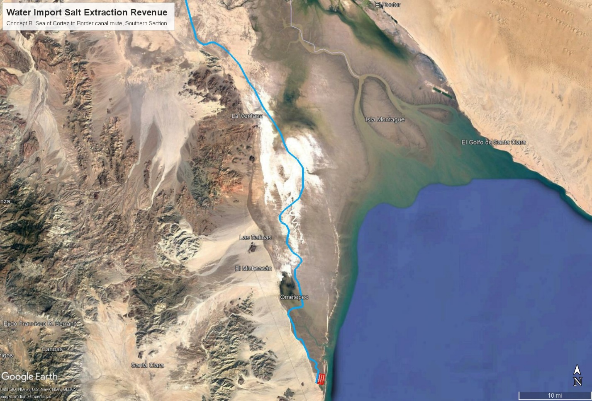
Figure 34. Concept B, Seawater Canal Route from Intake to Southern Mexicali Valley
Under Water Import Concept B, the seawater delivered to the Cerro Prieto geothermal power plants will be further filtered, pre-treated by the UF/NF membrane process shown in Figure 7 to separate divalent ions, then purified water and salt will be separated by a high efficiency thermal VTE-MED process driven by geothermal steam bought from CFE. The products will be pure distilled water, purified salt, and a small volume of concentrated mixed salt brine that will be delivered to salt gradient solar ponds built in the Cerro Prieto area to generate more renewable energy. The VTE-MED plants located adjacent to the CFE geothermal plants will convert 500,000 AFY of the seawater to distilled water that will be re-mineralized at the plants by slaked lime percolation to produce potable water. The potable water will flow from each VTE-MED plant by canal to three points of delivery on the Mexican side of the U.S. border. The western delivery point will be the Acueducto Rio Colorado Tijuana water treatment and pumping facility immediately south of the U.S. border at the western edge of the City of Mexicali fed by a 32 mile potable water canal that will skirt the western edge of the developed area of the northern Mexicali Valley (Figure 35) mostly paralleling existing canal routes. The water treatment and pumping facility is operated by the Baja State Water Commission and is the starting point of a pipeline that sends pumped Colorado River water over the mountains west to Tijuana. Any extra potable water, in addition to the 500,000 AFY needed for the Salton Sea, produced by the VTE-MED plants at Cerro Prieto can be delivered to the potable water system in Mexicali from there.
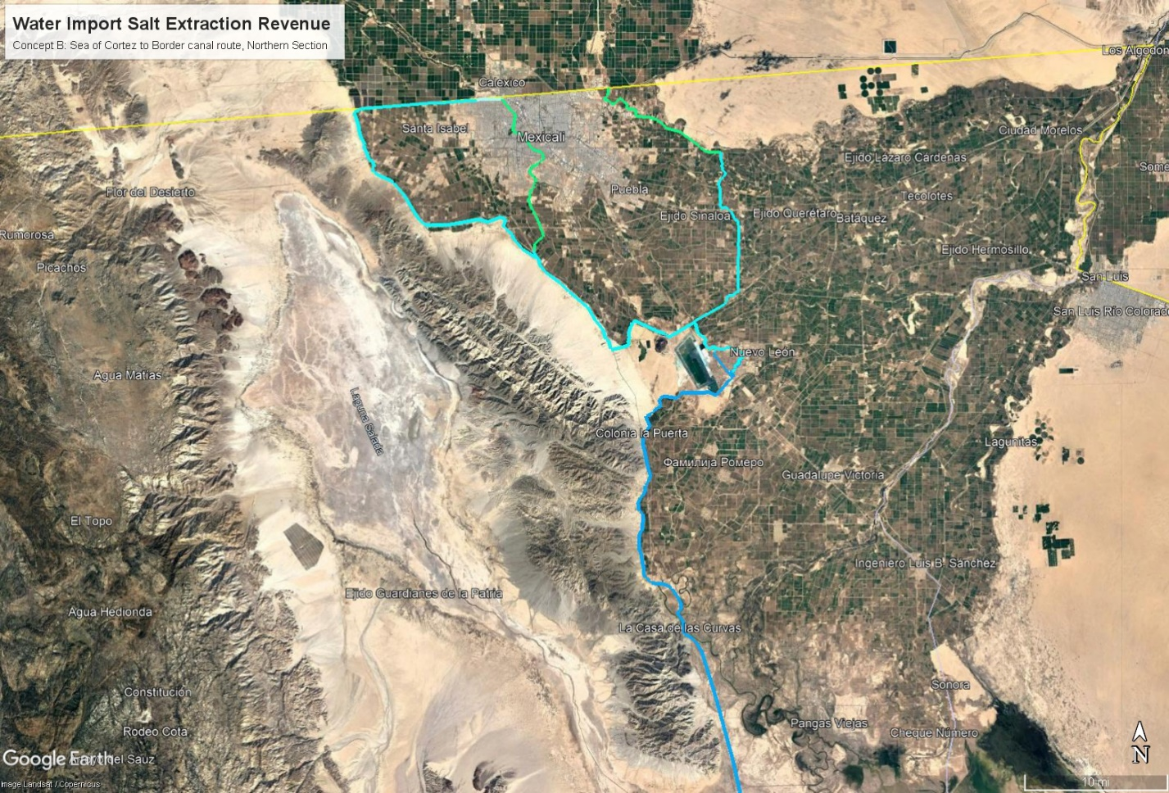
Figure 35. Concept B, Seawater Canal Route to Cerro Prieto Geothermal, Freshwater Routes to Border
An existing channel runs just south of the U.S. border east from the Baja State Water Commission pumping plant to a point very close to the New River in Mexicali. This channel could be used to deliver potable water to the New River through the channel then from Fronteriza via a 2 mile culvert under the street Aguascalientes and into the New River just south of the Calexico West Port of Entry, where it will flow across the border.
The headwaters of the New River is a natural flow from a lake near Cerro Prieto. A second portion of the annual 500,000 AFY of potable water from the VTE-MED plants will flow from Cerro Prieto along existing canals and into the headwaters of the New River, then continue north to the outskirts of Mexicali. Through the City of Mexicali, the New River flows in existing culverts under the key Mexicali roadway Boulevard Rio Nuevo to the border crossing. A portion of the potable water will join the flow and cross into the U.S. with the New River Border Crossing (photo Figure 36), then down to the Salton Sea replacing agricultural drain flows lost to the QSA water transfers with better quality water and diluting the high level of pollutants in the current New River cross border flow.
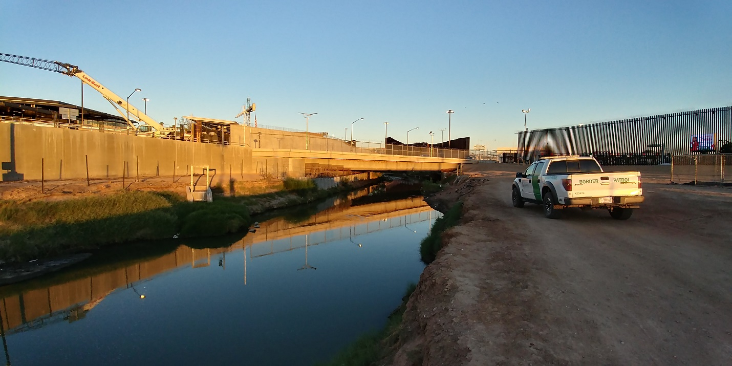
Figure 36. Concept B, New River as it Crosses the Border on the U.S Side
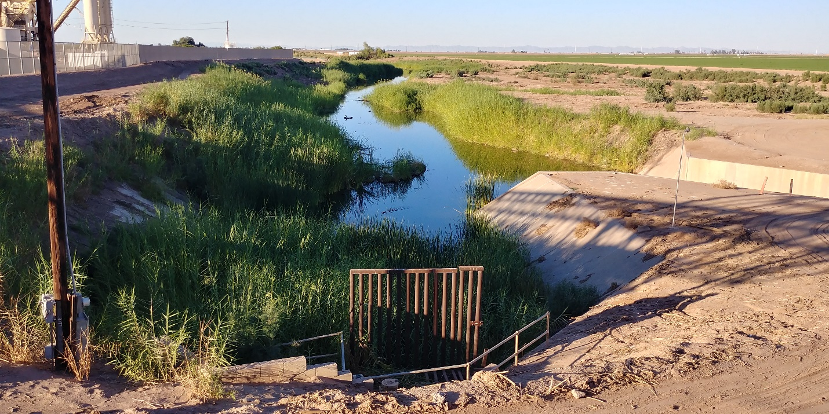
Figure 37. Concept B, Alamo River as it Crosses the Border on the U.S Side
To balance the flows within the capacity of existing New and Alamo River channels, a third portion of the annual 500,000 AFY of potable water from the VTE-MED plants will be pumped up a roughly 10 foot rise in elevation from Cerro Prieto north and east in a new potable water canal built along the right of way of existing irrigation canals. At roughly the halfway point the potable water will be blended with Colorado River water in existing canals, then flow downhill to join the headwaters of the Alamo River near San Augustine. From there the blended Alamo River and potable water will flow across the border in an existing channel under the All American Canal one mile east of the Calexico East Border Station (see photo Figure 37). Some potable water in excess of the annual 500 KAFY for the Salton Sea may be drawn from this canal to serve local needs on the East side of Mexicali.

Project Canal Route Alignment and Land Use Status, Concept C
For Water Import Concept C, only existing canals, dams, and waterways are needed. These are all publicly owned. The Colorado River and dam system is operated by the U.S. Bureau of Reclamation. The All American Canal from Imperial dam is Federally owned, but is operated by the Imperial Irrigation District (IID). The irrigation and drain canal system that flows down from the All American Canal to the Salton Sea is owned and operated by IID as a public trust. The Coachella Canal is operated by the Coachella Valley Water District (CVWD). All of these waterways may be needed. Water wheeling fees may be charged by the IID and by the CVWD.

Environmental Impact
The Water Import Salt Extraction Revenue project will avoid impacts to existing surface waters other than the Salton Sea by using a lined canal, or piped sections, that does not discharge to any surface waters until reaching the Salton Sea. The impact on the Salton Sea will of course be very significant, but beneficial to wildlife and humans by driving down salinity and raising the level.
The use of a lined canal for virtually the full route will largely eliminate impacts on groundwater basins. There could be temporary leaks in the event of major earthquakes, but flow can be cut off until the damage is repaired.
Birds can be expected to alight in the canal. Fencing will be used to keep large terrestrial animals out. Shallow slope diagonal escape ramps can help animals or humans that do fall in to exit. In sensitive areas like the Yuha Desert, sections of the canal can be covered and graded with natural materials as bridges to prevent terrestrial animal populations from being cut off. Depending on the intake type, fish may colonize the canal. If so, the use of Archimedes screw pumps and turbines with soft leading edges will prevent injury to fish. The one way screws will also block non-native Salton Sea species from swimming up the canals to the Sea of Cortez.
A variety of fish inhabit the tidal estuary and shoreline of the northern Sea of Cortez. The region is the only habitat for the endangered vaquita porpoise and a spawning area and maturation habitat for the totoaba fish. Adults will be blocked from entering the canal by grates on the tidal inflow gates. It is possible that some juveniles could swim into the sand filtration ponds. The infrastructure proposed would be unlikely to harm them and they would be able to return the Sea of Cortez by the marine life return channel. Any other impacts to the Alto Golfo de California Biosphere Preserve deemed by Mexican authorities and environmental groups to be significant will be mitigated.

Salton Sea Salinity
The Water Import Salt Extraction Revenue Project Concept A will remove the salts carried in by ocean water import by drawing hypersaline water from the Salton Sea. An inflow of 900 KAFY of water from the Sea of Cortez at a high side estimate 3.58% TDS by weight and a specific gravity of 1.025 at 20°C will carry an annual salt load of roughly 20 million metric tons each year. Clearly, that’s a lot of salt. How that impacts the actual salinity in the Salton Sea is influenced by several factors including other salt bearing inflows and changes in volume from the water inflow and evaporation balance. These factors are described in the water & salt balance equations in Appendix A and calculated in the spreadsheets in Appendix B. The Project will extract all of that salt load over time to return the Salton Sea to a balanced salinity.

Figure 38. Annual Extraction of Salt from the Salton Sea, Concept A
The strategy to manage salinity in the Salton Sea involves initial dilution of the hypersaline Salton Sea of 2030 with ocean water combined with phased installation of a suite of five types of facilities engaged in salt extraction, purification, and storage as described in the Concept Narrative in Section 2. The Concept A annual salt extraction is shown in Figure 38. The effect of this schedule of salt extraction is illustrated in Figure 14. The salinity of the Salton Sea is driven down by the salt extraction for revenue facilities, returning to a level where desert pupfish can thrive by about 2040 and to a level where tilapia can thrive by about 2050 assuming ocean water import can start in 2035.

All salts extracted go either to salt purification for shipment and sale, or to storage and use in salinity gradient solar ponds on the exposed playa and/or nearby barren upland areas. There is zero brine discharge to the environment from the process proposed. The VTE-MED technology used is capable of very high distilled water recovery rates with very low brine volume compared to other desalination technologies. The salinity gradient solar ponds, and possibly other future brine to energy technologies, benefit from the relatively small volume of brine at near saturated concentration, making brine a valued product, not a waste product.

Water Use
The water balance impacts of the Water Import Salt Extraction Revenue concept on the Salton Sea are illustrated in Figure 39. Ocean water import is shown in the light green plot starting in 2035 and continuing at 500 KAFY throughout the QSA water transfer time period to 2077. Consumptive use by all Salt Extraction Revenue facilities combined is shown in the light blue plot. Evaporation loss from the Salton Sea as a whole is shown in red. The net positive or negative impact on the volume of the Salton Sea is shown in the yellow plot. The start of water import has a dramatic effect on the Salton Sea’s volume, but this is moderated year by year by rising consumptive use until a rough balance is achieved around 2045. Moderate fluctuations continue. Evaporation loss remains the main outflow from the Salton Sea.
Figure 39. Salton Sea Water Balance with Import and Salt Extraction, Concept A
There is a serious risk of further reductions to brackish inflows to the Salton Sea over and above those predicted by full implementation of the QSA water transfers. One likely cause will be the further implementation of the Drought Contingency Plan (DCP), under River Agencies may hold back water from use to build elevation in Lake Mead. The amount of these elevation building hold backs and the schedule under which they may or may not be implemented is hard to prdict at this point. Absent Water Import, these measures could have a dramatic impact on the Salton Sea.

Cross Border Governmental Coordination and Permitting

Cross Border Negotiations Needed
At the high level, the Water Import aspects of the proposed concept will require approval from the President of Mexico to move ahead with negotiations, designs, and cross border contracts. On the U.S. side that will involve, at a minimum, involvement from the Department of State will be needed to set up a negotiation of the basic concept of bringing seawater across the border between the executive branches of government in Mexico and the U.S. If general, non-specific agreement can be achieved at the Federal executive level, the details of a new Minute, or amendment, to the 1945 Mexico-U.S. treaty controlling border water issues would be negotiated between the U.S. Section and the Mexican Section of the International Boundary and Water Commission to allow ocean water across the border. There was a precedent for this set originally in Minute 319 to allow desalinated water from Mexico into the U.S. There was a subsequent agreement negotiated for a Mexican desalination plant to sell water to the City of Chula Vista. Raw ocean water is not desalinated ocean water, but the precedent is relevant, water sourced from the coast of Mexico can be sold across the border to a U.S. entity under the amended treaty.
When the ocean water import concept can be allowed in a new Minute to the 1945 Treaty, then specific negotiations with the Government of Baja State and the City of Mexicali about specific route options can get underway to balance the concerns of various land owners and interests locally. It will be up to the Mexican Federal Government to determine what agency in Mexico will take primary responsibility for the project development there, probably either ConAgua or the Baja State Water Commission. Once that selection is made, then the Project private entities can engage in specific price and canal route negotiations with the selected agency in Mexico.
A similar determination will need to be made whether the State of California through the Department of Water Resources or the U.S. Federal Government through the Bureau of Reclamation will take responsibility for the design, permitting, build, and operation of the conveyance infrastructure from the border to the Salton Sea. Once that selection is made, the Project private entities can start specific price and canal route negotiations with the selected agency in the U.S. The water agency selected in the U.S. will need to negotiate directly with the agency in Mexico over details of the physical border crossing infrastructure and access. The U.S. Department of Homeland Security will undoubtedly require oversite of the border crossing planning. This may be physically more complicated if a siphon needs to be built under the Great Wall of Trump, should that be in place by 2025 or thereabouts.

Mexico Side Permits and Rights of Way
It will be the responsibility of the selected government agency in Mexico to negotiate right of way agreements with affected landowners. Some of the landowners that may need to be negotiated with include the Cucapah Community in El Major if the east side of Laguna Salada is impacted plus at least two ejidos. If the west of Laguna Salada is impacted, then there are half a dozen ejidos to negotiate with. At least two Federal highways, 2D and 5, will be crossed and at least one Baja State pipeline right of way.
The required permits in Mexico will be the responsibility of the chosen managing agency in Mexico to obtain.

U.S. Side Permits Required
Conveyance impacts will be handled by environmental documents drafted by the U.S. side water agency and permits applied for by that agency.
The Water Import Salt Extraction Revenue Project will be responsible for obtaining permits for the Salt Extraction and Revenue plants and infrastructure and playa coverage ponds. The company will have to work through a Federal agency for NEPA and through a State agency for CEQA.
The environmental documentation required in the USA is expected to include:
- CEQA Environmental Impact Report, preferably to cover the whole Project, not separate plant by plant reports. The State, the Salton Sea Authority, Imperial County, or IID are possible lead agencies.
- NEPA Environmental Impact Statement, preferably to cover the whole Project. The Bureau of Reclamation would be a logical agency to file.
The required permits on the U.S. side of the border are expected to include:
- California Department of Fish and Wildlife and Colorado River Basin Regional Water Quality Control Board (RWQCB) permits for seawater intakes incorporating fish screens and minimum depth restrictions to avoid take of desert pupfish, if any survive in the Salton Sea by then.
- Discharge of waste water to any public waterway is not expected to occur, but an NPDES permit may be required.
- California Department of Fish and Game Section 1602 notification and permit for any ponds or facilities on the playa.
- Army Corps of Engineers Section 404 permit for any ponds or facilities on the playa.
- RWQCB Section 401 permit for any ponds or facilities on the playa.
- Imperial County Conditional Use Permit for any construction in the County jurisdiction.
- Imperial County Building Permit for any construction in the County jurisdiction.
- Imperial County Grading Permit for any dirt construction in the County jurisdiction.
- Imperial County Air Pollution Control District permits for dust control and diesel equipment during construction.
- Imperial County Public Works Department Encroachment Permit for any pipeline or cables that cross a County road.
- Imperial Irrigation District (IID) Encroachment Permit for any pipeline or cables that cross an IID canal, power line, or other right of way.
- Permit with CalTrans to cross under Highways 98 and 86.
- Federal permit to cross under Interstate 8.

Project Development Schedule
The project development schedule is included in the Annual Cost & Revenue spreadsheets in Appendix D from 2025 through 2035.

Project Operation Schedule
The project operation schedule is included in the Annual Cost & Revenue spreadsheets in Appendix D from 2025 through 2077.

Cost Projection
The total annual capital and operating costs are summarized in Figure 20. The detailed cost projection is in the spreadsheets of Appendix D with annual capital and operating cost amounts for each facility type and in total in the Annual Cost & Revenue tab and supporting documents in the later tabs.
The construction of the canal and pipeline conveyance and hydro-turbine infrastructure is expected be under the design and contracting control of either the U.S. Bureau of Reclamation or the California Department of Water Resources on the U.S. side of the border. All design, procurement, and contracting will be under agency control so a detailed line item cost projection cannot be made by Sephton Water Technology. The cost can be realistically estimated by using actual cost on a very similar project executed by that agency.
As a basis for estimating the cost of constructing the water import conveyance infrastructure, the 2006 construction of the lined section of the Coachella Canal. This was a 35 mile section of a concrete lined canal constructed in a very similar, and close by, desert environment. The design capacity of that section of the Coachella Canal was 1,300 CFS equivalent to 941,157 AFY, slightly higher than the 900,000 AFY specified for this proposed Water Import concept after allowing for evaporation losses along the 150 mile length of the canal. This section of the Coachella Canal includes 25 siphons under wide dry washes similar to and greater in number than the six to eight siphon under-crossings needed by this project. The 2006 Coachella canal lining project was a public agency cooperation between the U.S. Bureau of Reclamation and the Coachella Valley Water District with funding support from the San Diego County Water Authority. It was completed on time at a cost of about $119.7 million. Dividing by the length and adjusting for inflation from 2006 to 2018 that gives a current per mile construction cost of $4.3 million per mile. Applying this cost per mile for a lined canal of similar capacity and through similar terrain to each section of the Water Import canals proposed under this concept gives a reasonable basis to estimate the cost of construction in the U.S. The canal construction estimate in the U.S. for this concept comes to $178 million for a 41.6 mile canal.
The construction of the canal and pipeline conveyance and pumping infrastructure is expected be under the design and contracting control of a Mexican Government entity in Mexico, either ConAgua or the Baja State Water Commission, so costing will be under their control. Labor costs in Mexico should be cheaper. The cost of equipment, fuel, and supplies should be similar. Parts of the canal construction sites in Mexico are more remote than in the U.S. and will have mud in places. The per mile canal construction costs are assumed to be about the same on both sides of the border for the purpose of arriving at an estimate of what to offer Mexico per acre foot of water delivered. The canal construction estimate in Mexico comes to $385 million.
See Appendix E for the derivation of costs by each section of lined canal from the Sea of Cortez to the Salton Sea. The Coachella Canal is all gravity driven, so these costs do not include pumping and hydro-turbine infrastructure specified under this Water Import concept. A derivation of costs for the pumping and hydro-turbine infrastructure is included in Appendix F along with calculations of the power requirement for pumping over the high points either west or southeast of Signal Mountain and calculations of the maximum power that can be recovered from the drop down to the Salton Sea for each route option. The estimated capital cost for pumps, hydro-turbine generators, transmission, and support infrastructure came to $270 million. That gives a total construction cost estimate on both side of the border of $833 million.
The basis for a $60 per acre foot delivered water purchase price estimate for the managing agency in Mexico and for a $45 per acre foot conveyed payment to the managing agency in the U.S. is shown in Appendix E after adding a rough estimate of operation and maintenance costs and an estimate of the cost to finance the capital with 30 year public bonds divided by the annual delivery of 900 KAFY.

Plan for Funding of Proposed Project
The Water Import Salt Extraction Revenue Project will sell stock to raise funds for project planning. The more costly design, permitting, and construction work, and early operations will be funded with loans from banks and other financial institutions and/or from private investors. Revenues from the sale of power, salt, water, and any other products will be used to pay off the loans and construction bonds needed to design, permit, construct and operate the salt extraction, salt purification, water treatment, brine to energy, and playa covering infrastructure at the Salton Sea. These borrowed funds plus revenues will also be used to purchase ocean water from Mexico on a per acre foot delivered basis and to pay for the conveyance of that water to the Salton Sea to complete a restoration.

The early planning phase of the project will be funded by equity investment in the Water Import Salt Extraction Revenue Project. Late planning and engineering design phases of the project will be funded from loans raised for the design, permitting, construction, and early operation phases.
The Water Import Salt Extraction Revenue Project will be responsible for the operation and maintenance of all plant and equipment, pipes, pumps, electrical generation, buildings, vehicles, tools, and personnel directly related to salt and saltwater extraction from the Salton Sea, salt purification, distillation, salt evaporation ponds, salinity gradient solar ponds, and related infrastructure that deals with water and salt drawn from the Salton Sea. The O&M budget varies substantially from year to year as water and salt treatment facilities are commissioned or decommissioned. The project O&M costs by facility type and in total are included in the Annual Cost & Revenue tab of the spreadsheet in Appendix D from 2020 through 2077.
The Mexican Government will select a government entity responsible for the operation and maintenance of the intake, canal, pipeline, pumping, flow regulating, power transmission, and supporting infrastructure needed for all project related ocean water intake and conveyance infrastructure in Mexico. ConAgua and/or the Baja State Water Commission are the likely entities to be selected. The annual O&M cost is estimated at $21,800,000 with all, or nearly all of the power requirements for pumping across the border be supplied at no cost from hydro-turbine generation on the U.S. side of the conveyance system.
Either the U.S. Bureau of Reclamation or the California Department of Water Resources will be responsible for the operation and maintenance of the canal, pipeline, flow regulating, hydro-turbine generation, power transmission, outfall, and supporting infrastructure needed for all project related ocean water conveyance infrastructure between the Mexico-U.S. border and the Salton Sea. The annual O&M cost is estimated at $21,800,000.

Business Cost and Revenue Estimates and Private Funding Plan for Salton Sea Restoration
The concept will be funded by construction loans sought on the private capital market. An interest rate of 8% per annum on bank loans and private loan capital is assumed for this analysis. Revenues will come from sales of purified salt initially, potable water when ocean water import supply becomes available to supply it, and from the eventual sale of baseload solar power as the salinity gradient solar ponds are built out over time.
Figure 40. Capital Costs, Operating Costs, Revenue, Profit/Loss, and Loan Repayment, Concept A
Figure 41. Capital Costs, Operating Costs, Revenue, Profit/Loss, & Loan Repayment, Concept B
Figure 42. Capital Costs, Operating Costs, Revenue, Profit/Loss, & Loan Repayment, Concept C
Figures 40, 41, and 42 show the capital and operating costs, construction loan repayment, revenue, and profit/loss yearly throughout the life of the Project for each Water Import Concept. The derivation of these estimates is detailed in Appendix D. The Project private entities will operate at a loss for the first seven years through a long and complex planning, contracting, design, and permitting process. Profitability is estimated to start in year eight when salt production begins to come online. The Project private entities is estimated to earn a steadily rising profit for the duration of the QSA water transfers to reward early investors. Profitable operation is likely thereafter, but predicting conditions 60 years hence at the close of the QSA contracts is uncertain at best.

Cost Basis of Water and Salt Treatment Facilities
Estimates of the production capacity, capital costs, operating costs, and revenues for each type of water and salt treatment facility planned for the Project are included in Figures 5-10.
Figure 43. Cost Basis for Salt Separation Plants, 6 MGD unit basis scaled to 1 MGD and 30 MGD
Figure 44. Cost Basis of 10 acre Solar Salt Evaporation Pond
Figure 45. Cost Basis of 250 tonne/day Vacuum Salt Refinery
Figure 46. Cost Basis of 640 acres of Salinity Gradient Solar Pond
Figure 47. Cost Basis per Square Mile based on 640 acres of Salinity Gradient Solar Pond

References
- Sephton Thomas., Emmermann Dieter., and Bourcier William. 2013 “Vertical Tube Evaporator Geothermal Desalination Pilot/Demonstration Project” Final Report, U.S. Bureau of Reclamation, Cooperative Agreement # R11AC80272.
- Sephton Thomas. 2017. “Brine Lake VTE-MED Pilot with Geothermal Waste Steam”, International Desalination Association 2017 World Congress Proceedings.
- Thomas Sephton, “Barometric Evaporator Prototype Test”, International Desalination Association 2019 World Congress Proceedings.
- Sephton Thomas., Bourcier William., Lien Larry., Simonis Richard. 2019. “MED Brine Treatment for Geothermal Injection”, International Desalination Association 2019 World Congress Proceedings.
- Cortés-Ruiz, A. and Azuz-Adeath, I., “Estimating the future hydric needs of Baja California, Mexico. Assessment of scenarios to stop being a region with water scarcity”, Water Supply, 26.1, 2021
- Stearn, Charles V., Sheikh, Pervaze A., “Management of the Colorado River: Water Allocations, Drought, and the Federal Role”, Congressional Research Service, August 16, 2021.
- Geraci Jeff, “Garbage in, garbage out: Sacramento's Salton Sea restoration plan in a nutshell”, Special to The Desert Sun, April 10 2019
- Cohen, Michael, “Salton Sea Import/Export Plans” Pacific Institute, September 28, 2015, https://pacinst.org/salton-sea-import-export-plans/
- Haddad, Brent, “Drop Bid to Revive the Dying Salton Sea”, Los Angeles Times editorial, July 14, 2002, https://www.latimes.com/archives/la-xpm-2002-jul-14-oe-haddad14-story.html
- Prol-Ledesma, Rosa María, Arango-Galván, Claudia, Torres-Vera, Marco-Antonio, “Rigorous Analysis of Available Data from Cerro Prieto and Las Tres Virgenes Geothermal Fields with Calculations for Expanded Electricity Generation”, Natural Resources Research, Vol. 25, No. 4, December 2016.
- Truesdell, A.H., Nehring, N.L., Thompson, J.N., Janik, C.J., and Coplen, T.B., USGS, “A review of Progress in Understanding the Fluid Geochemistry of the Cerro Prieto Geothermal System”, Cuarto Symposio Sobre el Campo Geotermico de Cerro Prieto, Baja California, Mexico, Agosto 10-12, 1982, Guadalajara Jal.
- Lippmann, Marcelo, Truesdell, Alfred, and Frye, George, “The Cerro Prieto and Salton Sea Geothermal Fields – Are They Really Alike?”, Proceedings Twenty-Fourth Workshop on Geothermal Reservoir Engineering, Stanford University, Stanford, California, January 25-27, 1999.
- Truesdell, A.H., Lippmann, M.J., Guiterrez H., de León, J.,”The Importance of Natural Fluid Recharge to the Sustainability of the Cerro Prieto Resource”, June 1998, LBNL-42057
- Ocampo, J., Valdez, B., and Schorr, M., “The Impact of Corrosion and Scaling on Cerro Prieto Geothermal Wells Production”, Universidad Autónoma de Baja California, Instituto de Ingeniería.
- Lakeh, Reza Baghaei, Salerno, Christopher, Herlim, Ega P., Kiriakos, Joseph, and Delagah, Saied, “Repurposing Reverse Osmosis Concentrate as a Low-Cost Thermal Energy Storage Medium”, Journal of Clean Energy Technologies, Vol. 8, No. 4, October 2020.
- Huanmin Lu, John C. Walton*, Andrew H.P. Swift, “Desalination coupled with salinity-gradient solar ponds”, Desalination 136 (2001) 13-23.
- Moses D., Orth T., Mueller P., and El-Dessouky H. 2015 “Characteristics of Novel Polymer Composite Heat Transfer Tubes”, 11th International Conference on Heat Transfer, Fluid Mechanics and Thermodynamics, South Africa 20-23 July 2015.

